Team Solution Design White Paper:
“Operational Modelling”

(And Operational Technical Environment Diagramming)

Ian Charters
Former IBM Distinguished Engineer (retired)

Version 1.0
31st July 2012

Table of Contents
Note on cross references 6
Part 1: Introduction 8
Dimensions of Operational Modelling 10
Any Time - “As Is” or “To Be”? 11
Any Scale - Enterprise, Programme, or Project? 12
Any Level - Application, or Technical, or Both? 12
Anywhere - Located, or Not? 15
“SA4TeamSD”, “AmGro-from-Home”, SDS, and UMF 16
Part 2: Informal OM – Technical Environment Diagrams 17
Technical Environment from UMF Artefact (ART 0506) 17
Technical Environments for “AmGro-from-Home” 18
TE in SA4TeamSD – “Freeform Diagramming” 20
Part 3: Formal OM – Operational Modeling’s Viewpoints & Views 24
The Five Viewpoints of Operational Modelling 24
Who needs to connect? The Operational System Context Viewpoint 25
What needs deploying? The Component Deployment Viewpoint (Deployment Unit Model) 31
Where can it go? The Geographic Viewpoint (Location Model) 38
What can it run on? The Node Viewpoint (Node Model) 40
Where is everything? The Operational Deployment Viewpoint (Operational Model) 42
Part 4: Using Operational Modeling’s Formal Viewpoints 49
What are we doing? 49
What don’t we need? 50
The Dimensions of Architecture Thinking 52
“The Cube”: Relating a System’s Context and Operational Modelling 53
Part 5: The Operational Model’s Context 53
Upstream Context 55
System Context Model 56
Location Model 56
Data Model 56
Use Case Model 56
Non Functional Requirements 56
Peer Context 57
Component Model 57
Deployment Unit Model 58
Node Model 58
Downstream Context 59
(Node) Deployment Model 59
Network Design Model 60
System Operations Model 60
Part 6: Building the Operational Model: AmGro-from-Home’s OMS 61
OMS’s System Context’s Operational View 62
System Context’s Logical Operational View 63
System Context’s Physical Operational View 66
OMS’s Deployment Unit Model 67
DU Model’s Logical View 69
DU Model’s Physical View 75
OMS’s Location Model 76
Location Model’s Logical View 76
Location Model’s Physical View 78
OMS’s Node Model 81
Node Model’s Logical View 81
Node Model’s Physical View 82
Defining Node Realisation Options 82
OMS’s Operational Model 85
Step 1: Outlining the Logical Structural View 86
Step 1a: Lay Out Locations and Borders 86
Step 1b: Place Located Actors 88
Step 1c: Place Access Mechanisms and Edge Located Nodes 89
Step 1d: Identify Potential “Inner” Located Nodes 91
Step 2: Completing the Application Level Logical Structure View 94
Step 2a: Deploy Located Presentation DUs 95
Access mechanisms, PDUs, located actors, and edge nodes 98
Step 2b: Deploy Located Data DUs 101
Step 2c: Deploy Located Execution DUs 106
Step 3: Adding the Technical Level Logical Structure View 110
Step 3a: Identify Located Nodes’ Required Technical Software and Hardware 112
Step 3b: Identify “Technical” Located Nodes and Routing Connections 114
Step 3c: Use the (Technical) Node Model 116
Step 4: Verifying the architecture via Logical Walkthrough Views 117
Step 4a: Walk Through Accurately – Located DU to Located DU 118
Step 4b: Walk Through Approximately – Located Node to Located Node 121
(Directly Determining the Physical Structure Views) 123
Step 5: Outlining the Physical Structure View 125
Step 5a: Transform Located Actors to Located Users 126
Step 5b: Identify Technologies (Realisation Options) 129
Step 5c: Realise and Rationalise Physical Located Nodes 131
Step 5d: Realise and Rationalise Physical Networks 134
Step 6: Sizing the Physical Operational Model 136
Step 6a: Identify Sizing “Hot Spots” 138
Step 6b: Size Physical Located Nodes & Networks 141
Part 7: Appendices 142
Appendix A: Techniques of Product Selection 142
Appendix B: Views and Viewpoints 144
Basic and Cross-cutting Viewpoints 144
Viewpoints and Operational Modelling 147
Part 8: References 149

Table of Figures
Figure 1: Operational TE (example 1 from UMF Artefact) 17
Figure 2: Operational TE (example 2 from UMF Artefact) 18
Figure 3: Typical Technical Environment diagram (AmGro’s “as-is” IT environment) 19
Figure 4: Existing locations which may be used for "AmGro-from-Home" (TE) 19
Figure 5: SA4TeamSD TE freeform diagram (AmGro’s “as-is” IT environment) 21
Figure 6: SA4TeamSD TE freeform diagram (Figure 5 with formal symbols) 22
Figure 7: SA4TeamSD version of Figure 4 23
Figure 8: Actors and Logical Access Mechanisms (from [Ref 6]) 26
Figure 9: Access mechanism “in” external agent’s location (from [Ref 6]) 29
Figure 10: A simple system: two types of computer, one word processing application 32
Figure 11: Options for deploying a single component 32
Figure 12: Three parts of a car 43
Figure 13: The functional viewpoint 43
Figure 14: The operational viewpoint (I) 43
Figure 15: The operational viewpoint (II) 44
Figure 16: The three dimensions of Architecture Thinking 52
Figure 17: Operational Modelling’s “overall context” 54
Figure 18: Operational Modelling’s “upstream context” 55
Figure 19: Operational Modelling’s “peer context” 57
Figure 20: Operational Modelling’s “downstream context” 59
Figure 21: AmGro-from-Home's Architecture Overview Diagram 61
Figure 22: AmGro-from-Home’s System Context’s logical operational view (detail) 63
Figure 23: Interlock between what a user does (actor) and how they access the system to do it 63
Figure 24: AmGro-from-Home’s System Context’s physical/logical access mechanisms (detail) 66
Figure 25: AmGro-from-Home’s System Context’s physical operational view (detail)) 67
Figure 26: AmGro-from-Home’s Component Model’s logical structure view 68
Figure 27: AmGro-from-Home’s Component Model’s logical structure view (part) 68
Figure 28: AmGro-from-Home’s Deployment Unit Model 74
Figure 29: AmGro-from-Home’s Location Model’s logical structure view 77
Figure 30: AmGro-from-Home’s Location Model’s physical structure view 79
Figure 31: AmGro-from-Home’s Node Model’s logical structure view 81
Figure 32: AmGro-from-Home’s Node Model’s physical structure view 82
Figure 33: AmGro’s EA’s Node Realisation Options 84
Figure 34: Step 1a -Laying out the locations and borders “backdrop” 87
Figure 35: Step 1b - Locating located actors in logical locations 88
Figure 36: Step 1c - Placing access mechanisms & edge located nodes 89
Figure 37: Step 1d - Identifying Inner Located Nodes 91
Figure 38: An alternative, “pictorial view” of the OM’s outline logical structure view 93
Figure 39: Step 2a - Deploying located presentation DUs 96
Figure 40: Step 2a - Deploying located presentation DUs (detail) 97
Figure 41: Access mechanisms, PDUs, located actors and edge nodes 98
Figure 42: Step 2b - Deploying located data DUs 103
Figure 43: Data distribution located DU connectors 105
Figure 44: Step 2c – Deploying located execution DUs 108
Figure 45: Application management requirements 111
Figure 46: Deploying “data distribution” technical components 111
Figure 47: Step 3a - Identifying technical nodes 112
Figure 48: Node box diagram (notation) 113
Figure 49: Step 3b – Application-level nodes and “point to point” logical connections… 114
Figure 50: Step 3b – …achieved by technical-level nodes and routed logical connections 115
Figure 51: Step 3c - Using the Node Model 116
Figure 52: Step 4a - Logical walkthrough view (accurate), backdrop 119
Figure 53: Step 4a - Logical walkthrough view (accurate), interactions 119
Figure 54: Step 4a – Logical walkthrough view (accurate), comparison with component sequence views 120
Figure 55: Step 4b - Logical walkthrough freeform diagram (approximate), backdrop 122
Figure 56: Step 4b - Logical walkthrough freeform diagram (approximate) 123
Figure 57: Step 5a - Locating located users in physical locations 127
Figure 58: Step 5a - Locating located users in physical locations (detail) 127
Figure 59: Step 5a - Locating located users in physical locations (formal notation) 128
Figure 60: Step 5b - Using Node Realisation Options 130
Figure 61: Step 5c - “pictorial view” of the OM’s outline physical structure view 133
Figure 62: Step 5c – merging logical located nodes onto physical located nodes 134
Figure 63: Step 5d – identifying physical located networks 135
Figure 64: (Summarising technical physical nodes underpinning physical located nodes) 137
Figure 65: Step 6a – identifying Performance Hot-spots 138
Figure 66: Step 6a – identifying Availability hot-spots 139
Figure 67: Step 6a – identifying Security hot-spots 140
Figure 68: Standard basic and representative cross-cutting viewpoints 145
Figure 69: Basic viewpoints represented in UMF's artifacts 146
Figure 70: Example cross cutting viewpoint 146
Figure 71: Using Viewpoints to “frame” specific solution architecture concerns 147

Document Summary and Structure
This document is in five parts.

- The first part (“Introduction”) introduces the overall concept of Operational Modelling, and emphasises how it applies in a wide variety of circumstances – it is not just a tool for complex “Systems Integration” solutions, but can bring great value in many different situations, whether modelling existing or new systems that are either large or small; whether modelling just the “infrastructure” or including the deployment of an application; and whether the modelled system has a specific sense of location, or is intended as reference model that can work in many environments.
This section also offers a brief discussion on the underlying operational modelling methods (“SDS, “UMF”, “Team Solution Design”) and tooling (“SA4teamSD”) available for Operational Modelling, as well as an introduction to “AmGro-from-Home”, the example used throughout the paper
- The second and third parts highlight how Operational Modelling can either be done informally, via infrastructure sketches (“Informal OM – Technical Environment Diagrams”); or in a more sophisticated way using a variety of formal modelling viewpoints and views (“Formal OM – Operational Modeling’s Viewpoints & Views”). Critically, these two sections highlight how both approaches have distinct advantages, depending on the circumstances in which they are being used.
- The forth part (“Using Operational Modeling’s Formal Viewpoints”) describes how different circumstances will determine which combination of the Operational Model’s formal viewpoints are needed to do the job: in other words:
  - Don’t decide if you need the Operational Model
  - Decide which viewpoints of the Operational Model you need.
- The fifth part (“The Operational Model’s Context”) defines Operational Modelling’s relationships with other UMF artifacts, with the intention of highlighting where OM “starts and stops”, thereby emphasising “don’t put something into the OM because it’s not covered anywhere else – put it where it should be!”.
- The sixth part (“Building the Operational Model: AmGro-from-Home”) uses an extensive case study to present a deep insight into the detailed techniques available for creating the various views associated with Operational Modelling’s five basic viewpoints.

Note on cross references
This document is very heavily internally cross-referenced as means (hopefully) of keeping the myriad of themes involved in Operational Modelling connected but not entangled. Generally, this is signalled as a reference to a section, figure or table such as:

- Section “Note on cross references”
- Figure 1
- Table 1

Therefore, if you are reading this “on line” in WORD, you may wish to take advantage of these embedded hyperlinks as you navigate this document back and forth. Since WORD uses Field Codes for these hyperlinks, to avoid confusion they are not highlighted in any published (read only) document.

If you want to see them explicitly, select “Tools/Options…” from the WORD menu, and set “Field shading: Always”:
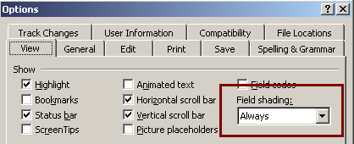
Once you’ve used a hyperlink you will notice “backwards and forwards arrows” appear in the menu.

Introduction
Operational modelling provides a structured, well established and proven approach to understanding and/or determining the operational architecture of an existing, new, or enhanced IT system, at any scale, degree of abstraction, or completeness. Put simply, it helps the IT Architect understand where everything is and/or where everything should go, what it is doing or will do there, and what will be needed to help ensure the IT system continues to operate effectively and efficiently.

Operational modelling may be used to understand the technical “underpinnings” of an IT system, whether this be described in formal terms or via a freeform technical environment diagram, as well as enabling the modeller to understand and/or make decisions on where the IT system’s functionality is or will be deployed, in which case it offers a complimentary set of viewpoints to those of the functional viewpoint’s component modelling (discussed in [Ref 5]).

In all cases, operational modelling provides a “white box” view of the internal structure and behaviour of the target IT system, corresponding to the “black box” views provided by System Context Modelling [Ref 6].

In the IBM Unified Method Framework (and therefore Team Solution Design), separate work products are used to portray the freeform and formal variants of the views seen from the operational viewpoint onto a target IT system’s architecture:

- Freeform operational diagramming. “Sketching” out the system’s operational architecture is documented in the artifact “Technical Environment (ART 0506)”, which requires no formal modelling notation, nor places any constraints on the nature and form of the diagram’s content.
When used to convey the operational viewpoint of a system, it is probable the technical environment (TE) diagram will be predominantly composed of things that are (or resemble) nodes and connections, maybe also with the IT system’s locations and their borders; although the meaning of these model elements’ inter-connections cannot, usually be determined without textual descriptions.
Compared to a functionally oriented technical environment diagram, the operational TE often provides no or maybe limited documentation of the target IT system’s components and their inter-relationships, and when it does it may be difficult to distinguish those components associated with the business purpose of the system (“the application”) and the underlying technical componentry required to operate the target IT system (“the infrastructure”).
- Formal operational modelling. Explicitly and formally describing the structure and behaviour of the target IT system’s architecture from the operational viewpoint is documented in a set of UMF artifacts centred on the “Operational Model (ART0502)”, which provide a range of well defined views of the IT system’s operational architecture, each rendered using a formal notation that removes ambiguity of meaning and provides explicit linkages with other models of the target system, such as use case modelling, non-functional requirements modelling, system context modelling, and component modelling.
In formal operational modelling, the modeller may use these UMF artefacts to understand:
  - Where are the target IT system’s external agents? (Documented in the operational views of the System Context)
Modelling how and from where the target IT system’s external agents connect to it. This artefact documents the system as a “black box” and is discussed in detail in [Ref 6].
  - Where can things go? (Documented in the Location Model)
Modelling the locations and their connections over which (or into which) the target IT system and its users is or will be deployed, giving the modeller an insight into the environment into which the target system will be deployed. The Location Model highlights those things that will or have influenced the target IT system’s design, such as the levels of security or systems’ management capability available in each location and across their connections.
  - What needs to be deployed? (Documented in the Deployment Unit Model)
Providing views on various aspects of the IT system’s components, such as the characteristics of their execution (transactional, conversational, batch and so on) or data (volatility, size, currency and the like).
  - What could they go on? (Documented in the Node Model)
Modelling the underlying technical hardware platforms used by (or to be used by) the solution, as well as the manner in which these platforms inter-connect.
These four artefacts may then be used to guide the development of the Operational Model itself, which conveys
  - Where does everything go and how does it all work? (Documented in the Operational Model)
Modelling the deployment of the IT system’s components’ aspects (DUs) onto the IT system’s platforms; modelling where and what these platforms need to be (in appropriate locations); and modelling the connectivity needed to support the communication requirements of the solution’s components within the capabilities and constraints of the locations and their connections.

The phrasing of these five questions implies a “forward engineering” approach, in which the modeller is intent on the design of a new (or maybe a heavy modification of an existing) IT system, including the deployment of a specific business application.

But this is not the only scenario in which Operational Modelling provides great value - the next section highlights how operational modelling brings significant value in many other circumstances, including the need to understand an existing system (“reverse engineering”); or when there is a focus on the underlying infrastructure without regard for the application.

Dimensions of Operational Modelling
Whether working informally (using the “Technical Environment” artifact) or more formally (via the Operational Model artifact) operational modelling enables the IT Architect to reason about an IT system in many ways:

- Any Time - “As Is” or “To Be”? – the operational model may represent an existing system, one being modified, or one that is brand new.
- Any Scale - Enterprise, Programme, or Project? – the operational views of a model may be on an enterprise scale (whether part of an Enterprise Architecture’s reference architecture, or documenting an enterprise-scale system); they may describe the operational viewpoint of a large programme (whether part of an EA’s pre-funded Transition Initiative, or as a funded programme’s overall design); or be for a project (usually part of a funded initiative).
- Any Level - Application, or Technical, or Both? – the operational views can include all the elements associated with an IT system’s purpose; or they may be restricted in some way, such as focusing on the deployment and distribution of the business application, or just the underlying technical infrastructure.
- Anywhere - Located, or Not? – the operational viewpoint’s views can document the actual distribution of the target IT system across the involved locations, whether these are defined as specific locations or via sets of non-functional characteristics; or they may present a more abstract “location-free” pattern, probably serving as a reference model for a variety of specific solutions and which therefore documents the environmental requirements of the system’s parts (sometimes via the notion of “zones”).

Each of these questions relates to a cross-cutting viewpoint of the target IT system’s basic operational viewpoint which is independent of the others – for example, the decision to focus on the application rather than technical considerations is equally valid whether the Architect is working on an Enterprise or Project Architecture. Experience tells us, however, there are common combinations, such as
- An Enterprise Architect creating a “location free OM reference architecture” for use by many Programmes and Projects
- A Project’s Architect will be focused on their IT system’s located operational model, maybe guided by the reference architecture provided by the Enterprise Architect.

Therefore, as the following sections discuss each of these dimensions in turn, they do include some common examples of the way these dimensions inter-relate.

Any Time - “As Is” or “To Be”?
Sometimes, the previous paragraphs referred to the IT system in terms of its current “as is” state (functionality is… deployed, over which, used by) as well as its future “to be” design (functionality… will be deployed, into which, to be used by). This reflects the dual value of operational modelling helping the IT Architect understand:

- An existing IT landscape, whether there is a need to
  - Improve the IT infrastructure’s operational effectiveness
  - Deploy a new IT solution into a pre-existing environment
- The shape of the future IT landscape as part of the deployment of an IT based business solution - whether this be for new or enhanced business functionality (“Application Level”), or because of IT effectiveness enhancements (“Technical Level”).

While there can be a temptation to think “informally” about an as-is environment, concentrating formal modelling to a future state, both freeform and formal modelling of the operational viewpoint can provide significant value to the IT Architect, for example
- Conveying the overall operational design of a new system to a non-technical sponsor using a “To Be Technical Environment” artifact,
- Obtaining a clear understanding of an existing systems ability to handle the extra work load of a new system (using an “As is Operational Model” artifact.

However, and particularly during the pre-sales proposal process or shortly after, there is often not time, resource or skill available to produce complementary as is and to be technical environments and operational models. It is therefore common to see the Technical Environment used to document the “as is” infrastructural context for the proposed new or enhanced IT system (in which case the work product may sometimes be called the “Current Environment”), limiting the use of the more formal and detailed operational model to those aspects of the solution requiring careful (albeit outline) “to be” design in order to ensure the viability of the proposal.

Any Scale - Enterprise, Programme, or Project?
Operational modelling enables the IT Architect to understand and design the operational aspects of any IT system whatever its “scale”. It is also the case, however, that operational modelling can involve vast quantities of information, often requiring precise and complex diagrams and views.

While it is therefore perfectly reasonable for operational models to be constructed as part of Enterprise, Programme or Project level architectures, it is usually necessary to focus on features of the operational viewpoint appropriate to the specific purpose, for example:

- The wider scope of enterprise scale IT systems’ operational models may mean they are far more coarse grained than those needed at the Project Architecture level, so probably documenting model elements in a more abstract manner (such as choosing to model “departmental server” rather than modelling the differences between “office server”, “warehouse server” and “store server”).
Nevertheless, given that the objective is to model an actual (as is or to be) system, it is probable that all the artefacts of operational modelling will be required (including, when formally modelling, the views presented in the Location Model, DU Model and Node Model).
- The desire of an Enterprise Architect to provide operational model reference architectures for their enterprise’s many programmes and projects will require these reference models to be at the same level of granularity as is needed in these narrower situations, but they will, never-the-less, be less complete than those of the programmes and projects (without “generalisation”, reference models would be impossible to reuse).
In this finer grained enterprise-scale context the operational model may therefore focus on the underlying platforms (“Technical Level” only), any may choose to abstract away any sense of specific location (if formally modelling, then there will be no “Location Model”), nor have a focus on application placement (i.e. no “DU Model”).
- Operational modelling as part of a Programme Architecture, is “earlier, wider less detailed” than the OMs of the programme’s associated Project Architectures; and will, therefore of necessity be less complete – for example it’s unlikely to model specific non-functional characteristics, or have fully worked through the implications of data placement decisions.

Critically, operational modelling is of value in Enterprise, Programme and Project Architectures – just because OM can require vast quantities of precise and detailed information does not mean it has to.

Any Level - Application, or Technical, or Both?
A complete operational model will include both “application” and “technical levels” – documenting how the application’s operational requirements will be met by the underlying technical componentry – but such a complete OM is not always needed.

For example, earlier it says “Operational modelling may be used to understand the technical ‘underpinnings’ of an IT system… as well as… where the IT system’s business functionality is or will be deployed”. Elsewhere, the discussion focuses on the premise that the target IT system is there to deliver an application (function and data) to a set of users (human or IT) – “deployment of the IT system’s components’ aspects”. These two very different objectives show how these cross-cutting operational viewpoints can be used:

- To model a technical operational environment, focused on modelling the structure and behaviour of an IT infrastructure, in which the modeller is designing or understanding the target IT system’s hardware and systems software, without direct reference to what business purpose the IT system is there to achieve.
Such a cross-cutting viewpoint may for example be required:
  - By an Enterprise Architect, endeavouring to ensure their enterprise’s programmes all exploit the same “common infrastructure”.
  - In projects focused on infrastructure renewal, where there is a need to understand and enhance the technical behaviour of an existing IT system.
- To model the application operational environment, modelling the deployment of the application and its data, understanding how the target IT system is structured and behaves when its users are doing their job.
Such a cross-cutting viewpoint can help architects’ overall design decisions – for example whether:
  - They will exploit centralised data (ease of systems management), or rely on data distribution (improved data access)
  - Its processing will be centralised (“lightweight clients”, easy to manage), or do performance requirements indicate distributed processing?

It is critical to recognise that “application” does not necessarily relate to “business” – it does not need to be an “ERP” application, nor does the target IT system need to be for something such as an “order management system”. Rather, “application” is intended to represent the purpose of the target IT system from the perspective of the person working on its design.

As an illustration, these three “systems” are all “applications” to different Architects:

- AmGro’s ‘AmGro-from-Home Order Management System’ is the “application” to the Solution Architect responsible for AmGro’s home shopping services. In this case, this architect may consider those parts of their system needed to maintain distributed data bases as being its “technical level”.
- Thus, their “technical level” ‘Data Distribution System’ is the “application” to the architect responsible for designing the mechanisms needed to distribute data around the AmGro-from-Home IT System. In turn, this Data Architect may consider those parts of their operational model that transfer files from A to B to be part of its “technical level”.
- Thus, their “technical level” ‘File Transfer System’ is “the application” to the Infrastructure Architect responsible for designing AmGro’s approach to managing the transfer of files (any files) around the AmGro IT environment. In their turn, this architect may then consider those parts of their operational model that keep the computers running (Operating Systems and so on) to be part of their “technical level”.
- Thus, their “technical level” ‘Operational Platform’ is “the application” to the… and so on…

But what is THE application? While it may be helpful for individual or groups of architects to think about “their application” within a wider project or program context, there is a danger that “one person’s application is another’s infrastructure” will cause confusion. Therefore there is always the need for the project/programme as a whole – i.e. the Programme Architect to recognise and maintain what is at “the” application level.

The need for “absolute levelling” of the target IT system’s application is, none the less, distinct from the relative levelling needed for modelling, in which the difference between the two cross-cutting viewpoints (“application” and “technical”) of the basic operational viewpoint is simply the absence or presence of a representation of the purpose(s) of the system, as perceived by the modeller:

- “If my OM models what I perceive the purpose to be, then it’s at the “application” level”
- “If my OM models what I perceive to be needed to support some purpose, then it’s at the “technical” level”

It is reasonable to assume that the application and technical cross-cutting views of the target IT system will “look the same”, with the same sort of model elements, relationships and behaviours; it’s just that some views will have application content and others technical. Therefore, as is discussed in section “Formal OM – Operational Modeling’s Viewpoints & Views”, formally modelling the target IT system from the operational viewpoint (ie using UMF’s various artifacts of operational modelling such as the Operational Model), it is normal practice to:

- Document the deployment of the system’s components (as found in a component model) via the Deployment Unit Model, placing the components’ deployment units (as located DUs) onto located nodes (based on technical nodes from the Node Model) across the target IT system’s locations (identified in the Location Model).
In which the components and DUs are either “application”, “technical”, or maybe a mix of the two. However, given that the focus of an architects work is “their application”, it is common for them to take a simpler approach for the technical cross-cutting viewpoint and to:

- Model the deployment of a system’s technical components in a less complete fashion, using the ideas of “technical nodes” composed of “software” and “hardware” components, as discussed in section “What can it run on? The Node Viewpoint (Node Model)”.

Then, if a more complete view of how these deployed technical components work together is needed, another set of cross-cutting views of the OM can be developed in which the technical components are, in turn, considered to be “the application”. This would then mean, for the Solution Architect, the Data Architect and the Infrastructure Architect identified above,

- AmGro’s Home Shopping Solution Architect will have an application level component model, as well as a DU model for the AmGro-from-Home order management system, and will treat those other functional parts of their system that, for example, do data distribution as “software”.
- AmGro’s Data Distribution Architect may have an application level component model, and therefore will have a DU model for the Data Distribution System, and will treat the underlying functional parts of their system that do file transfer and other things as “software”.
- AmGro’s Infrastructure Architect may have an application component model, and will have a DU model for the File Transfer system, and will treat those other functional parts of their system that keep the computers running (operating systems etc.) as “software”.

None-the-less, if a Programme Architect were to bring all of these cross-cutting views together, looking at the target IT system from the complete basic operational viewpoint, they would then choose to see the model:

- Either as sets of paired application/technical views, in which any part of the model was observed as “software” when looked at as supporting something above, as well as observed as DUs when the focus of the pair.
- Or as a single integrated set of views, all portraying DUs, in which a DU may be from any level and in which “software” was restricted to the lowest level.

Anywhere - Located, or Not?
Operational modelling enables the modeller to understand, design and communicate where the target IT system is or will be, whether concerned with its application or technical cross-cutting viewpoints, and at any scale.

To do this there is an underlying need to know
- Where the parts of the target IT system can be, though the notion of locations (which, for formal operational modelling is captured in the Location Model)
- Where the parts of the target IT system actually are, as captured (formally) in the idea of located model elements, located in those locations, (and, for formal operational modelling captured in the Operational Model).

However there is also significant value in modelling the structure of an IT infrastructure without concern for where things are – this could, for example, be of great use when defining the underlying, maybe standard platforms and connections on which an enterprise’s systems can be built. In this case the concept of location and located model element are not needed (in which case, for formal operational modelling, the Node Model provides the necessary views of the operational viewpoint).

“SA4TeamSD”, “AmGro-from-Home”, SDS, and UMF
The diagrams and views used throughout this white paper conform to the approach and work products of the Team Solution Design (TeamSD) Method – and many are screenshots of the AmGro-from-Home case study modelled in TeamSD’s configuration of Rational System Architect (SA4TeamSD):

- Team Solution Design is IBM’s corporately agreed method for the pre-sales design of IBM’s IT based solutions, used by all Business Units in all Geographies. It is based on a suite of artefacts defined in the Unified Method Framework mostly taken from the Framework’s IT Architecture domain.
- The SA4TeamSD configuration of Rational System Architect addresses all parts of all these artefacts at levels of detail appropriate for pre-sales design work, as well enabling much deeper analysis and modelling for IT Architects working in post sales solution delivery.
- AmGro-from-Home is the IT Architect Profession’s education case study, described briefly in section “Building the Operational Model: AmGro-from-Home” and more fully in Ref [6].

AmGro-from-Home is available as a sample model (i.e. a System Architect encyclopaedia) shipped with the SA4TeamSD configuration (at the time of writing, this is version 1.15.12) of IBM Rational System Architect (version 11.4.0.3, build 170) – see Ref [9]. It is expected to be compatible with all subsequent releases of both SA4TeamSD and Rational System Architect.

This paper assumes the reader is familiar with the work products and techniques associated with “Architectural Thinking” within UMF, and in particular with the underlying language of architectural modelling defined in IBM’s System Description Standard’s metamodel and its key engineering perspectives [Ref 2], together with the Unified Method Framework’s use of basic and cross-cutting viewpoints & views “Appendix B: Views and Viewpoints” and [Ref 3].

Informal OM – Technical Environment Diagrams
The operational version of the Technical Environment Diagram is a free form sketch intended to convey a general sense of the target IT system from the operational viewpoint, usually with limited underlying notational formality and often therefore as a high level representation for audiences who may not be trained in the formalities of the UMF.

Technical Environment from UMF Artefact (ART 0506)
This UMF artifact’s description begins “This artifact is an inventory of an enterprise’s existing technology resources and related management aspects”. However, the TE need not be just of an enterprise, it need not be just an inventory, and it need not be “existing” - UMF provides two examples:

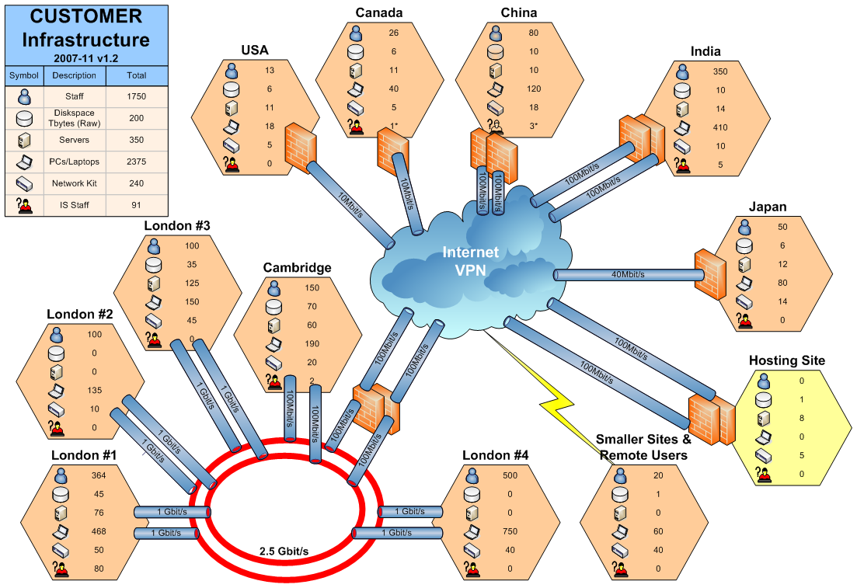
Figure 1: Operational TE (example 1 from UMF Artefact)

While having an enterprise scope, and providing an inventory-like listing of the operational infrastructure, Figure 1 gives a simple indication of the infrastructure’s (location centric) network.

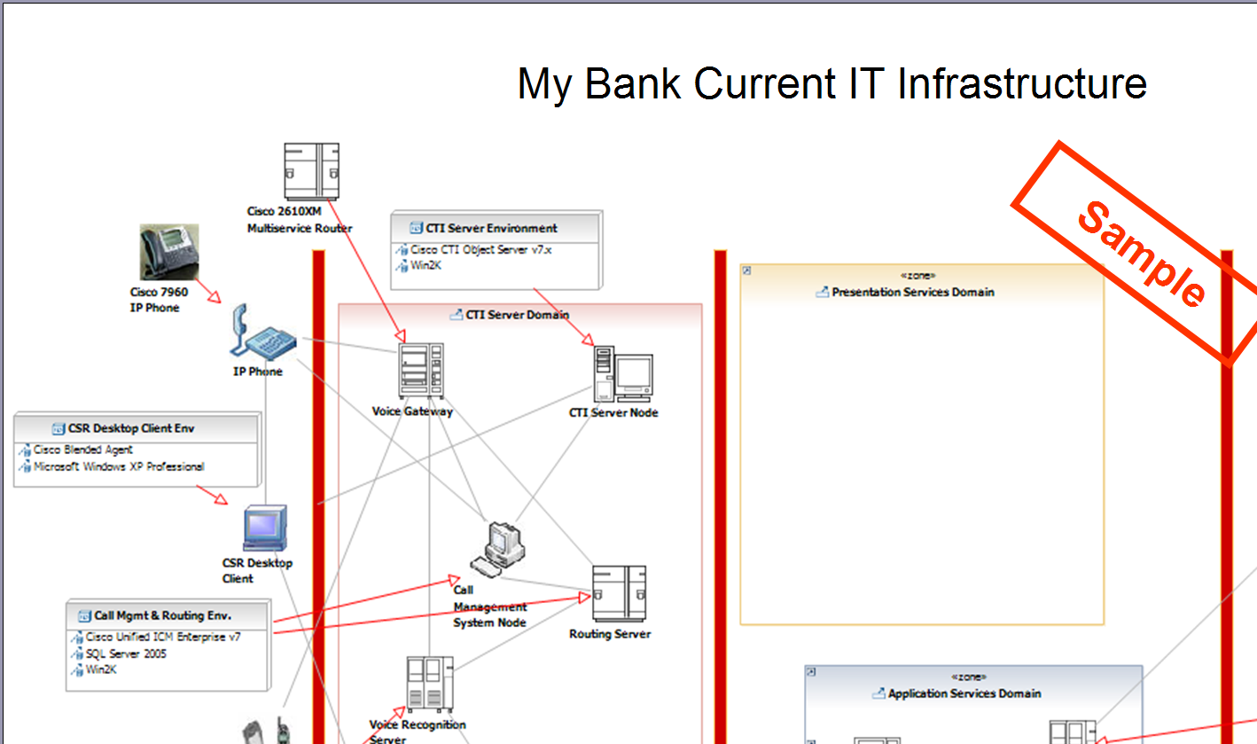
Figure 2: Operational TE (example 2 from UMF Artefact)

Figure 2’s TE documents a system’s architecture’s operational structure, albeit still at a very high level, – we can interpret the thick vertical lines as probably being firewalls, the images seem to be representative physical nodes, and the thin lines look like logical connections.

While both cases present sketches that will be valuable to the artefact’s author in communicating operational concerns to their audience, neither can be relied upon (without extensive textual descriptions) as a trustworthy representation of the target IT system from the systems’ operational viewpoint. To do this, while assuming a desire to continue “sketching”, we will need to ensure the freeform TE has extensive meaning behind its different symbols (both boxes and lines), that are clearly communicated via a key, and as for example is illustrated in the next section:

Technical Environments for “AmGro-from-Home”
The TE illustrated in Figure 3 sketches out the “as is” operational environment in AmGro, in order to describe the overall environment into which the new AmGro-from-Home home shopping order management system (described in section “Building the Operational Model: AmGro-from-Home”) will be deployed:

Figure 3: Typical Technical Environment diagram (AmGro’s “as-is” IT environment)

This sketch is a TE similar to that of Figure 2, although the connections appear (that’s an assumption) to be physical rather than logical, and there is a greater sense (another assumption) about the locations over which the target IT system is deployed, which may themselves be documented in a separate TE:

Figure 4: Existing locations which may be used for "AmGro-from-Home" (TE)

These four examples show an operational TE’s sketch has little or no formality in the precise meaning of the things that appear on it. Specifically, it is generally the case that a TE does not generally distinguish:

- What things are (physically), compared with what they do (logically). For example, it is assumed that both Figure 2 and Figure 3 are documenting physical computers (“nodes”), although Figure 2’s connections seem logical (they’re drawn “point-to-point”?) while those of Figure 3 are probably physical (they seem to be “networks”)
- Between operational and functional viewpoints of the target IT system. All examples included here have been carefully chosen to convey views from a target system’s operational viewpoint; but how can we be sure? It may be that the “computers” in Figure 2 are actually intended to represent functional “sub-systems” or even components – is “Call Management System Node” really an operational node, or is it a tightly coupled set of components? Is “Voice Gateway” a functional component or a collection of components running on a single node?
- Application or Technical level. Probably both, sometimes neither! We can be pretty sure Figure 1 and Figure 3 are intended to convey information about the underlying technical infrastructure (they make no reference to why the infrastructure’s there), Figure 2 is a mix between application level (“Voice Gateway”) and technical (“Routing Server”), and Figure 4 is neither – or both!

Interpreting a TE diagram can be aided by the provision of a key, if a consistent (but private) set of icons and line types has been used (as with parts of Figure 1 and can be imagined for Figure 3). None the less, it is important to recall that the diagram is informal and that its content is always likely to be ambiguous. It also means that critical issues may not be identified until more formal work products are produced, and therefore not be available for preliminary architecture discussions.

TE in SA4TeamSD – “Freeform Diagramming”
A TE, whether functional or operational in nature can be created in the SA4TeamSD configuration as a type of “freeform diagram”.

SA4TeamSD’s freeform diagrams provide the modeller with a powerful hybrid between completely informal sketches and notationally rich views of formal models: freeform diagrams allow the modeller to portray informal relationships between formal parts of a formal model.

Those parts that can appear on an operational Technical Environment’s sketch include:
  - One or more target systems
  - (Logical) actors and (physical) users
  - Logical and physical access mechanisms
  - Logical and physical locations and borders
  - Logical and physical nodes

These are all rendered on the TE using the same icons as are available in the formal notation of the Operational Model’s views, but may be “connected together” in any manner that suits the needs of the modeller – including ways that may be forbidden in the formal modelling context (such as an “connecting” an actor to a node, without the need for an access mechanism). For example, Figure 5 presents the SA4TeamSD version of the freely drawn sketch in Figure 3:

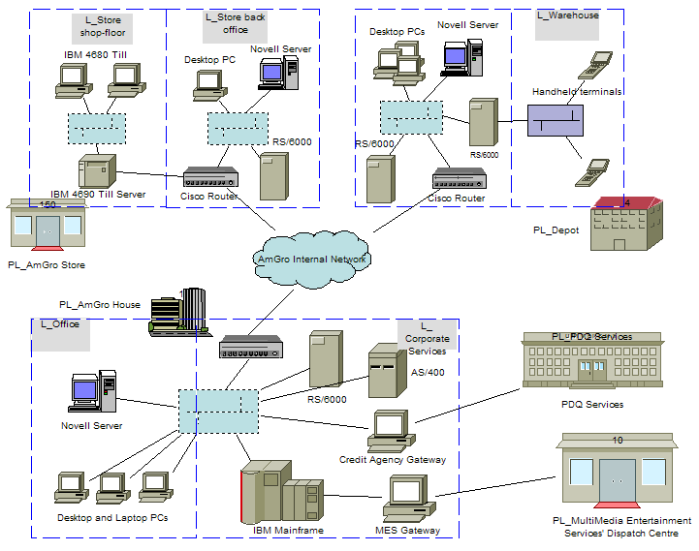
Figure 5: SA4TeamSD TE freeform diagram (AmGro’s “as-is” IT environment)

As with all SA4TeamSD freeform diagrams, Figure 5 demonstrates how

- All the symbols on the diagram represent actual model elements in the underlying (formal) model of the system.
- The relationship between any two model elements is a “Freeform Connector”, and therefore need not represent a relationship in the underlying System Architect model. They therefore allow the modeller to portray otherwise contradictory or maybe “invalid” model element relationships, such as in this case between the location “PDQ Services” and logical node “Credit Agency gateway” (locations cannot be connected to nodes, although locations do contain located nodes!)
As a consequence of their hybrid nature, freeform diagrams cannot model “indeterminate” things: for example it’s not possible to model nodes that are neither logical nor physical, or to model “something” that may turn out to be a component or a node. As a counterpoint to this, exploiting SA4TeamSD’s freeform diagrams for sketches such as those found in a TE supports the common custom and practice of a modeller:
- Having good confidence in the exact nature of the system’s parts, whether distinguishing logical descriptions of what something does (e.g. logical node) from a description of what it is (i.e. a physical node)),
- While glossing over the complexities (or ignorance of) how all the bits fit together – allowing ambiguous or “invalid” relationships that facilitate “natural language” discussions and clarifications of the target IT system’s requirements and obligations with “non-IT” audiences.

None the less, the pictorial nature of the model elements on these SA4TeamSD examples may still cause confusion – only by interrogating Figure 5’s underlying content can we tell that it is composed of physical nodes. Figure 6 show how, by adopting a more formal notation, a TE can overcome this limitation, although at the expense of attractiveness to non-IT Audiences:

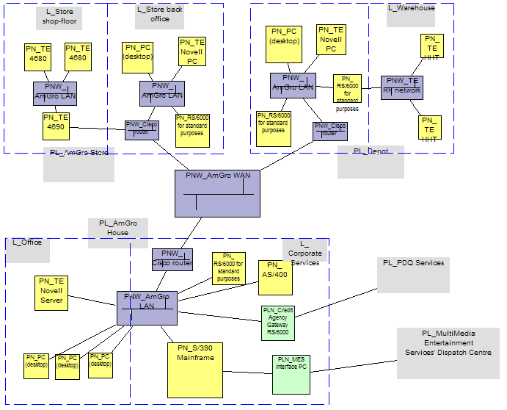
Figure 6: SA4TeamSD TE freeform diagram (Figure 5 with formal symbols)

For completeness, Figure 7 shows SA4TeamSD’s rendering of Figure 4, the locations which may be involved in AmGro-from-Home’s order management system:

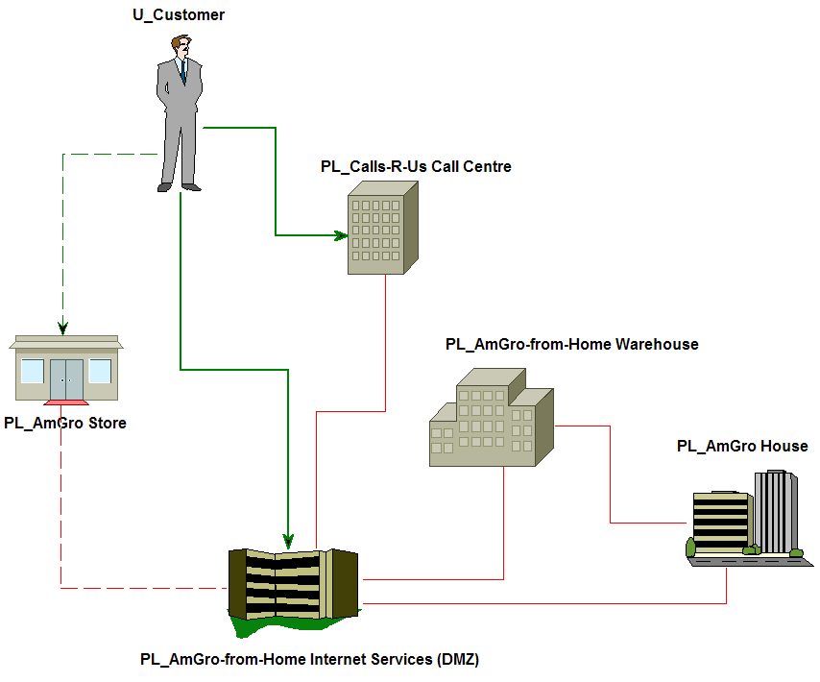
Figure 7: SA4TeamSD version of Figure 4

To remove all further ambiguity in the documentation of a target IT system’s operational structure and behaviour requires the use of a formal modelling language and notation, presented for a known set of operational viewpoints and with defined views draw from those viewpoints – it needs “Formal Operational Modelling”.

Formal OM – Operational Modeling’s Viewpoints & Views
The formal views of the IT system’s operational viewpoint provide unambiguous “white-box” statements about the logical and physical deployment of the target IT system and its external agents (both humans and IT systems) across the geographic landscape. Together, they “explain” how the target IT system will achieve the operational “black-box” context defined in the operational views of the system’s System Context Model.

It is recognised that this section contains no figures, even though the operational viewpoint contain many views. All views are exemplified in section “Building the Operational Model: AmGro-from-Home”, where they are used to extensively illustrate Operational Modelling’s many modelling techniques.

The Five Viewpoints of Operational Modelling
“Appendix B: Views and Viewpoints” briefly discusses the notions of models, viewpoints and views, highlighting how a target IT System’s model may be formally observed from four standard viewpoints, including the Operational Viewpoint:

- There is only one “Operational Viewpoint” onto the target IT system model

It goes on to explain how, when it is necessary to look in depth at the target IT system, the Operational Viewpoint may be used to refine the scope of the model to be “just” an Operational Model, which can then be observed in detail from a series of secondary basic viewpoints,

- There can be multiple secondary viewpoints onto the operational model.

The views seen from these secondary viewpoints are described in specific artifact descriptions:

- Operational System Context Viewpoint (defined in “System Context (ART 0651)”), concerning the external agents that need to use the target IT system
- Component Deployment Viewpoint (defined in “Deployment Unit Model (ART 0525)”), concerning the things that need to be deployed
- Geographic Viewpoint (defined in “Location Model (ART 0523)”), concerning the locations where things can be deployed
- Node Viewpoint (defined in “Node Model(ART 0524)”), concerning the platforms and connections onto and across which things can be deployed

These four viewpoints form a “backdrop”, being the inputs to help document:
- Operational Deployment Viewpoint (defined in “Operational Model (ART 0522)”), concerning where all the target IT system’s parts will (or have been) deployed, together with the location of and access mechanisms used by the IT system’s external agents
The following five sections discuss each of these five secondary viewpoints onto the Operational Model in turn, followed by a section discussing how it is not always necessary, appropriate or possible to reason from the operational viewpoint using all of these secondary basic viewpoints, nor how these viewpoints need to be developed in one pre-defined order. Subsequently, in the last major section of the paper, a fully detailed description of all these viewpoints of formal operational modelling is presented, including examples of each viewpoint’s views using the AmGro-from-Home Order Management System as a consistent example.
It is important to note at this stage, however (and before reading the following sections), a critical difference between the Operational Deployment Viewpoint and the other four viewpoints: the idea of something being somewhere – the related notions of “location” and “located model element”. The next four sections discuss how the artefacts describing deployment units, nodes, connections and external agents do so largely without regard for their location – only when the modeller looks at the system from the operational deployment viewpoint do they think about where these things are, and therefore realise that for the target IT system to work it needs a model element to be “here” as well as “there”; inevitably leading to the need for the model to include “Located DUs”, “Located Nodes”, “Located Actors” and so on.

Who needs to connect? The Operational System Context Viewpoint
Ref [6] discusses in great detail the modelling of a target IT system’s System Context – documenting what the system’s external agents are doing functionally, as well as describing how they operationally connect to the target IT system.

At the heart of the system’s context’s operational viewpoint lies the notion of an “access mechanism”, a way of describing the (logical) characteristics and (physical) means used by the system’s external agents to connect to the system, and enabling the modeller to develop an operational “black box” view of the target IT system. Ref [6] discusses how, from this “black box” system context perspective, access mechanisms are:

- At the system’s boundary
- One of three types, connecting the target IT system to:
  - A human being
  - An external IT system that is independent of the target IT system
  - An external IT system that is hosting part of the target IT system.

Access mechanisms provide a significant amount of information for stakeholders considering the target IT system from the operational deployment viewpoint that go beyond this “black box” system context perspective; summed up in a number of critical observations extending beyond this logical example from [Ref 6] :

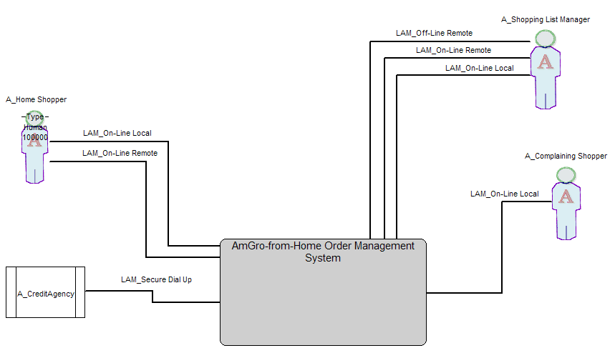
Figure 8: Actors and Logical Access Mechanisms (from [Ref 6])

Figure 8 includes actor “A_Shopping List Manager using access mechanisms:
  - “LAM_Off-line Remote” that enables actors to use the home shopping system, but in a disconnected manner. This access mechanism is “anywhere” the actor wishes it to be.
  - “LAM_On-line Remote” that enables actors to access the central home shopping system’s full range of capabilities anywhere they are able to connect to the internet and use a device enabled to support home shopping.
  - “LAM_On-line Local” that is provided to actors via PCs provided as part of the Amgro-from-Home target IT system
The following observations summarise additional considerations when modelling access mechanisms from a “white box” perspective, including some “best practice” approaches that have been found to help ensure a clear and communicable model:

- Observation #1: Actors are modelled as located actors
When looking at a model from the functional viewpoint, a (logical) actor represents a role taken by one or more (physical) users in their use of the target IT system – as discussed in [Ref 6], this is reflected in the best practice guidance of modelling an actor having one relationship with the target IT system, modelled as a logical exchange. This exchange is then described in terms of the use cases the actor initiates and supports, or maybe as a set of functional requirements, in all cases with one set of non-functional characteristics, such as response times or scheduled hours.
From all the secondary operational viewpoints, however, we are interested in how the actor accesses the target IT system to do what they do and how this affects what they can do – such as via these three different logical access mechanisms, each with different non-functional operational characteristics that therefore either supplement or refine those considered from the functional viewpoint: in this internet based example it’s almost inevitable that the “response time” across an off-line access mechanism (where the actor’s using an application on their own PC) will be faster than that across the on-line option. As a consequence, best practice indicates that:

  - For the operational system context viewpoint’s views (and as exemplified in Figure 8) it is convenient to portray the functional viewpoint’s actor with many access mechanisms, helping ensure holistic “black box” modelling of a target IT system’s requirements across both functional and operational concerns.
  - In the “white box” views (i.e. the operational deployment viewpoint) it is more important to consider the operational consequences of an actor using multiple access mechanisms and therefore to model the functional viewpoint’s actor as one or more located actors, each using exactly one access mechanism, with each access mechanism modelling the non-functional characteristics required by (or available to) the actor when using that access mechanism.
- Observation #2: More than one located actor may use an Access Mechanism
[Ref 6] discusses how access mechanisms are used by different actors – for example, Figure 8 shows the “Remote On-line” logical access mechanism being used by actors engaged in Order Management and Customer Profile Management as well as Shopping List Management.
Combined with observation #1, this means each access mechanism is being used by a “collection” of located actors, all in the same location - although located actors in the same location need not be using the same access mechanism.
- Observation #3: Access Mechanisms are “connective” – they have two ends
[Ref 6] describes Access Mechanisms as modelling how (functional) actors access the target IT System – they “connect” these actors to the target IT system. As a “connection”, an access mechanism must therefore have two ends:
  - An outer end “attaching” to an external agent, outside of the target system.
  - An inner end “attaching” to an edge node inside the target system.
Thus,
  - It is helpful to focus on modelling an access mechanism’s outer end when considering the operational system context viewpoint, since it is used to describe the actor’s “access requirements”, including a description of the mechanisms being used to put information in (which for a human actor may be mouse, keyboard, voice, or specialised access devices), as well as get it out (human: screen characteristics, sound, etc.): even though its symbol is a line between the actor and the target IT system, its inner end can’t be seen in this “black-box” view.
  - In “white box” operational views it is a connection between a located actor and an edge node within the target IT system, in which it models the characteristics of the connection. While an access mechanism can connect more than one located actor (observation #2), it is common to limit logical edge nodes to exactly one logical access mechanism, in order to focus the model on what the solution needs in order to support it’s external agents, particularly when multiple physical access mechanisms are available from physical edge nodes.
- Observation #4: Both ends of an Access Mechanism are “somewhere”
[Ref 6] discusses in detail how an actor is in different places when using their different access mechanisms: for example, the access mechanism’s names on Figure 8 suggest the target IT system’s actors are somewhere (anywhere) where they have access to the service in a stand-alone way; somewhere else where they directly connect to it “remotely”, and somewhere else again when they are “locally connected”.
In each case, the access mechanism’s outer end must in the same (external) location as the actor using it. However, the access mechanism’s inner end is attached to an edge node “somewhere” inside the system, and therefore the access mechanism’s inner end must be in the same (internal) location as the edge node it is connected to. Thus, since the located actor and edge node need not be in the same location, the access mechanism’s ends need not be in the same place.
Thus
  - From the operational system context viewpoint, one of the “access requirements” described by the access mechanism (observation #3) is the location of its outer end.
  - The location of an access mechanism’s ends are not directly modelled in “white box” operational views - best practice follows the same approach used for inter-node connections, in which each end of an access mechanism is connected to located actors and a located edge node, which in turn have a location.
- Observation #5: Access Mechanisms “carry traffic”
Just like connections between nodes, access mechanisms carry traffic between edge nodes and the system’s external agents. This traffic can be modelled in two ways:
  - From the operational system context viewpoint, it is typical to model this traffic in relatively descriptive terms, documenting the exchanges that are transported over the access mechanism between the external agent and target IT system. In turn, these exchanges may be more completely defined, whether they are interactive (such as a collection of interactions associated with the use cases between the external agent and the target IT system), or otherwise (such as the transfer of files to or from an external agent).
  - In the Operational Model’s “white box” views, it may be necessary to model the traffic in more formal terms, in which the access mechanism is used to model the functional support for component connectors (between the external agent and an edge component - connectors carry messages between an external agent and an edge component) or, as is discussed in section “Step 2c: Deploy Located Execution DUs”, the operational transport of located DU connectors (between a located external agent and a located PDU, in which the located DU connector carries located DU messages between a located external agent and the located Presentation DU).
- Access Mechanisms and the target IT system’s boundary

An Access Mechanism describes the location and nature of the connection between the target IT system and one or more external agents, and is at the boundary between them.
[Ref 6, “Modelling the System’s Operational Boundary – Access Mechanism”]

This quote includes the phrase “is at the boundary” – but an access mechanism is not in one place, it is a connection between two places - observation #3 highlights how one end is connected to an actor outside the system, while the other end is connected to an edge node inside the target IT system, each end having potentially different operational characteristics. Where then, along the access mechanism is the target IT system’s boundary? It may first be useful to define “boundary”.

A boundary is not a “thing” in the conventional sense – while it can be described, it is “not something you can see”; while it can be crossed, it can never be stood on. In general, a boundary represents a change in some characteristic, such as the boundary of a sports field lies between somewhere (a zone) considered “in play” and somewhere (another zone) considered “out of play”. For access mechanisms, and as discussed later in “Access mechanisms, PDUs, located actors, and edge nodes”, the characteristic defining the boundary is “in/out”, with the target IT system in the “in” zone, and external agents in the “out” zone.

  - For the operational system context viewpoint, observations #3 and #4 highlight that the access mechanism’s “outer end” is modelled, recording information about the system’s boundary “as seen from the outside”, thereby modelling the boundary as it is perceived by the access mechanism’s located user, such as is shown in Figure 9:
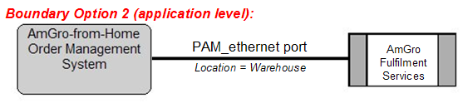
Figure 9: Access mechanism “in” external agent’s location (from [Ref 6])

In these “black box” views, therefore, the access mechanism “is” the boundary, and the conditions “at” the boundary are defined by the access mechanism.

  - It is more complex from the operational deployment viewpoint, since its “white box” views portray a more complete picture, with the access mechanism connecting two things – which end is the boundary? For example, consider:
    - Edge node and located actor in different locations
The located actor “outside” is a different location to the edge node “inside”, such as someone using the internet from their own PC at home. In this case, the actor is the PC, it’s access mechanism’s outer end is in location “Home”); while the target IT system’s edge node is in the service provider’s Service Centre, and the access mechanism’s inner end is in location “Service Centre”.
    - Different characteristics between edge node and located actor
The required operational characteristics, as seen from the “outside” at the outer end of the access mechanism may not match the offered characteristics, as seen from the “inside” at the inner end. For example, a user experiencing 5 second response times “at the glass” (i.e. their PC, as the actor, is experiencing 5 second response times); while the service provider is successfully delivering 2 second response times at their system’s edge node.

In all these cases the target IT system’s boundary can be seen to be at the inner end of the access mechanism. This may be most clearly seen in a somewhat unusual example – a human actor using a PC edge node. For “black box” views, it is simple to say the access mechanism is the “visual” (outwards) and “tactile” (inwards) boundary. But what if the PC is placed in a hazardous location? Then the access mechanism might be line of sight through a dirty glass window plus an un-reliable wireless keyboard, with all the consequential operational issues “between the target IT system’s boundary (the PC’s screen and wifi receiver) and the actor.

Note: Logical and Physical Considerations
The preceding section endeavoured to avoid reference to “logical” and “physical” access mechanisms ands their associated model elements – although the example was based around (logical) actors, it could equally well have been related to (physical) users.

In reality, physical located nodes may support any number of physical access mechanisms, each being used by any number of (physical) users, each in a different location (where they are modelled as a (physical) located user). In order to manage this inherent complexity, it is normal custom-and-practice to restrict logical located nodes to supporting one logical access mechanism each – any desire to model several access mechanisms per logical located node can be accommodated by re-factoring the node into several, ensuring each focuses on one specific type of logical access mechanism.

Also in reality, physical access mechanisms’ outer and inner ends are each in exactly one location (whether the same or different). Logical access mechanism facilitate modelling how a single “real world” access mechanism is used in several different ways, such as logical access mechanisms “Remote on-line” and “Remote off-line” modelling how one physical access mechanism is being used in different modes at different times.

What needs deploying? The Component Deployment Viewpoint (Deployment Unit Model)
The operational viewpoint of a target IT system describes “where the parts are going to go” (or have gone) in order to ensure the system works (functionally) and works well enough (non-functionally). More precisely, it describes the deployment of the system’s application and infrastructure parts into and across one or more locations, in such a way that the system’s human and IT system users can access and use (or be used by) the target system from their own locations.

But what are the parts that need deploying?

As discussed in section “Any Level - Application, or Technical, or Both?”, a Solution Architect considers their system to be made up of application level things and technical level things:

- Application level things
The components identified and described from the functional viewpoint (and therefore appear in the Component Model). This section discusses how the operational viewpoint looks at the deployment of these application level components via Deployment Units.
- Technical level things
The underlying (infrastructural) operational and systems management software needed to ensure the application does what it’s meant to do. Section “OMS’s Node Model” discusses how the operational viewpoint describes the deployment of this technical software.

Q: But what are Deployment Units?

A: They represent different aspects of a component, so that it can be successfully deployed into the Operational Model

Q: What does this mean? Why do we need to think about components as Deployment Units when looking at the target IT system from the operational viewpoint?

A: Consider a simple example, shown in Figure 10, in which a system’s users want to use a solution composed of exactly one component - a word processing application. The Solution Architect is constrained to deploy the word processing application across a system composed of two types of computer: the users’ PCs, and a central server.

Figure 10: A simple system: two types of computer, one word processing application

Where is the Solution Architect going to deploy the application?

- Will they install it on the PC, from where the user will run it and store their documents? While performance and (overall) availability could be better for each user, what if there are 1000’s of users - will Systems Management be a challenge? How will they share documents (the component’s data)?
- Will they install it on the server, but do everything else on the PC? Managing the application (version updates etc) might be easier, but what about data backup?
- Will they ensure documents are stored on the server and not users’ PCs? Or maybe they can run the application on the server too, with a remote desktop technology used to access it from users’ PCs?

There are so many choices! All of which place different parts of the one component onto different platforms! Here are just four examples:

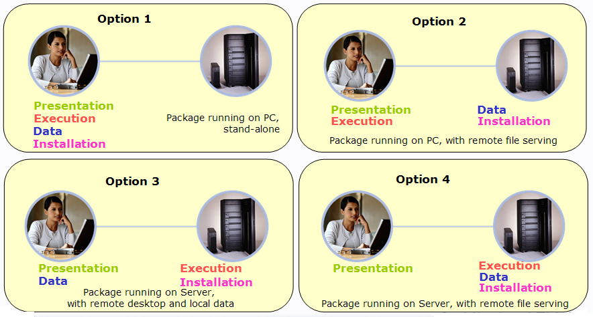
Figure 11: Options for deploying a single component

This is just for an application composed of one component – imagine what options there may be for applications with 10, or 30, or 100 components! Therefore, to help us reason about components from the operational viewpoint, we can (if we wish!) formally identify four different aspects of their deployment, each considered separately when deciding “where the component will be” across the Operational Model:

- Where will the component execute? (the execution aspect)
Will the component run close to the external agents using it, or close to the data it owns? Will it be split in some client-server fashion? Or will some of its functionality run in different places? This aspect is represented by the component’s Execution Deployment Unit, (EDU).
EDUs therefore represent what components can do: variously described as the component’s operation executions (SDS), its operational signatures (UML), its methods (more object-like), or its activities (business centric).
More specifically, EDUs describe the execution characteristics of these operations – ranging from performance characteristics such as transaction rates, CPU and memory requirements, through measures of security, availability and other “service level characteristics, to concerns such as relative importance and environmental issues.
- Where will the component’s data be stored? (the data aspect)
Will it be stored “conveniently close” to the external agents using it, maybe providing high levels of performance and availability, or will it be stored centrally, where security and systems management may be easiest? Will it be appropriate to deploy it in a master database with copies distributed around the system, or maybe it might help to split it up in some fashion? This aspect is represented by the component’s Data Deployment Unit (DDU)
DDUs therefore represent what components manage: variously described as the component’s I/O entities (SDS), its attributes (UML), its data items (business centric) – or just simply data.
More specifically, DDUs describe the storage and access characteristics of these I/O entities – ranging from performance characteristics such as record or database size, currency (how up to date does the data have to be), volatility (how often and by how much does the data change) and growth rate; through measures of security, availability and other “service level characteristics”, to concerns such as data type (structured files, relational, images, etc.) and their original, sometimes external source.
Not all components will have DDUs, for example a component that controls the dialogue between an application and a user may be purely “executional”.
- Where will the component be installed? (the installation aspect)
The component need not run in the same place as it’s executables are installed – might it be easier to install it on a server, even if it runs on a local desktop machine or laptop? This is represented by the component’s Installation Deployment Unit (IDU)
IDUs represent and describe the operational characteristics of all the target system’s components’ installed files – the “dot-EXE” and “dot-INI files” that need to be stored somewhere and from where the component’s EDUs are loaded into memory and run. As for all types of DU, IDUs’ characteristics are largely “service level characteristics” like performance (e.g. rate of loading to memory from file), security and availability, as well as concerns such as frequency of change and licensing requirements.
- Where will the component’s interface seem to be? (the presentational aspect)
For any component responsible for an interface with the outside world (an “edge component”), where will its presentation services be exposed? If it runs on a machine local to the actor, then (probably!) this will be in the same place as its EDU. But what if the EDU is remote from the actor? Will the system’s boundary be where the component is running, or will there be some kind of underlying technical service allowing the system’s boundary to be remote from this EDU? Where this “functional edge” is, is represented by the component’s Presentation Deployment Unit (PDU).
PDUs describe the nature of the edge components’ interfaces with two sorts of external agent:
    - Human external agents, in terms of the Human-Machine Interface (HMI), whether this be via a conventional device (PC, laptop, hand held terminal, PDA, voice or even printout) or some other means (special access interfaces).
    - IT system external agents, in terms of the information transfer mechanisms being used; such as messaging or file transfer, and the type of media (wire, wireless, physical media etc).

In addition to these “form factor” characteristics, PDUs also document the operational characteristics of performance, availability and the like, as well as other non-functional characteristics such as the nature of the traffic across the edge (e.g. “on-line”, “off-line”, “transactional”, “batch” and so on).
It is no coincidence that all the hardware in “a computer” is represented by these four types of DU:
- EDUs identify what processing power, associated circuitry and volatile memory are needed.
- DDUs and IDUs identify what permanent storage (disks, memory sticks etc) is required.
- PDUs identify the interfaces needed by the target IT system’s external agents, whether these are human (screen, keyboard, voice) or IT systems (such as data exchange via some for of media, or networking interfaces).

As is exemplified in the AmGro example later (section “OMS’s Deployment Unit Model”) it may be appropriate to

- Separate each and any aspect of a component into multiple DUs if this particular aspect demonstrates a widely varying set of characteristics, such as:
  - Some presentation aspects of a component are associated with file transfer activities (PDU A), while others relate to inter-active transactions (PDU B)
  - Some execution aspects of a component must continue to be available in the event of a partial system outage (EDU J), while it may be acceptable for others not to be (EDU K).
  - Some data aspects of a component are “small and volatile” (DDU S) while others are “large and stable” (DDU T).
  - Some installation aspects of a component can be readily made available remotely (IDU Y), while others must be co-incident to the component’s execution (IDU Z)
- Group (aggregate) a particular aspect of a number of components’ into one DU, if it can be seen that this aspect of all these components will always be co-located somewhere in the operational environment, such as several components having:
  - The same presentation characteristics, since they all present to the same external agent from the same place(s), where-ever that agent is located,
  - The same data characteristics and therefore always co-located in the same database or other form of data storage, where-ever that database is located.
Whether components’ aspects are separated or grouped is done aspect by aspect – for example, for Component A:
- Its data aspect could be separated into DDUs “D_A1” and “D_A2”;
- Its execution aspect grouped with that of component B into EDU “E_A+B”;
- One part of its presentation aspect is grouped with that of component C into PDU “P_A1+C”, while another part is represented by a PDU dedicated to A alone, “P_A2”

It’s therefore also the case, for example, that one component’s EDU is never grouped with another’s DDU.

Note: Why are “edge components” the only ones with PDUs?
Every component has one or more interfaces, so why do we only need PDUs for “edge” components - those that interface with external agents? It is because we use PDUs to model the characteristics of the target IT system at the system’s boundary even if the application’s edge components are not at that boundary. This need to understand the operational separation between an edge component’s execution and its presentation contrasts with internal application components, whose “presentation” is always co-incident with their execution, and therefore modelled as part of their execution.
PDUs (and indeed all DUs) model the application level of the target IT system – they are used to represent the operational location and requirements of the application. These “application level requirements” are then solved by technical components (often modelled as software and hardware, as discussed in sections “What can it run on? The Node Viewpoint (Node Model)” and “Step 3: Adding the Technical Level Logical Structure View”).

Thus the application level’s PDUs drive the selection (and execution) of the technical software and hardware needed to achieve the application’s apparent presentation. For example, the PDU in Option 4 of Figure 11 might be satisfied by the execution of the front-end part of some technical “remote terminal server” software, while the application’s EDU is “underpinned” by the back-end part. This is exactly the same reasoning process as for the component’s other DUs, that drives the selection (and execution) of technical software – for example, DDUs drive the selection of file management or database software, and EDUs drive the selection of collaboration, transaction management, or batch management software.

It is important to recognise, however, that the application’s DUs do not “disappear” when the technical level is introduced – the apparent presentation of the application must still be modelled by its PDU, just as it’s EDUs and DDUs must be retained, although all now underpinned by appropriate technical software and hardware.

Note: Working without Components
It is not always possible or appropriate to reason about the model from the functional viewpoint using a component model; for example a COTS package may not be described via a component model, but in some “module and database” fashion. Or it may be the case that the functional viewpoint describes the target IT system’s model via classic “function and data decomposition” techniques.

Whatever the cause, Deployment Units offer a mechanism for bridging between the functional and operational viewpoints of the application - so long as their purpose is understood, it is possible to relate the application to each of them in terms of how it will affect the solution’s “computers”:

- What are the application’s (part’s) “execution” characteristics?
The answers to this question is documented as the application’s Execution DUs
- What are the application’s (part’s) “storage” characteristics?
The answers to this question is documented as the application’s Data and Installation DUs
- What input/output mechanisms will the application’s part’s use or need?
The answers to this question is documented as the application’s Presentation DUs

Because this is still looking at the model from the functional viewpoint, none of these questions relate to “where?” Only when the functional viewpoint’s DUs are deployed as part of the operational model do they take on a sense of location.

Note: Located DUs
The Deployment Unit model represents four different sets of non-functional characteristics for the functional viewpoint’s components without any sense of placement; in other words they are “deployable deployment units”.

Later in this paper, section “Where is everything? The Operational Deployment Viewpoint (Operational Model)” will describe how these DUs are deployed into nodes within locations, and how, therefore, any one DU may be placed in any number of nodes and in so doing have its properties modified in each of those locations – for example, a component’s data DU may be placed on a centrally located node as a read/write “master”, where it is accessed constantly; as well as on a remotely located node as a readonly “copy” used intermittently. Each of these deployed deployment units are distinct, separate model elements, with their own characteristics (such as access rate) and referred to in the Operational Model as located DUs. Each remains strongly related to the corresponding DU in the DU model, but with additional properties (such as “copy” or “master”) as well as, potentially, different values to the characteristics of the underlying non-located DU (for example it may be acceptable for the currency of a copy to be “out of date” with respect to a volatile master, synchronised back with the master only intermittently).

Note: Working without DUs
Conventionally, Deployment Units are used to represent the target IT System’s application level components, where the various operational characteristics of “presentation”, “execution”, “data” and “installation” can lead to very different placement decisions for a component’s aspects.

However, it may be the case that a modeller chooses to model the placement of the application level components without resorting to DUs; as is most commonly the case when dealing with technical components.

In these cases it is necessary to “place components onto nodes”. For example, in section “Any Level - Application, or Technical, or Both?”, reference is made to “software” representing the placement of technical components. What does this notion of a “component on a node” mean? Which aspect of a component is being placed? Some of them? All of them?

It is the author’s experience that “placing components (or software) onto nodes” during operational modelling (whether following convention with technical components, or freeform diagramming) with a light-touch approach to placement means one of two things:
- either “this is where the components run”
- or “this is where the components are installed”.

It is rare for such component centric placements to imply the other two types of placement decision. This simplification can happen under many circumstances, such as in the early stages of a design when operational considerations like systems management or performance have not yet had significant thought, or when the operational infrastructure is accepted to be “as is”, or when the operational model is being created by Architects more used to the architecture’s functional viewpoint.

But, all too often, this simplification leads to automatic (and limiting) design decisions such as
- “Where the component is installed is the same place as where it runs”.
- “This component’s data must be collocated with where it runs (and is installed)”

Therefore, whenever such design approaches are seen to be too simplistic, it is recommended that the “offending components” be brought into focus and properly modelled via deployment units.

Note: Identifying DUs “forwards” and “backwards”
It says above: “a number of components’ into one DU, if it can be seen that this aspect of all these components will always be co-located somewhere in the operational environment”.

This highlights the definition of DUs is not only driven “forwards” from an analysis of the solution’s components, it is also driven “in reverse”: for example, the Solution Architect may originally be satisfied with a data DU, only to discover they need to split it in order to deploy different parts into different places (as located DUs). Alternatively, they may find that it’s possible to co-locate a certain aspect of several components, therefore retrospectively re-modelling that aspect of all of them grouped into a single DU, rather than the original “one per component”.

Where can it go? The Geographic Viewpoint (Location Model)
The Location Model is used to document the locations and borders over which the target IT system’s nodes and DUs could be, are, or will be deployed – they represent the existing or anticipated operational capabilities of the environment in which the target IT system (application and infrastructure) and its external agents sit.

Later, section “Where is everything? The Operational Deployment Viewpoint (Operational Model)” discusses the placement of these nodes and connections, DUs and DU connectors, and external agents into these locations and across these borders – and when we do, we will be taking account of the operational capabilities of the locations and borders, being sure to ensure they can support the needs of the target IT system’s parts. Otherwise we’ll need to “upgrade” the locations and borders, or the target IT system will fail to operate effectively!

The notion of a location is straightforward: “somewhere where the parts of the target IT system and its external agents may be placed”, such as a data centre machine room, or a branch back office, or a user’s home. Usually, each location is also described logically, in terms of its IT related capabilities and limitations (such as systems management or security levels, or its connectivity capability), such as
- “Secure Server room”, “Internet Services” and “DMZ” - all of which may be part of the data centre’s machine room;
- “On-line home office” and “off-line home office” – both of which are logical ways of configuring a user’s (physical) home location.

These examples represent the common practice of modelling physical to logical locations 1:N – one physical location is reasoned about as several logical locations, although there is no reason why a logical location could not represent (parts of) more than one physical location, experience shows this may add unnecessary complexity to the model.

Borders connect locations. Specifically, in operational modelling, borders represent the available (existing or anticipated) connectivity between exactly two locations and so, while any part of the target IT system can be located in a location, only connections and DU connectors can be located across a border.

Physical borders represent the “real world” connectivity available between physical locations and may therefore be every bit as complicated as are physical locations – for example

- The internal network between a machine room and a branch back office may offer many different sorts of connectivity, such as “high capacity” for normal traffic, but only “limited bandwidth for secure messages”.
- Within a physical location, there will be various connectivity available between the different logical locations, whether concurrently or at different times – such as “no border” when the home office is logically “off line”, and a “broadband” border when the home office is logically “on line”.

Therefore, and as with locations, borders may be described logically as well as physically. Thus, in order to ensure clarity of presentation and communication, it is normal practice to represent the actual environment over which the target IT system is deployed as a physical view (documenting physical locations and their physical borders) “as it is”, as well as using one or more logical views to document the operational landscape in a more cohesive and understandable manner, with logical locations and logical borders of uniform characteristics.

Note: Borders and Boundaries
Borders represent the “available connectivity” between locations, and as such – when drawn on a Location Model’s structure view are drawn connecting locations. However, and as is discussed in the “Step 1a: Lay Out Locations and Borders” part of section “OMS’s Operational Model”, the Operational Model’s structure view draws borders parallel to their locations.

This parallel notation may lead to confusion on what the border represents, in that it may wrongly be thought to represent a boundary. Appendix C in Ref [6] provides a full discussion on the nature of, and differences between a border and a boundary – but simply put, for Location Modelling, a border connects two locations (i.e. it is a thing in its own right), while a boundary represents a change in some characteristic between two locations or between a location and a border (a boundary is not a “thing” in the conventional sense – it can be crossed, but never stood on).

Note: Working without Locations
In some circumstances (as will be discussed in section “Using Operational Modeling’s Formal Viewpoints”), it is not always appropriate or possible to describe the operational model’s backdrop in terms of borders and locations. In these cases, it can be helpful to lay the OM out over a set of zones, each with a distinct value for a specific non functional characteristic, such as security or systems management. Correspondingly, zones are separated by boundaries (as discussed in Appendix C of Ref [6]).

What can it run on? The Node Viewpoint (Node Model)
Later, section “Where is everything? The Operational Deployment Viewpoint (Operational Model)” discusses how the target IT system’s operational structure is built on located nodes and located connections:
- Located nodes supporting the target IT system’s application components’ DUs, and located connections support the communication between these DUs.
- Located nodes and connections must therefore have the technical capabilities needed to support these DUs and their interactions.

When modelling the target IT system at the application level, the Operational Model focuses on where the (application’s) DUs are, plus the point-to-point connections they need in order to work – the located nodes and connections are otherwise “empty” with no detail on the underlying technical structure needed to support the operation of and communication between located DUs.

However, modelling the target IT system fully requires the Operational Model to describe the underlying technical structure of these located nodes and connections – the Operational Model describes the solution’s infrastructure, including technological decisions on the software and hardware from which its nodes and connections are made so that the target IT system can support the application’s:
- EDUs, by delivering the right execution (and communication) characteristics
- DDUs and IDUs, by providing the right data access and storage characteristics
- PDUs, by ensuring the solution delivers the right presentational characteristics.
Wherever they might be, and however they may need to communicate.

It can be appropriate to document the technical (logical) capabilities and corresponding (physical) technologies of the solution’s located nodes and connections directly and individually, located node by located node and located connection by located connection directly within the Operational Model. For example, this approach is likely to be adopted when reverse engineering an existing system that’s evolved in an ad-hoc way over many years: each part is distinct and probably unique.

However, enterprises often provide (or will want to provide) “standard parts” for their many different IT systems – whether to ensure they are built the same way, or so that they use the same underlying installed infrastructure. Whatever the reason, there will need to be significant commonality across the technical level of each target IT system’s Operational Model.

It is therefore necessary to describe the underlying technical level of any Operational Model as a deployment of standard technical nodes and connections. These technical nodes and connections may then feature in many designs, used in many ways and in many places, supporting different applications (or different parts of the same application). For example, it may be that

- In an “Office Productivity” solution, the located node supporting “Time and Attendance” applications in a branch office is (to be) based on the same underlying platform as the solution’s “Office Automation” server nodes in a head office department.
- The “Office Productivity” solution’s “Time and Attendance” application needs to run on the sane located node as the “Replenishment” solution’s “Stock Management” application.

These standard nodes and connections are described in the Node Model, as (logical) descriptions of standard capability (in the logical structure view) and standard (physical) technology implementations (in the physical structure view).

Logical and physical technical nodes are usually documented as collections of hardware and software. As discussed in section “What needs deploying? The Component Deployment Viewpoint (Deployment Unit Model)”, in paragraph “Note: Working without DUs”, this is a simplified approach; insofar as properly modelled technical nodes should be composed of technical components’ deployment units, enabling the modeller to specify the deployment of a technical component’s aspects across multiple nodes. However such precision is usually not required until detailed deployment modelling, using information provided from the solution’s Operational Model.

Note: Zones
The nodes and connections in a Node Model are “neutral” to location – a server node may be deployed to any location where the capabilities of a server node are required. However, the location into which the server node is deployed must be capable of supporting that node – it must have right levels of systems management, security, physical environment and so on.

Also, there is often the need to convey a sense of “distributability” in a node model – some nodes may be more or less suitable for deployment into 100s of office locations, whereas others need to be restricted to the machine room.

Understanding how the nodes and connections in a Node Model can be used in the Operational Model is therefore eased by laying out the Node Model over zones, highlighting how they are matched to different levels of security, systems management and so on: while the most common zoning mechanism is security (red zone, yellow zone/DMZ, green zones), any non-functional characteristic can be selected for zoning.

Note: Logical Nodes offer implementation choices (NROs)
When used as a tool for documenting reference infrastructure designs, the Node Model often documents the range of physical choices an architect may have when implementing a located logical node:
- “This located server node in this location is based on the standard “server node”, implementing it as a mainframe; whereas this other located server node in another location is based on the same server node but is implemented as a PC”.

This is the idea of a “node realisation option” (NRO): the author of the Node Model ensures each logical node provides list of possible physical implementations, each with a selection criteria. Then, the author of the Operational Model chooses an option from the list for each logical located node, based on a specific selection decision. The provision of NROs is discussed in detail in “Defining Node Realisation Options” in section OMS’s Node Model”; and their use in helping identify appropriate technologies for located physical nodes in “Step 5b: Identify Technologies (Realisation Options)”.

Note: Reference Architectures might be “located”
Usually, the Node Model models technical level nodes and connections without reference to location, facilitating their use as standard parts in the location-centric Operational Model. There may, however, be circumstances in which it is appropriate to model technical located nodes and connections - for example:

- A technical level Reference Architecture in which it is necessary to make specific acknowledgement of the locations in which its nodes and connections can operate.
This is more precise than, for example, saying “standard node A can operate in office environments” which can be expressed in the standard zone-based Node Model. It would declare “standard node A can operate in the Head Office”.
- Modelling the existing (or to be) IT infrastructure of an enterprise, or similar context on which many (maybe undocumented) applications are or will be running.
This is more general than a technical-level “as is” Operational Model, which would (in all probability) model individual (sets of) nodes, such as “store server” in a store location, and “regional server” in a regional office. A location-centric Node Model would emphasise commonality across the infrastructure, probably modelling both as the same “back-office server”, albeit specifically located twice.

Both of these exemplify a Node Model resembling – even using the same notation as - a “technical level Operational Model”, in which the located nodes and connections are “technical”, without reference to the applications (DUs) they are supporting.

Where is everything? The Operational Deployment Viewpoint (Operational Model)
The structure views of the Operational Model describe comprehensively “what is where”, and its walkthrough views describe “how they all work together from these places”. It’s this notion of placement, where things are, that is at the heart of operational modelling - as was introduced in section “What needs deploying? The Component Deployment Viewpoint (Deployment Unit Model)”, operational modelling is all about things being “located”.

“Located model elements” are therefore at the heart of Operational Modelling. But what does “located model element” mean? How is it linked to and yet different from an ordinary model element?

Maybe an analogy will help

Imagine you wish to model; the braking system of a car – you might consider a car’s “wheel”, “pair of brake pads” and “brake pedal”, that you represent by these three symbols:

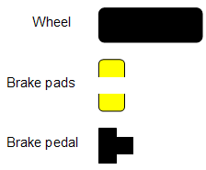
Figure 12: Three parts of a car

(The wheel’s been drawn from above!). The functional viewpoint considers how these three parts might be connected together:
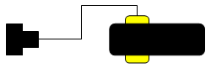
Figure 13: The functional viewpoint

This figure shows how “a brake pedal is connected to brake pads, either side of a wheel. Another figure might show that “when the pedal is depressed, the pads close on a disk attached the wheel”. In other words the functional viewpoint describes how “a” wheel works with “a” pair of brake pads, and “a” brake pedal.

It’s the operational viewpoint that considers the deployment of these parts around the car, such as:

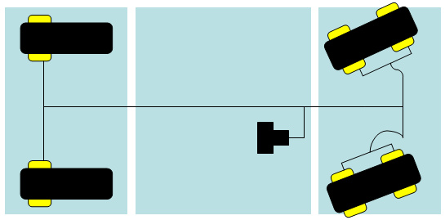
Figure 14: The operational viewpoint (I)

Or, echoing the notation used for operational modelling, in which “duplicates” are removed and replaced by a cumulative enumeration notation:

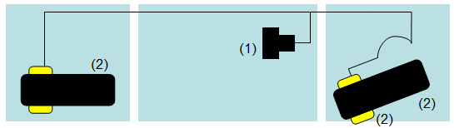
Figure 15: The operational viewpoint (II)

Both figures represent an operational model in which there are four located wheels, two at the back and two at the front (the front ones have extra steering capabilities). They show how the rear located wheels have one set of brake pads each, but those at the front need double the braking so have two each (i.e. there are six pairs of brake pads on the car altogether). All are operated from one brake pedal.

Critically, all the located wheels are strongly related to “the functional wheel” – although the front ones are a little different (they steer). Similarly all the located brake pads are strongly related to “the functional brake pads” although they are doubled up on the front wheel, while there is need for only one brake pedal.

If these figures were views onto a single “model” of this part of the car, then (ignoring relationships) the model would contain:

- A functional wheel
- A functional pair of brake pads
- A functional brake pedal
- Four located wheels
- Six located pairs of brake pads
- One located brake pedal

Only the first three “ordinary” model elements are seen from the functional viewpoint, while the last three “located” model elements are seen from the operational viewpoint.

This notion of “location” is a specific example of a common modelling phenomenon, in which an element in the model is based on another more abstract equivalent model element, usually with variation (specialisation) and with other model elements based on the same root (different specialisations) – examples include

- The use of “ABBs” provided in an architectural “catalogue” as the basis for specific parts in a particular target IT system’s model.
- “Service templates” providing the basis on which a component’s offered service is matched to another component’s requested service.

This generalised “engineering perspective” is discussed in detail in [Ref 2].

So – for the operational viewpoint of a target IT system, what needs placing where? This depends on the degree of detail to which the model is being developed:

- In simpler (outline) Operational Models, often intended to describe the basic structure of the infrastructure underlying the application, it’s common to find:
  - Located Things:
    - Located Actors and Located Users (human and IT)
    - Logical Located Nodes and Physical Located Nodes
    - Physical Located Networks
  - Connective things:
    - Logical & Physical Access Mechanisms, available on “edge nodes” and used by these external agents
    - Logical Located Connections, connecting Logical Located Nodes
    - Physical Located Connections, connecting Physical Located Nodes to Networks.
- More sophisticated (complete) Operational Models intended to describe how the application will work when its deployed across the target IT system also include:
  - Located Things:
    - Logical and Physical Located Deployment Units, located on Located Nodes
  - Connective things:
    - Logical and Physical Located DU Connectors, located on Located Connections
    - Logical Located DU Messages, carried by Located DU Connectors
In all cases these located model elements are either deployed across the target IT system’s locations and borders or, in the case of some reference operational models, across zones.

As the Operational Architect makes operational deployment decisions, trying to balance the target IT system’s non-functional characteristics within a host of operational constraints, they inevitably find it necessary to place functional things (such as actors and components’ DUs) in many locations. For example:

- Data Deployment – masters and copies
  - The solution architect may decide to put the data DU associated with a Product Catalogue component on a located node in a central location, therefore making it easier to manage while being equally accessible to all those who need product data.
  - However, if the networking capability in some part of the target IT system’s landscape is uncertain, the designer may also decide to place a copy of the Product Catalogue in a remote (intermittently connected) location.
- External Agents – here, there and everywhere
  - The solution architect realises that the “Home Shopper” actor could be shopping from home (where the user acting in this way is the “Customer” user), or in a call centre (when the implementation of that actor is a CSR user).
- Distributed Computing – client/server etc.
  - The Solution Architect decides that, for performance and availability reasons, the “Home Shopping” application will be deployed into several places, running:
    - On the customer’s own PC, when the customer is shopping “off-line”.
    - In client-server mode, with the client on the customer’s own PC and the server running on an internet server, when the customer is shopping “on-line”.
    - On a central application server shared by all CSRs

Thus functional things such as actors and components are more abstract than their located equivalents; for example the operational differences between the Home Shopping actor “at home” and the Home Shopping actor “in the call centre” (such as the number of times they use the system per day, or even their level of IT skills and familiarity with the application) is often abstracted away when looking at the model’s “home shopping actor” from the functional viewpoint.

It is therefore necessary to ensure strong linkages between the more abstract (unlocated) model elements of the functional viewpoint, and the more concrete (located) model elements seen from the operational viewpoint – they are, essentially, representing the same thing although it is simultaneously necessary to recognise the differences between several located model elements and their common unlocated (functional) equivalent.

The inherent complexity of these more concrete operational concerns is usually controlled by a number of conventions that lead to larger models of simpler model elements, rather than smaller models of more complex parts:

- For located actors and logical access mechanisms:
  - A located actor represents the characteristics and behaviour of an actor in one specific logical location.
  - The behaviour and characteristics of located actors representing the same actor in different places are usually different.
  - A located actor uses exactly one logical access mechanism, whose outer end must be in the same logical location as that located actor.
  - A logical access mechanism makes the target IT system available to located actors in one logical location
  - A logical access mechanism can be used by more than one actor (so long as they are all in the same logical location).
  - A logical located edge node supports the inner end of exactly one logical access mechanism, although it need not be in the same logical location as that logical access mechanism’s outer end.
- For located users and physical access mechanisms, the same rules can be applied except those that would constrain reality:
  - Located users can use multiple physical access mechanisms
  - Physical located nodes can support multiple physical access mechanisms.
- For logical and physical located nodes:
  - A located node represents a technical platform (a collection of co-operating technical components, possibly modelled as “software” and “hardware”) on which a collection of co-located located application DUs have been deployed, possibly based on a specific, maybe standard technical node.
- For Logical and Physical located DUs:
  - A located DU represents the characteristics and operational requirements of a DU as it is deployed on one particular located node, so that for example:
    - For data DUs, this may result in located DUs representing “master” and “copies” of a DU
    - For data DUs, this may result in some form of data segmentation, such as located DUs representing different data fields (for all records) or different records (for all data fields)
    - For execution DUs, this may result in “client” and “server” parts of a DU
  - It may be necessary to include functionality (at the technical level of the operational model) to synchronise, connect or manage located DUs representing the same logical DU

Note: Nodes are not “components” – they are more like “sub-systems”!
The language of previous sections would seem to suggest that nodes are tangible things. They appear on Operational Modelling views, are concrete notions in SDS, and can be reasoned about as things with relationships to other things (such as being in locations and containing DUs).

However, and more exactly, it is insightful to recognise that nodes and located nodes represent collections of things – they are convenient, short hand ways of referring to a set of co-located things:
- Technical level nodes are “only” collections of software and hardware.
- Located application level nodes “only” represent collections of co-located DUs.

This greater accuracy of thought may be vital to good design, since the idea that nodes “are things” rather than “collections of things” may lead to an operational model structured in a highly functional way – naming nodes as if they were components (e.g. “database server”) can lead to operational issues such as data distribution or client-server arrangements being overlooked, and subsequently leading to a target IT system which fails to deliver its operational requirements.

It is therefore critical to remember a node is only a co-located collection of things that have a collective, connective relationship to other co-located collections of things. Nodes are “operationally cohesive collections” of functionality and data, often (usually!) sharing underlying resources - they are not “functionally highly cohesive and encapsulated” things that are loosely coupled. Rather than being “like a component” (which is a thing!), a node can be more accurately thought of as a sub-system in which the sub-system is a “collection of things in the same place”, and that have been put in the same place for operational reasons.

But it is of course perfectly reasonable to think of this “co-located collection of things” as a tangible and complete object in it’s own right – it’s a node. It’s a thing in exactly the same way as a bridge or a car are things, even though they are actually collections of things. However, and just like a bridge or a car, it remains true that a node’s characteristics are defined by what it is made up of: for example its required (or achievable) availability is defined by the required (or achievable) availability of its parts – a node is identically equal to the sum of its parts; unlike a (composite) component that is more than the sum of the sub-components it is composed of.

Note: Locations – or Zones?
These discussions on “located model elements” and the distribution (or deployment) of a target IT system’s parts describe that distribution to locations: real places such as offices, stores, homes and factories. These may be described physically (what they are, “AmGro House”), or logically (how the target IT system is using them, “Central Home Shopping Services Location”).

But – as discussed in the section “What can it run on? The Node Viewpoint (Node Model)”, it is not always possible or desirable to relate a system’s deployment to real places, but to do so only with reference to “types of place”; where the predominant factor on a place’s suitability or usefulness is wholly based on non-functional characteristics. This may be the case, for example, when the Operational Model is to be used as a reference model for many different situations involving a variety of “real places”.

In these cases, and always taking care to distinguish the intent of such a model from the normally locationless Node Model, the operational model’s backdrop may be modelled as zones, not locations.

In almost all respects, views of zone-based operational models look the same, except their backdrop is “zones and boundaries” not “locations and borders”, and the located model elements are “located in a zone”, and not “located in a “location”. Zone based Operational Models have, however, a number of distinct challenges:

- Any operational characteristic can be chosen to determine zones.
For example, zones may be based on security level, or systems management capability, or environmental issues (hazardous etc). Any operational model “laid out” over zones of type A will almost certainly lay out differently over zones of type B. It would therefore, be necessary for any located model element to record “which zone it’s in” for many different sorts of zone.
- Zones are distinguished by boundaries.
Unlike locations and borders, a zoned backdrop provides no information on existing or planned networking capabilities, therefore making it much more difficult to reason about the challenges that may be faced when distributing data, or exploiting client-server arrangements
- Zones have no notion of “logical or physical”.
Zones represent areas of common value for a given characteristic – a characteristic shared by many model elements, both logical and physical. It is therefore likely to be harder to “map” a logical operational model laid out over zones to the real world.

Thus, while zones provide significant value to the (locationless) Node Model, and while acknowledging zones can be a powerful way of understanding a location based operational model, they tend not to be used without locations as a primary means of locating model elements in an Operational Model.

Using Operational Modeling’s Formal Viewpoints
The previous sections reviewed five different viewpoints, each largely independent of the other, but all part of one large whole. Although not intended, the sequence in which they were discussed may inadvertently be seen as

- Forward Engineering
in which the Operational Model was constructed a step at a time (actors and access mechanisms, then the components’ DUs, Location Model, Node Model and finally the complete Operational Model).
- Focused on “Greenfield” systems
in which the various viewpoints were constructed from scratch, as if the target IT system was being designed from the ground up for deployment into a new environment.
What are we doing?
While an excellent way of describing the viewpoints of operational modelling, the real world is rarely “just” forward engineering a green field solution. Many architects find themselves using Operational Modelling as a means of understanding existing systems (“reverse engineering”), while it is a rare case that target IT systems are wholly new – it is far more common for them to describe enhancements to existing systems, or the way a new application is being deployed onto an existing infrastructure:

- Reverse Engineering:
“How does my existing system work?”, “what’s it made up of?”, “What does it do?”
In these circumstances, it may be appropriate to start with the direct development of the operational model’s physical view, and work backwards towards the system context’s logical functional view
- Package Implementation
“We don’t have a component model!”, “We’re heavily constrained by the package!”
Once the system’s context is established, it may be appropriate to work on the operational model without linking the solution’s DUs (directly defined by the packages modules and databases) to “components”
- Infrastructure Design:
“We don’t have an application!” “Our requirements are not defined by use cases!”
Maybe it’s only necessary to think about the system context’s operational views, together and technical level of the operational model?
- Reference Modelling:
“This is the way we’d like all our applications to be deployed across a standard infrastructure”
Many enterprises want to define a standard approach to deployment, or maybe a systems integrator has a standard reference architecture documenting the best way of designing an IT infrastructure. In these cases it can suffice to document these “standard platforms” and preferred patterns of their deployment via focus on a node model.
What don’t we need?
Paradoxically, the various operational viewpoints help enormously in these circumstances by helping us decide what we do not need - for example:

- No Deployment Unit Model if (1)…
the objectives are to create an operational model that describes the underlying infrastructure for many applications – maybe for a programme or an enterprise: For example, a Bank may want to design a “branch infrastructure” capable of supporting any and all of the many banking applications used in its branches.
In this case, the architect should focus on the technical level of the operational model, probably understanding the way a set of “standard platforms” (nodes and connections) may be deployed into the enterprise’s locations (as located nodes and connections).
- No Deployment Unit Model if (2)…
the objectives are to create an outline operational model as part of an infrastructural proposal, when there may not be sufficient time (or knowledge) to model the internals of the target IT system’s nodes
in this case, the architect should focus on the nodes as active model elements, rather than as collections of co-located DUs.
- No Location Model if…
the objectives are to create a standard operational reference architecture, for use across many programs and projects, thereby bringing cohesion to the IT infrastructure being used by many applications, possibly across many parts of the enterprise.
In this case, the architect should focus on the node model, as a means of documenting an operational reference architecture with wide applicability.
- No Node Model if…
the objective is to (initially) understand an existing IT estate. Reverse engineering an existing IT infrastructure will probably first focus on understanding the located nodes (physically and then logically). It may later be appropriate to identify if the located nodes can be described as standard platforms – or, rather, it may later be appropriate to define a set of standard platforms on which the located nodes should be based!
In these cases, the architect should focus on the operational model (using zones in place of locations if necessary) and without concern for the located nodes being based on (standard) nodes.
- No Operational Model if…
the objective is to define a set of standard hardware/software platforms that may be included in any number of target IT system designs, as may be the case in hardware (and software) sales.
In these cases, the architect should focus on the node model, using zones if necessary.
- No Walkthrough views if…
the objective is to replace an existing infrastructure “like with like”, or any other circumstance in which it is sufficient to create a static structural model.

In addition, it is not always necessary for the Deployment Unit Model to be based on an explicitly defined component model:

- DUs without a Component Model if (1)…
the objective is to deploy an application defined in terms of functional and data decomposition. In these cases, the DUs directly represent
  - the application’s presentation to its external agents (PDUs),
  - the execution of the application’s modules (EDUs),
  - the storage of the application’s databases (DDUs),
  - the application’s executables (IDUs).
Therefore the architect should focus on the DU model directly, establishing the “lists” of application modules and databases they have to deploy.
- DUs without a Component Model if (2)…
the objective is to deploy a conventionally described package. It is rare for packages to have a component model, yet the same concerns apply – the package will have users somewhere, application code running somewhere else, and data stored somewhere different again – thus all four sorts of DU (and therefore located DUs) are still needed.
- Located DUs without DUs if…
you are “reverse engineering” an existing system. In this case, you need to know what’s running on or being stored on the located nodes. But there is not a fundamental need to link these located DUs back to DUs – only when you want to understand how “the same thing is being done in multiple places” or if “this data’s also being stored over there”.

The Dimensions of Architecture Thinking
The five operational viewpoints discussed earlier relate directly to the broader set of architectural viewpoints often described as the “dimensions of Architecture Thinking”, which architects use to navigate the underlying architecture model when, for example and as discussed in ref [6], understanding the linkages between operational (and also component) modelling and system context modelling.

Figure 16 shows these architectural dimensions (viewpoints, sometimes called “perspectives”) as a 2 by 2 by 2 “cube” arranged below the four secondary viewpoints of System Context modelling:
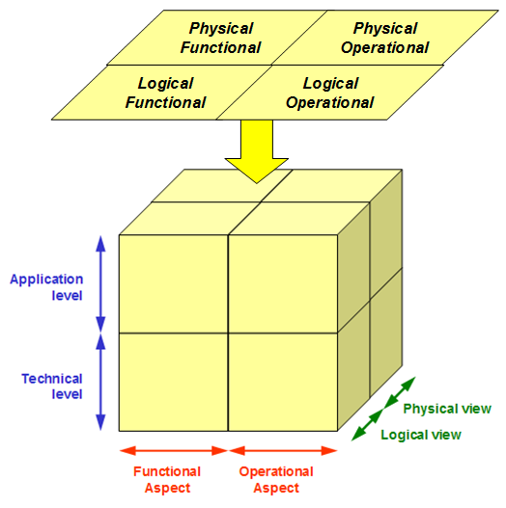
Figure 16: The three dimensions of Architecture Thinking

In this orientation, the cube presents the standard “operational modelling” viewpoint as its right hand side, in which the secondary basic viewpoints described earlier are used for both logical and physical views, but at different levels:

- The Deployment Unit Model is typically only used to model the application level (application cross-cutting viewpoint), and therefore relates across to the application component model.
- The Location Model acts as backdrop for either level.
- The Node Model is typically only used to model the technical level, therefore relating across to the underlying technical components needed to support the application component model.
- The Operational Model is used at either or both levels.

Thus:
- The vertical physical dimension of the operational viewpoint represents the operational structures and behaviours of the target IT system in terms of the actual (or candidate) hardware and software implementations (what things are, and how well they can work).
- The vertical logical dimension of the operational viewpoint represents the operational structures and behaviours of the target IT system in terms of their required characteristics and responsibilities (what things do, and how well they have to do it).

- The horizontal application level of the operational viewpoint models the operational structures of those parts of the IT system associated with its target purpose
- The horizontal technical level of the operational viewpoint models those parts needed to keep the IT system working and therefore usually “below” the prime focus of the modeller, whatever the primary purpose may be.

“The Cube”: Relating a System’s Context and Operational Modelling
As hinted by the way Figure 16 has been drawn, it is typical for system context modelling to “look down onto” the application level (i.e. it exploits the application cross-cutting viewpoint), particularly when exploring the requirements being placed on the target IT system. Subsequently, as decisions are taken to use external services rather than support them within the target IT system, it may be important to extend the system context to “look through” the cube into the technical cross-cutting viewpoint, altering the System Context views accordingly, such as through the addition of technical external IT systems for file, print and security services. This distinction between the application and technical cross-cutting viewpoints has a particularly significant impact on what’s seen from the basic operational viewpoint - both for system context modelling (and the way access mechanisms are used) and operational modelling (and the use of presentation deployment units).

The Operational Model’s Context
Discussions on Operational Modelling’s techniques and views throughout section “OMS’s Operational Model” describe how Operational Modelling needs information from “upstream” viewpoints’ views (i.e. upstream work products), shares information with “peer” work products, and supplies information to “downstream” work products. As for all artefacts in a structured method such as UMF, it’s therefore important to understand where Operational Modelling “starts and stops”, and to focus particularly on the distinction between Operational Modelling and other activities that have historically been done in OM because there was no where else to do them:

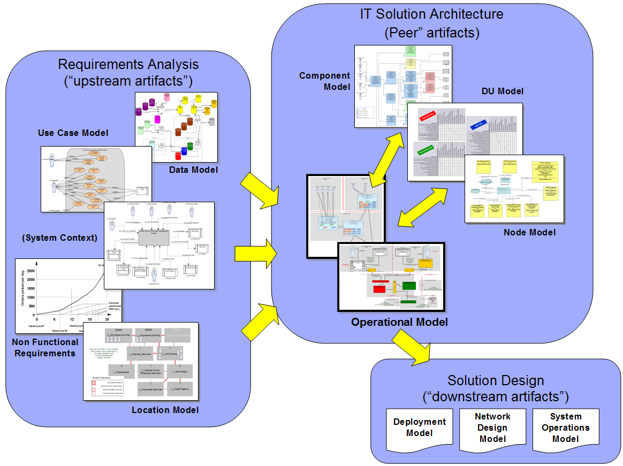
Figure 17: Operational Modelling’s “overall context”

Specifically, it is vital to ensure OM does not “bleed” into other areas, such as using it to define the solution’s operational requirements (in which the target IT system should be thought of as an operational “black box”) or to document fine grained information about the deployment (IP addresses, disk layouts, admin scripts) of the target IT system’s individual parts.

This separation can be most easily maintained by recognising how any model of a target IT system must

- Understand the context in which it sits (the system’s context, the system as a “black box”)
- Determine the nature of the parts from which the system is built, so that it’s structure and behaviour can be documented in terms of those parts as a “white box”
- Resist the temptation to “look inside the parts”, which should rather be accomplished by considering the model’s part to be a system in its own right
  - However, in order to determine and understand the model’s parts more completely, it is common practice to model them as being composed of lists of things, with scant regard for how those things work together

In the case of the Operational Model, the “fundamental part” is the node, whether this be modelled logically or physically, and whether it be located or not. Therefore, Operational Modelling’s views show how nodes are connected together (structure views) and how they support the applications interactions (accurately via DUs or approximately). And anything “smaller” than a node (DU, software, hardware) is modelled via simple lists of things inside nodes.

Upstream Context
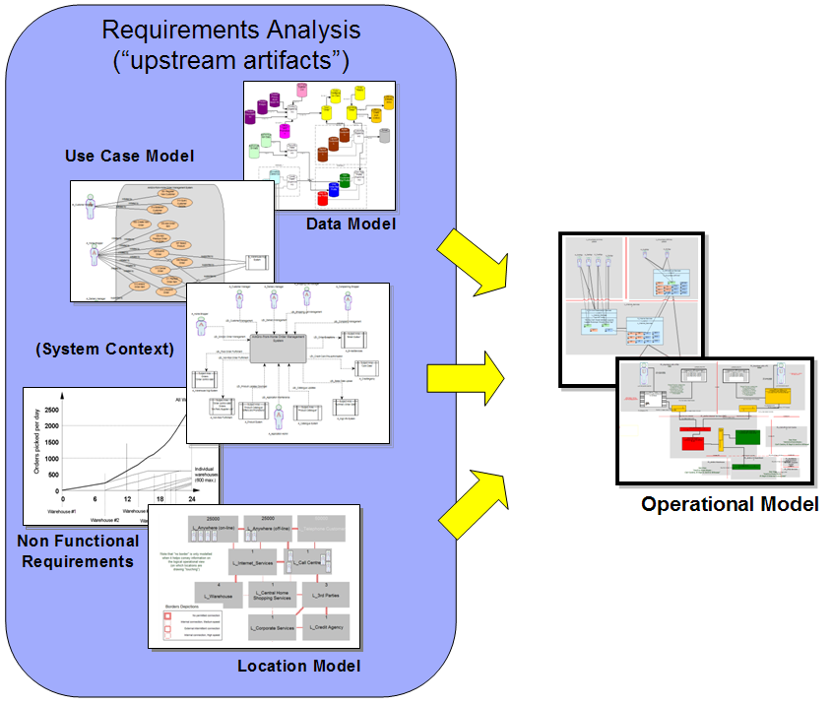
Figure 18: Operational Modelling’s “upstream context”

The requirements placed on the Operational Model are set by its upstream context, described by the target IT System’s “Requirements Analysis” artefacts:
- System Context Model
- Location Model
- Data Model
- Use Case Model
- Non Functional Requirements

System Context Model
The System Context Models’ operational views:
- Document the access mechanisms used by the target IT System’s external agents (human and IT, logical actors and physical users) to access the system.
- Provides information on the locations from where these external agents access the system (the access mechanism’s outer end – it does not determine where the systems boundaries are, at the access mechanism’s inner end)
- Describes what the system’s users can do from those locations (as actors)

Location Model
- Documents the locations over which the target IT System’s nodes and connections may be deployed, and where its located external agents are accessing the system from
- Defines the available connectivity between these locations (as borders)
- May use the notion of zones to highlight non-functional characteristics of these locations and borders that may influence the design of the Operational Model

Data Model
In formal operational modelling, the data model relates to the Operational Model via the association of its entities to the solution’s components and thence data DUs. There may, however, be circumstances in which (a) there is no component model, and (b) the data model’s entities are not mapped directly to data DUs. In this case, the Data Model:

- Defines the “entities” that require deployment across the operational model’s located nodes

Use Case Model
- Defines the “conversations” that take place between the target IT system and its external agents (as actors), providing information needed to help create the operational model’s walk through views, by describing the “trigger events” and “required responses” between the (located) actor and the edge of the target IT system.

Non Functional Requirements
The specific service level requirements of the solution are modelled via their association with the operational model’s DUs, their deployment as located DUs and the subsequent rolling-up into the service level characteristics of the model’s located nodes. But there are many other NFRs, such as those that define overall requirements (such as operational flexibility and capacity for change) and constraints (such as technology choices, budget and timescales). In this case, NFRs:

- Define the overall operational characteristics and constraints being placed on the target IT system.

Peer Context
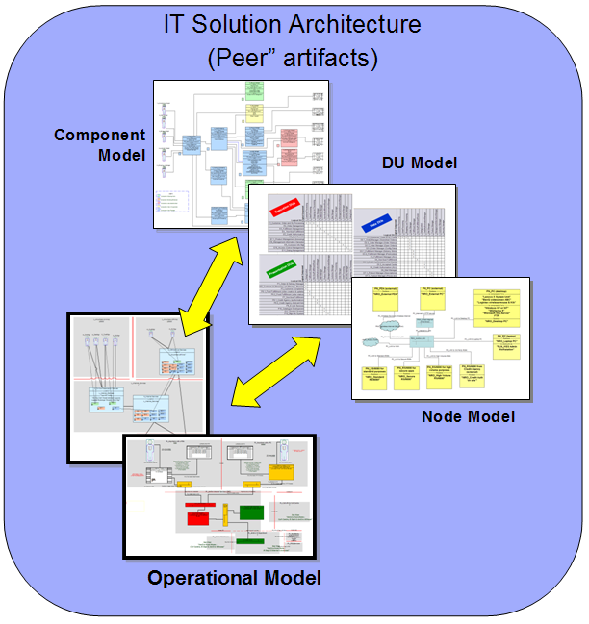
Figure 19: Operational Modelling’s “peer context”

The Operational Model’s context is one of several associated with the target IT System’s architecture:
- Component Model
- Deployment Unit Model
- Node Model

Component Model
In formal operational modelling, the component model relates to the Operational Model via the four operational aspects of its components, as modelled via presentation, execution, data and installation DUs. However, it may be appropriate to approximate the relationship, since the Component Model:

- Documents the structure of and behaviours between the target IT systems’ application level components, for placement onto the operational model’s located nodes.

Deployment Unit Model
- Documents the various operational characteristics of the target IT systems’ application level components and their relationships for placement onto the operational model’s located nodes:
  - Presentation DUs
  - Execution DUs
  - Data DUs
  - Installation DUs

The Deployment Unit model may still need to be developed in the absence of a component model, in which case the DUs must be directly determined, such as establishing the target IT system’s Data DUs from a Data Model, or it’s Presentation DUs inferred from the operational views of the System Context (although PDUs are at the inner end of access mechanism, not the outer end, at the external agent).

Node Model
The underlying technical hardware and software (systems software and middleware) needed by the Operational Model’s located nodes may be directly determined, located node by located node. It may, however, be appropriate for these technical requirements to be defined separately - either beforehand (such as standard parts in an EA), or as the design enfolds; in either case as technical nodes, in which case the Node Model:

  - Documents the technical nodes needed to support the application level located nodes, as collections of
    - Hardware
    - Systems software
    - Middleware
  - Describes the manner in which these technical nodes can connect and communicate, via connections.

Downstream Context
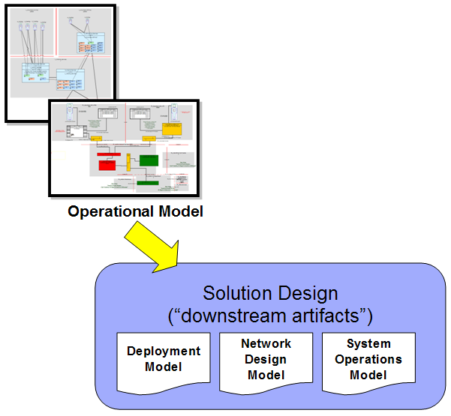
Figure 20: Operational Modelling’s “downstream context”

Operational Modelling’s focus on “infrastructure” and the manner in which it supports the deployment and operation of the target IT system’s application may tempt Solution Architects into using it to document all manner of specialised detailed designs.

This is perfectly possible – just as the component model can be used as a vehicle for documenting the detailed internal structures and behaviours of the application’s components. But, just as component modelling is not the same as object modelling or detailed database design, so operational modelling should be separated from the “downstream” work products it defines requirements for:
- (Node) Deployment Model
- Network Design Model
- System Operations Model

(Node) Deployment Model
The operational model provides lists of things from which each located node will be built:
- Located DUs (presentation, execution, data, installation)
- Systems software and middleware components
- Hardware components

From these lists, it is expected that the Deployment Model will consider the insides of each and every located node as a separate context, and therefore model the structure and behaviour of each located node’s parts, such as:
- Detailed software specifications (compatible versions etc),
- Disk layouts,
- Network addresses, port identifiers etc.

In very complex cases, it may be necessary to consider the operational models’ physical located node as a system in its own right and therefore in need of all the work products described in this part, including an operational model!

Network Design Model
The operational model provides an outline structure of the networks to which the target IT system’s located nodes are connected.

From this, it is expected that the Network Design Model will detail the structures needed of each and every network needed to achieve this connectivity, and therefore model the structure and behaviour of each network’s parts, such as its:
- Routers, bridges, network segments and other “passive” parts,
- Firewalls, filters and other “active” parts,
- Network Management monitors and controllers.

In very complex cases, it may be necessary to consider the operational models’ physical network as a system in its own right and therefore in need of all the work products described in this part, including an operational model!

System Operations Model
The operational model provides a description of where the target IT system’s parts will be:
- The application’s executables (located IDUs)
- The application’s data (located DDUs)
- The underlying technical system software and middleware

From this, it is expected that the System Operations Model will determine how these parts will be monitored, maintained and repaired, and therefore model how the system will be run, such as:
- System start up and shutdown procedures
- Data backup mechanisms and procedures
- Data and code distribution scripts and procedures
- System Monitoring and reporting
- Problem identification, diagnosis and handling

Such things can often be considered part of an underlying systems management application, which may in complex (and probably not so complex) cases, require a Solution Architect to model a Systems Management target IT System and therefore be in need of all the work products described in this part, including a System’s Management operational model!

Building the Operational Model: AmGro-from-Home’s OMS
The next sections use the “AmGro-from-Home” Order Management System case study to explore the detailed modelling techniques and views of the operational viewpoint’s five secondary viewpoints and their inter-relationships with component modelling and the functional viewpoint of the System Context.

Earlier sections “Technical Environments for “AmGro-from-Home”” and ““SA4TeamSD”, “AmGro-from-Home”, SDS, and UMF” sketched out the environment into which AmGro’s internet based Order Management system will be deployed. For us to now formally model this deployment, it’s helpful to first describe the system’s design in general terms via Figure 21, a “sponsor friendly” architecture overview diagram:

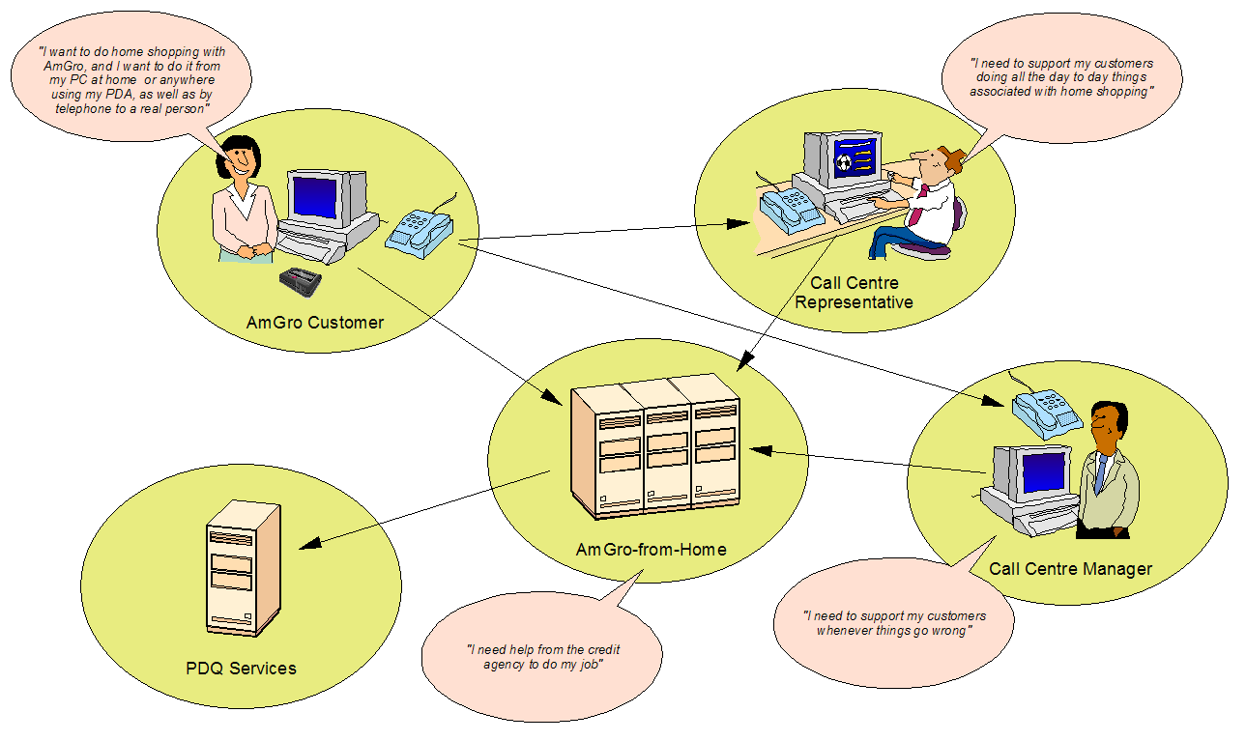
Figure 21: AmGro-from-Home's Architecture Overview Diagram

This shows how three separate users of the home shopping system all want to do the same sort of thing, accessing the system in a variety of ways and from various places, while the home shopping system itself uses an external agent for credit card pre-authorisations.

This AOD forms the starting point for the “forward engineering” development of AmGro-from-Home’s Order Management System’s Operational Model, beginning with a review of the System Context’s operational views.

Note: Scope
Please note that this case study does not address the complete solution – it focuses only on those parts of the OMS system associated with supporting the “shopping” roles of AmGro’s customers and Call Centre staff.

If required, see Ref [7] and [8] for full descriptions and discussions on the case study. Also see Ref [9] to obtain an “AmGro-from-Home OMS” SA4TeamSD encyclopaedia, as discussed in section ““SA4TeamSD”, “AmGro-from-Home”, SDS, and UMF”.

Note: Notation
All figures in this section conform to a standard diagrammatic notation first documented in Ref [1] and referenced in the appropriate UMF artifacts. Note, however that there are minor additions and changes that post-date the publication of Ref [1]. Where appropriate, notes such as this provide additional commentary on the use of this notation.

Note: Process Considerations
As a general principle, the following sections follow a “forward engineering”, almost waterfall approach – in order to simplify the descriptions and discussions. However, in practice this is rarely if ever the case. Therefore, where appropriate, notes such as this provide insights into the cross-relationships that inevitably exist, particularly between the “black box” views of the System Context and the “white-box” views of Operational Modelling.

Note: OM and SA4TeamSD
This document is totally focused on the techniques of Operational Modelling. In order to
illustrate these techniques, however, most figures in the following sections have been taken from the “AmGro-from-Home OMS” SA4TeamSD encyclopaedia. In addition, notes such as this provide insights into the utilities (aka “Gucci® Gadgets”) provided by SA4TeamSD intended to ease the sometimes complex operational modelling.

OMS’s System Context’s Operational View
Ref [6] discusses in extensive detail the operational viewpoint of AmGro-from-Home’s Order Management System’s “black box” System Context. It is therefore sufficient here to focus on the implications for Operational Modelling’s “white box” views via the logical operational and physical operational views of AmGro-from-Home’s OMS’s System Context.

AmGro-from-Home will support a variety of “home shopping” users:
- Customers, using the service
  - “on-line” (i.e. connected to AmGro via the internet)
  - “off-line” (i.e. accessing an AmGro application on their own PC or PDA)
- Call Centre Client Service Representatives, who are either
  - Permanent employees, fully trained in the home shopping service
  - Contractors, brought in from time to time, capable of doing some things
- Call Centre Managers, fulfilling roles for which CSRs are not qualified.

System Context’s Logical Operational View
Figure 22 and Figure 23 describe how each of these five users will fulfil a variety of roles (five roles) via a variety of access mechanisms:
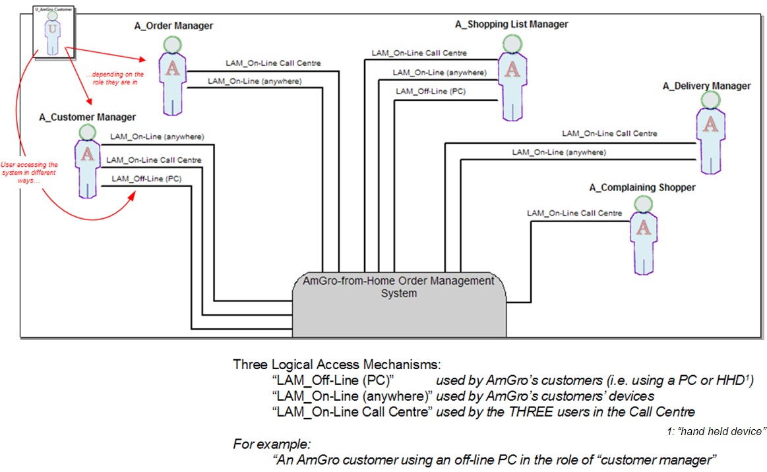

Figure 22: AmGro-from-Home’s System Context’s logical operational view (detail)

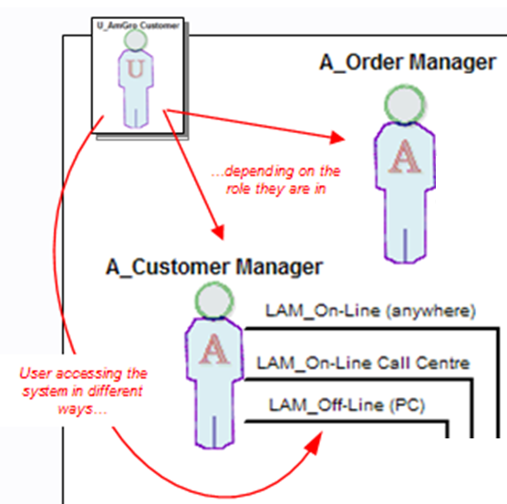 means that: 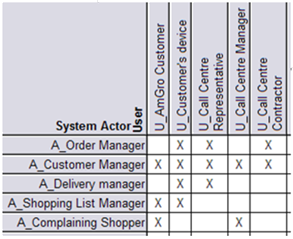

Figure 23: Interlock between what a user does (actor) and how they access the system to do it

The figures highlight the need for the model to clearly document how these users interact with the OMS both functionally and operationally – and how this need for both to be unambiguous leads to a finer grained description than might first seem necessary:
- If there was no concern for the “operational context” – there would only be two roles
If everyone connected to the system in the same way, exhibiting the same operational characteristics (or if we simply ignore operational considerations), then there might be just two roles;
  - Home Shopper actor, a role of the Customer and CSR users.
  - Complainant actor, a role of the Customer and Call Centre Manager users.

Correspondingly, the system’s use cases and other requirements could be defined according to these two roles taken by the systems three types of users.

- Considering the “operational context” – five roles on three access mechanisms
But Figure 22 shows the “real operational world” is more complex than this – it turns out that each type of user cannot do everything associated with each role on each of the mechanisms they are using to “shop”. For example, a customer cannot do all the things done by the “Home Shopper” role when they are accessing the system “off-line” – while they cannot place orders, they can organise shopping lists.
It is therefore necessary to refine the two “shopping roles” so that each one can be completely associated with one or more of the access mechanisms being used. Analysis of AmGro’s requirements leads, in this case, to the three types of user acting in five different ways (i.e. having five distinct roles as five actor types) across the three different access mechanisms illustrated, as shown on Figure 22.
Each of the three logical access mechanisms is available to the five actors from specific locations - i.e. the outer end of each access mechanism is in a specific logical place:
- Anywhere where there’s a PC with the AmGro application installed
- Anywhere with internet access
- The Call Centre, with local connectivity to the AmGro “backend”.

Thus the outer end of: “LAM_Off-line” is in Location: “L_Anywhere (off-line)”
“LAM_On-line (PC)” “L_Anywhere (on-line)”
“LAM_On-line Call Centre” “L_Call Centre”

However, access mechanisms don’t only define the location from where actors access the target IT system, they also define the nature of the interface with the external agent (most obviously whether it’s a human or IT system interface) at the target IT system’s boundary. These all differ greatly for the three AmGro access mechanisms:

- “LAM_Off-line” interfaces with human actors remote from AmGro
When shopping “off-line”, AmGro’s customers use AmGro-from-Home in limited ways via their own devices running an AmGro application. i.e. “LAM_Off-line”:
  - Interfaces with human actors (roles’ of AmGro’s customers)
  - Defines the system’s boundary to be between these actors (“outside”) and their devices (“inside”)
  - Has its outer end in the same location as its inner end (“L_Anywhere (off-line)”)
- “LAM_On-line (PC)” interfaces with IT system actors remote from AmGro
When shopping “on-line”, AmGro’s customer’s use browsers running on their PCs and other devices. i.e. “LAM_On-line (PC)”:
  - interfaces with IT system actors (the customers’ devices)
  - Defines the system’s boundary to be between AmGro’s customers’ devices (“outside”) and a to-be-identified edge node (“inside”) – AmGro’s customers are even further “outside”.
  - Probably has its outer end in a different location (“L_Anywhere (on-line”)) from its inner end (wherever the edge node is located, probably on the AmGro side of the internet).
- “LAM_On-line Call Centre” interfaces with human actors local to AmGro
The Call Centre’s CSRs and Managers interact with AmGro’s applications running on devices provided by the Call Centre. i.e. “LAM_Call Centre”:
  - Interfaces with human actors (roles of Call Centre staff)
  - Defines the system’s boundary to be between these actors (“outside”) and the Call Centre’s devices (“inside”).
  - Has its outer end is in the same location as its inner end (“L_Call Centre”)

Note: Where’s the boundary?
One end of an access mechanism is attached to an external agent (outside the system), its other to an edge node (inside the system). Where’s the boundary? This is discussed in section “Step 1c: Place Access Mechanisms and Edge Located Nodes”.
Note: Humans and IT systems can behave as the same actor
A critical insight emerges from this operational analysis – an actor (such as “Order Manager”) can in some circumstances be a role of a human user (AmGro’s customers), but in others it is a role of an IT System (AmGro’s customers’ devices):
- The same actor can define a role of a human user as well as an IT system user

This conflict will be untangled in section “Step 1b: Place Located Actors” via the notion of a located actor which represents a (functional) actor using one of their access mechanisms in one specific place.

Note: Process Considerations (1)
The previous discussions highlight how some of AmGro-from-Home’s Order Management System’s access mechanisms interface with human actors using devices on which AmGro-from-Home has been installed. How do we know this since such statements depend on design decisions? How can it be known that parts of the target IT system will be placed on customers’ PCs and CSRs’ workstations? References to “forward engineering” might be taken to imply only “Requirements Analysis” has been performed so far, but clearly this cannot be the case.

Some design work must be taking place, either simultaneously with this requirements analysis:
  - “It’s obvious that an off-line customer must have some parts of AmGro-from-Home installed on their PC, so it’s obvious the system’s interface is between the AmGro-enabled PC and the customer.”

Or has already taken place and this requirement analysis is a revision of earlier work:
  - “After balancing performance requirements with systems management challenges, a ‘thick client’ will be implemented on Call Centre workstations”

Note: Process Considerations (2)
Initially, the System’s Context is likely to be based purely on an understanding of the business requirements (“we need users who can shop without a high speed link”) and infrastructure constraints (“you will use our centralised Data Backup service”). As the “white box” design unfolds, the Solution Architect may make design decisions such as:
- Using an existing print service rather than to develop one within the target IT system.
- Identifying the need for an application administrator
- To use a real person to perform a complex business algorithm

Thus, in reality, the solution’s System Context must evolve in parallel with the internal design work, and in particular whenever a new “actor” (human or IT) is identified.

System Context’s Physical Operational View
As with all logical-physical relationships, the logical access mechanisms of Figure 22 describe how a range of physical access mechanisms are being used, as shown in Figure 24.

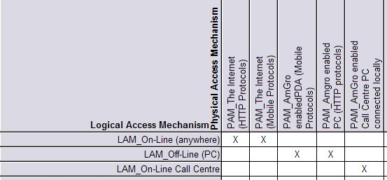
Figure 24: AmGro-from-Home’s System Context’s physical/logical access mechanisms (detail)

- For AmGro-from-Home’s OMS, each logical access mechanism describes the way users use one or more physical access mechanisms in their various roles, exemplifying a N:1 relationship: different physical access mechanisms being used in the same way.
- It is also perfectly possible for a physical access mechanism to be used in different ways (i.e. a 1:N physical to logical relationship), as is the case elsewhere in AmGro-from-Home’s OMS, where the “PAM_Leased line” physical access mechanism AmGro use to connect to their Credit Reference Agency is used for intermittent file transfer (“LAM_Secure File Transfer”) as well as regular transactional traffic (“LAM_Secure Transactions”).

Figure 25 therefore highlights how AmGro’s customers access the order management System directly (either working “off-line” via AmGro’s own applications on their PCs and PDAs, or “on-line” via their own devices), while various staff in the Call Centre all use the same, third physical access mechanism:
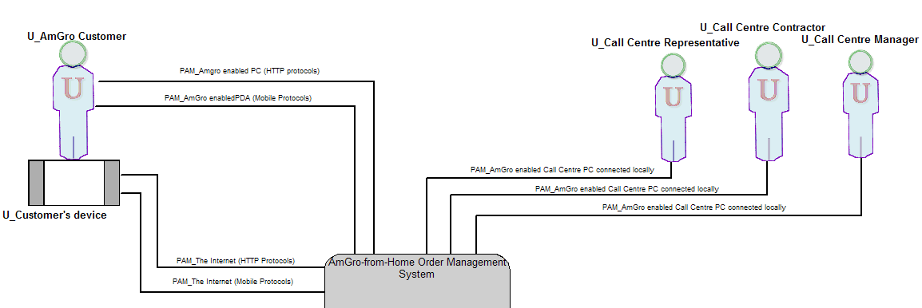

Figure 25: AmGro-from-Home’s System Context’s physical operational view (detail))

Note: Process Considerations
In keeping with the forward engineering approach, what AmGro’s Order Management System needs to do with its users (logically) has been analysed before presenting a physical implementation of who and what will actually be doing all these things with the system.

It is often more likely that the Solution Architect will have been given a physical description of the target IT system’s users and their “real world” access mechanisms, which they will then have “reverse engineered” to discover what these physical users will be doing logically (as actors) and how they will use their physical connections to the system (as logical access mechanisms) in order to do what they do.

Reality is probably a mix of both, with both types of operational view developing in parallel as the Solution Architect improves their understanding of the (logical) “who wants to do what and how”, then reflecting “the art of the possible” back into the real (physical) world.

OMS’s Deployment Unit Model
Section “What needs deploying? The Component Deployment Viewpoint (Deployment Unit Model)” describes how the operational viewpoint documents “the deployment of the target IT system’s parts”, and how these parts can be
- Application level components, modelled as Deployment Units and discussed here
- Technical level components, modelled as software & hardware and discussed later

Figure 26 presents the overall logical structure view of AmGro-from-Home Order Management System’s Component Model, while Figure 27 is a detailed view of two external agents and three components whose DUs are discussed in detail below.
.

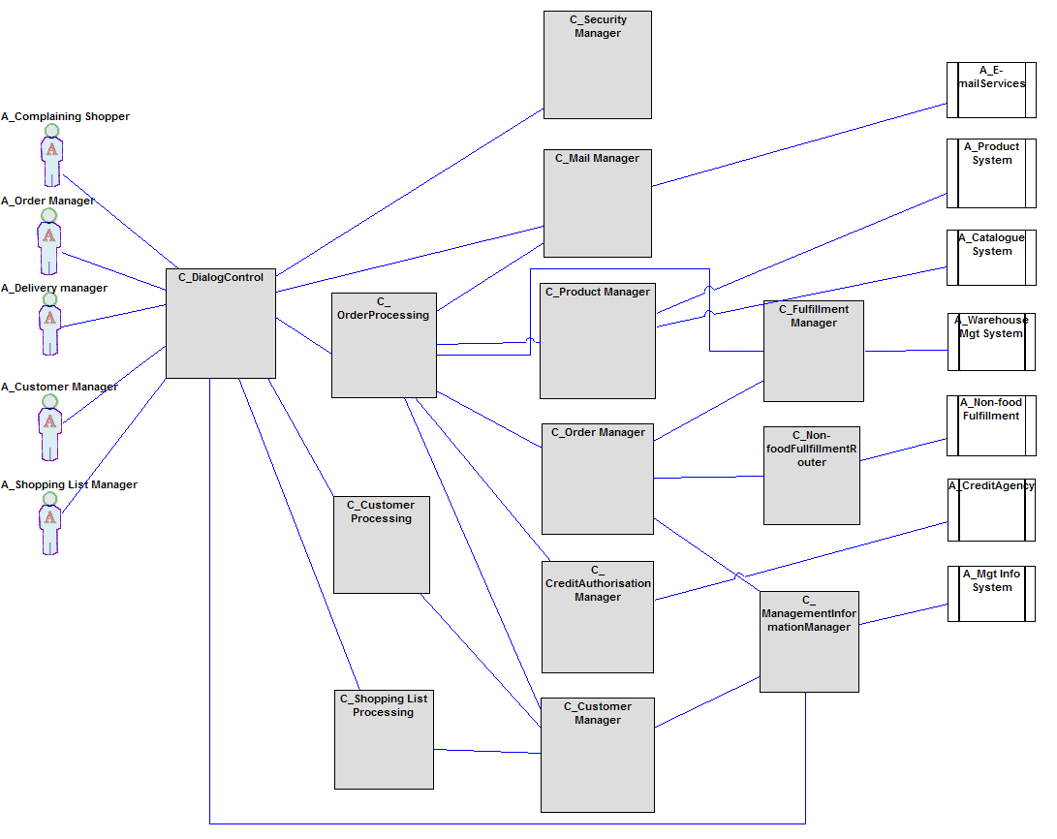
Figure 26: AmGro-from-Home’s Component Model’s logical structure view

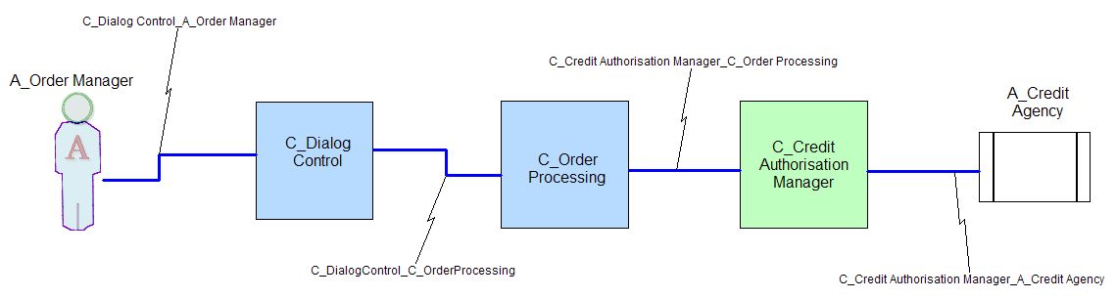
Figure 27: AmGro-from-Home’s Component Model’s logical structure view (part)

The figures show:
- All five of the (logical) actors using the OMS – the five roles of the system’s various (physical) “shopping” users, including “Order Manager”.
- All seven “backend systems” needed by the OMS in order for it to support home shopping, including the “Credit Agency” actor.
- In the centre, the solution’s 13 logical components and their various logical connectors, including the three involved in verifying he order manager’s credit worthiness.

(Notice how, in this functional view, the “shopping” actors are all drawn using human icons, even though the operational viewpoint tells us some of them are roles taken by IT systems.)

DU Model’s Logical View
(Unlike other models discussed here, the DU Model’s views are not diagrams – they are presented as tables, matrices and textual descriptions)

This section provides a full discussion on the DUs representing the components shown on Figure 27, followed by a summary of all DUs representing the components on Figure 28.

Each logical component must be represented by up to three sorts of logical DU, with any “edge” component also having one or more presentation DUs. Each may have several DUs of each type (representing variation in the component’s NFCs) or may be represented by DUs shared with other components (whenever their NFCs are the same, and there is confidence that they will be co-located):

- “C_Dialog Control”
  - Presentation DUs
This component is responsible for the application’s interfaces with its five “shopping” actors (only one of which is shown on Figure 27), via a variety of actor-component connectors (visible on Figure 26). It therefore requires up to five PDUs (one per actor). Analysis of the non-functional characteristics of the system’s interactions with it’s home-shopping actors highlights how these five can be refined to three PDUs for the one component:
    - P1_Order and Delivery Management
    - P2_Customer and Shopping List Management
    - P3_Customer Complaints
  - Execution DUs
The component’s execution will be modelled as a single EDU, considered separately from the execution of other components:
    - E11_Dialog Management
  - Data DUs
A design decision was taken in the component model not to hold display configuration and other presentation data (such as language choice etc) in the component – rather, it was decided to use “environmental variables” managed by the underlying infrastructure. This component therefore has no DDU.
  - Installation DUs
This component’s executables will be modelled as a single IDU, enabling it to be deployed independently of other components:
    - I1_Dialog Control
- “C_Order Processing”
  - Presentation DUs
This is not an edge component, and therefore does not require a PDU.
  - Execution DUs
Operational analysis of the three “processing” components (see Figure 26), indicates it is extremely likely these three will always execute in the same place (or places). They will therefore be represented in the component deployment viewpoint’s views by a single EDU:
    - E1_Customer, Order and Shopping List Processing
  - Data DUs
Analysis of the three “processing” components indicates it is extremely likely these three will store their profile data in the same place (or places). They will therefore be represented in the component deployment viewpoint’s views by a single DDU:
    - D1_Customer, Order and Shopping List Profiles
  - Installation DUs
It is highly likely that this component’s executables will form part of a single “front end” application and so always deployed together as a single IDU:
    - I2_AfH FE Application
- “C_Credit Authorisation Manager”
  - Presentation DUs
This component is responsible for the application’s interfaces with AmGro’s Credit Reference Agency. Analysis of the non-functional characteristics of the system’s interactions with this external IT system highlights two very different sets of NFCs across this interface:
    - P8.1_Credit Agency (authorisation), authorising card transactions
    - P8.2_Credit Agency (hotcard list), downloading the hotcard file
  - Execution DUs
The component’s execution can be modelled as a single EDU:
    - E5_Credit Authorisation
  - Data DUs
The NFRs of the data items associated with this component fall into two distinct groups, each of which requires a separate DDU:
    - D5.1_Credit Authorisation (hotcards), renewed daily & secure
    - D5.2_Accepted Card Types, which is stable and publically available
  - Installation DUs
This component’s executables will be modelled as its own IDU, reflecting the fact that it is being implemented as a separate stand-alone application:
    - I6_Credit Authorisation Manager
These DUs are summarised in Table 1, with a full list in Table 2 to Table 4 and Figure 28:

Component | Represented by Presentation DU | Represented by Execution DU | Represented by  Data DU | Represented by Installation DU
C_Dialog Control | P1_Order & Delivery  P2_Customer & SL  P3_Complaints | E11_Dialog Mgt | - | I1_Dialog Control
C_Order Processing | - | E1_Customer, Order & SL Processing | D1_Customer, Order & Shopping List Profiles | I2_AfH FE Application
C_Credit Authorisation Mgr | P8.1_Credit Agency (authorisation)  P8.2_ Credit Agency (hotcard list) | E5_Credit Authorisation | D5.1_Credit Authorisation (hot cards)  D5.2_Accepted Card Types | I6_Credit Authorisation Mgr
Table 1: AmGro-from-Home’s Component’s DUs (part)

 | Logical Presentation  DU | Nature of Interface | Actors using logical DU | Location of PDU’s user | Required Performance | Required  Hours | Comments
P1 | Order & Delivery Mgt | Standard HMI on Windows device | A_Order Manager  A_Delivery Manager | On-line  Call Centre |  | 00:00 - 24:00,  365 days/year
P2 | Customer & Shopping List Management | Standard HMI on Windows device | A_Customer Manager  A_Shopping List Manager | On-line  Off-line  Call Centre |  | 00:00 - 24:00,  365 days/year
P3 | Complaint Management | Standard HMI on Windows device | A_Complaining Shopper | Call Centre |  | 00:00 - 24:00,  365 days/year | Call Centre Managers who are on phone to shoppers
P8.1 | Credit Authorisation | Messaging (format defined by credit agency),  ISDN | Credit Agency | Order Mgt Center | Indicative: Sub 5-second response time “at the edge” | 00:00 - 24:00,  365 days/year
P8.2 | Credit Hotcard List | File transfer  (format defined by credit agency), ISDN | Credit Agency | Order Mgt Center | Download  Sub 2 minutes | Once daily,  365 days/year
Table 2: AmGro-from-Home’s Presentation DU Characteristics (part)
HMI: Human-machine interface

 | Logical Execution  DU | Type of proc-essing | Usage "window" | Numbers/hour  (peak hour,  after 24 months) | 95% response time | Comments
E11 | Dialogue Mgt | Inter active | 00:00-24:00  peak: 18:00-19:00 |  | See E1
E1 | Customer, Order & Shopping List Processing | Inter active | 00:00-24:00  peak: 18:00-19:00 |  | Order create: <1sec  add item: <0.5sec  Place order: <10 sec | Required on and off line, although order browsing may be OK “off line”
E2.1  E2.2  E2.3 | Order Management | Inter active  batch | 00:00-24:00  peak: 18:00-19:00  polled for overnight | 136 orders placed/hour (on-line) +  81 orders placed /hour (Call Centre) | Part of “place order” for E1  Not critical | Order creation (E2.1)  Order submission (aka “check-out”) (E2.2)  Order History Mgt (E2.3)
E3 | Food Fulfilment Management | Inter active | 00:00-24:00  peak: 18:00-19:00 | 272 slot checks/hour (on-line)  162 slot checks/hour (Call Centre)  136 orders placed/hour (on-line)  81 orders placed /hour (Call Centre) | Part of “create order” for E1  part of “place order” for E1 | No information available on split between food and non-food orders
E4 | Non-food Fulfilment Management
E5.1  E5.2 | Authorisation check (front end)  Pre-authorisation (back-end) | Inter active | 00:00-24:00  peak: 18:00-19:00 | 272 card checks/hour (on-line)  162 card checks/hour (Call Centre)  136 pre-authorisations/hr (on-line)  81 pre-authorisations/hr (Call Centre) | <1 sec  part of “place order” for E1 | Authorisation separate to “order placement”, May be done locally (E5.1) or with pre-auth (E5.2 via P8.1
E6 | E-mail transfer | Store& forward | Preferably  00:00-24:00  6 days/week (warehouse opening hours) | 1% of submitted orders sent to Warehouse (via P9) raise exception: 26 E-mail/day  Customer complaints = 1% of created orders = 52 E-mail/day | confirmation of “sent”: <3sec | Assumptions based on industry data for exceptions per order.
E7 | Product Management (catalogue) | Inter active | 00:00-24:00  peak: 18:00-19:00 | Product searches:  8704 search/hour (on-line)  2816 search/hour (Call Centre) | simple (93%): <1sec  complex (7%):<2sec | Catalogue update also required
E8 | Management Information | batch | Assumed to be a poll overnight | 1 query + data transfer  (from E2 and E9 through P12) | Not critical
E9 | Customer Management | Inter active | 00:00-24:00  peak: 18:00-19:00 | 428 customer ref/hr (on-line  139 customer ref/hr (Call Centre) | create customer: <5sec
E10 | Security Management | Inter active | 00:00-24:00  peak: 18:00-19:00 | 45x6/hour for on-line = 270  44x3/hour for Call Centre= 132 | Part of “create order” and “place order” for E1
Table 3: AmGro-from-Home’s Execution DU Characteristics

 | Data DU | Type | Unit Size (bytes) | Number (after 2 yrs) | Currency | Volatility | Comments
D1 | User Usage Profile | Structured, "flat file"? | 1kB / user | 50,000 | real-time | low
D2.1 | Submitted Orders | Structured | 44kB | 10,000 | real-time | high | 3.8 days from order to fulfilment
D2.2 | Order History | Structured | 44kB | 100,000 | medium (24 hrs) | create nightly, no update | "write once, read many"
D2.3 | Open Orders | Structured | 44kB | 1 per user | real time | high | May be required if incomplete orders are to be “saved”
D2.4 | Service Configuration data | Structured, "flat file"? | -- | 100kB | Medium (24 hrs) | low | estimate  parameters and log of manual corrections
D3.1 | Delivery slots, | Structured | -- | 50kB | High | High
D3.2 | Post Codes | Structured | -- | 150kB | High | Low
D4 | 3rd party supplier list | Structured | 1kB | 7 | High | low | assumption:  1x 3rd party/warehouse
D5.1 | Hot Cards list | Structured | -- | 1MB | High | Medium (nightly)
D5.2 | List of accepted payment cards | Structured | 1kB per card type | 20 | High | Low | estimate
D6 | E-mail outbox | Unstructured | 10kB/mail | 26 mail/day | High | Medium | Minimum send/receive once/day
D7.1 | Product descriptions | Structured | 20kB | 7,000 (static) | Medium | Medium (10% / week)
D7.2 | Product prices, stock levels etc | Structured | 1kB | 7000 (static) | High | Medium (5% nightly)
D7.3 | Product images | Bitmaps | 100kB | 7000 (static) | Medium | Low (10% / month)
D8.1 | Summary Order data | Structured | 4.4kB | 2585 orders | Real-time  (1 record per order) | Medium (produced once/day) | Estimated 10% of order size
D8.2 | MIS config data | Structured | -- | 20kB | Medium | Low
D9.1 | Active customers | Structured | 1kB | 10,000 | High | Low | e.g. limited to those who submitted an order within the last 6 months
D9.2 | Lapsed customers | Structured | 1kB | 39,000 | Medium | Low
D9.3 | Barred customers | Structured | 1kB | 1,000 | High | Low | estimate 2%
D10 | Security data | Structured | 5kB | 1000 | Real-time | Medium | profiles, rules, logs  estimate
Table 4: AmGro-from-Home’s Data DU Characteristics

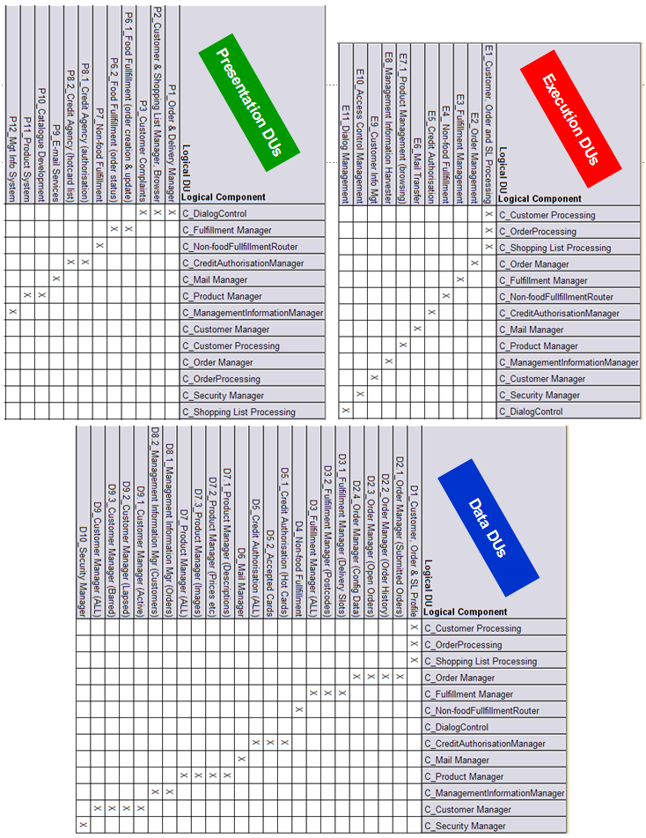
Figure 28: AmGro-from-Home’s Deployment Unit Model

Figure 28 highlights how:
- A logical component must be represented by at least one EDU, although it need not be represented by other types of DU (some rows in PDU and DDU tables are empty),
- A logical component may be represented by several distinctly different DUs for any given aspect (several “X” in the same row),
- Several logical components may be represented by the same DU, for a given aspect (several “X” in the same column),
- Logical components may be grouped with different components for different types of DU (different permutations of “X” in each matrix).

Note: Deployment Units are deployable, Located DUs are deployed
These DUs from the OMS Deployment Unit model represent four aspects of the solution’s application components in such a way that they can be deployed: loosely speaking, DUs are deployable parts of components.

But they are not deployed in the DU Model. They are deployed, as Located DUs, across the solution’s Operational Model (as documented in section “OMS’s Operational ModelOMS’s Operational ”). Therefore:

- The (Functional) Deployment Units of the DU Model record the solution’s components’ various operational NFCs as “overall characteristics”
- (Operational) Located Deployment Units of the Operational Model record where the functional DUs are variously deployed (once or many times), each time noting variations from the functional viewpoint’s NFCs

Note: OM and SA4TeamSD
While the “splitting and grouping” relationship between a component and its DUs can be complex, it always represents definite relationships between different parts of the component and different types of DU - as discussed in section “What needs deploying? The Component Deployment Viewpoint (Deployment Unit Model)” specific parts of a component “need” a specific type of DU:
- If the component has “Operations”, then it needs at least one EDU
- If the component has data, then it needs at least one DDU
- If the component is installed, then it needs at least one IDU
- If the component is an edge component, then it needs at least one PDU

This allows a tool, such as SA4TeamSD to provide a degree of automation in the identification of a component’s candidate DUs: a SA4TeamSD utility uses the above “rules” to auto-generate DUs from an existing set of components.

DU Model’s Physical View
The physical DUs in the OMS’s Deployment Unit Model follow exactly the same pattern as their logical counterparts: each physical component may be represented by up to three physical DUs (four for edge components).

Physical components may implement several logical components whilst best practice dictates logical components do not usually span physical components. There are, therefore, usually fewer (often far fewer) physical components than logical components. Thus there may also be fewer Physical DUs. For example, any part of AmGro-from-Home’s OMS implemented using traditional packages or legacy applications may need to be modelled by:

- One physical EDU representing the execution of a program module that must run “in a single address space”
- One physical DDU representing a store of application data that must be implemented “as a whole”
- One physical IDUs representing the installation of a package’s executables “all in one place”

However, if the physical components are of a more modular nature and/or capable of distributed deployment, it will be appropriate to represent each operational aspect of a component as several (even many) distinct physical DUs. For example:

- Several physical EDUs representing an application’s “client-server” configuration
- Several physical DDUs representing a “distributable” data store
- Several physical IDUs representing a “customisable” implementation

OMS’s Location Model
The geographic layout over which AmGro-from-Home’s Order Management System is (or can be) deployed is documented in the logical and physical views of the solution’s Location Model.

Location Model’s Logical View
Figure 29 shows the logical locations over which OMS may be deployed including those of the system’s external agents, together with the locations’ borders (i.e. the available inter-location connectivity):
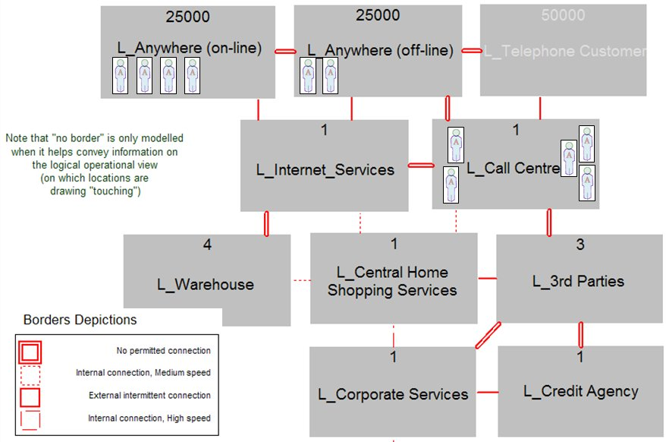
Figure 29: AmGro-from-Home’s Location Model’s logical structure view

The notation for the Location Model’s views draws all borders as connective lines. In addition, and hence the key, Figure 29 highlights the bandwidth available on the borders (i.e. between locations) – this characteristic was chosen since it is specifically important for this system; any other cross-cutting viewpoint could have been highlighted, such as security or management level. Although not exemplified here, some appropriate characteristic of each location could also have been similarly highlighted.

Some borders offering no permitted connectivity have also been drawn – this is not normally necessary in “box and line” notations such as this: no line would normally mean no connectivity. The figure, however, is from SA4TeamSD where it is used to auto-generate the locations & borders backdrop on the Operational Model’s structure views (see Figure 34 for example), on which borders are drawn parallel to the locations they are between, and which therefore requires active documentation of “no border”.

Supporting the focus of this case study, Figure 29 highlights the three locations from which the “shopping” actors access the target IT system (as located actors):

- L_anywhere (On-Line),
(logically) anywhere where the home shopping service can be accessed via the internet using the access mechanism LAM_On-line (anywhere). This could physically be, for example, an AmGro customer’s own home (using an ISP’s broadband) service, or anywhere they can access a roaming wireless service using a PC or PDA.
- L_Anywhere (Off-Line),
(logically) anywhere where AmGro-from-Home can be accessed by an actor without the need for on-line access to the central service, using the access mechanism LAM_Off-Line (PC). In physical (practical) terms, this means anwhere an AmGro customer has access to a PC (or PDA) on which the home shopping application has previously been installed, and which can (in all probability) subsequently connect to the service so the customer can submit their order.
- L_Call Centre,
(logically) anywhere where call centre services can be provided using the access mechanism LAM_On-Line Call Centre. This may be one physical location (such as a central Call Centre), or it may have also included satellite locations, such as the homes of home-working CSRs: anywhere where they can take customer calls and access the service.

The figure also shows that, for the AmGro-from-Home OMS,
- There is no connectivity possible between the two logical customer locations.
Even if these two logical locations are two modes of the same physical place (they are, as will be seen in the next section), there is no means of connecting between the two - in other words, it is not possible for the physical location to be in both logical modes at the same time.
- The two customer locations have “intermittent” connectivity available to the internet services location, via the internet “border”.
This cannot be taken to mean the target IT system uses the available connectivity – as will be seen later, the Solution Architect makes an architectural decision to enable a limited sub-set of home shopping functionality completely “off-line”, and only going “on-line” from time to time (such as to upload an order built off-line).
- Any parts of the solution placed into the Call Centre location will only be able to access the rest of the system via the Central Home Shopping Services location.
Therefore, for example, if there is a requirement for orders taken in the Call Centre to be forwarded onto the warehouse or a 3rd Party supplier, the system must do so via the central service location.

Location Model’s Physical View
Table 5 shows how the “real world’s” physical locations map to AmGro-from-Home’s OMS’s logical locations:

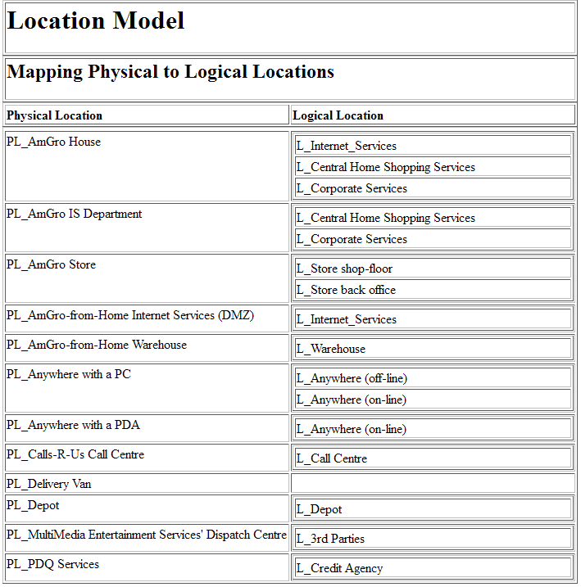
Table 5: AmGro-from-Home’s Location Model’s physical locations mapped to logical locations

AmGro-from-Home’s OMS is using most of these physical locations either in just one way (for example, AmGro-from-Home’s warehouse “is” the solution’s logical location “L_Warehouse”) or split up into several (such as AmGro House being modelled as three separate logical locations).

More interestingly, the figure shows that a user anywhere with a PC (that can be connected to the internet) can logically think themselves to be either in an “on line” or “off-line” AmGro-from-Home location, but when they are anywhere with a PDA they can only consider themselves to be in the same logical “on-line” location.

Thus, Figure 30 shows the physical view of the OMS’s Location Model:

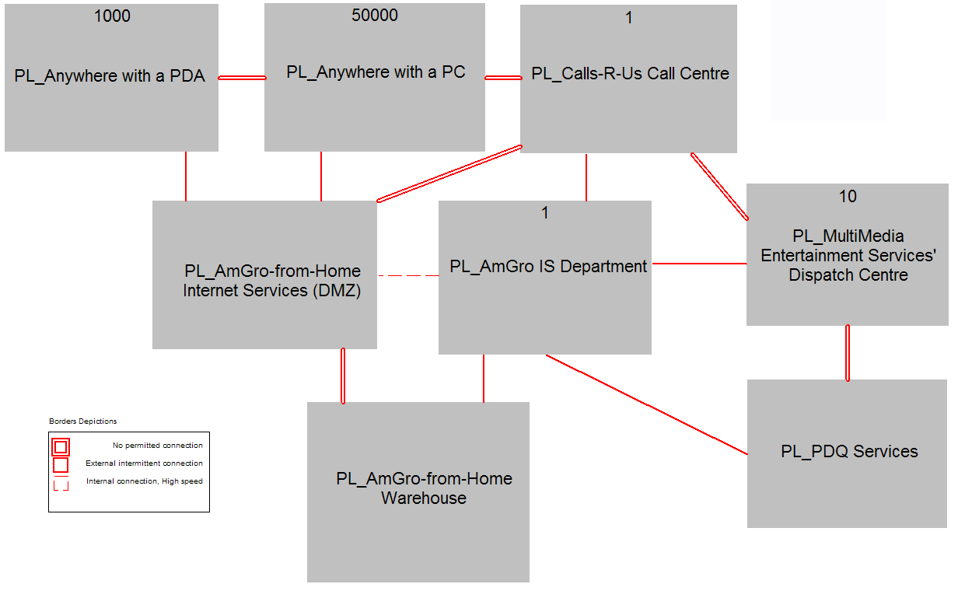
Figure 30: AmGro-from-Home’s Location Model’s physical structure view

Note: Relating physical things to the solution’s context
Mapping the real world into the target IT system’s Location Model highlights a common aspect of Architectural Thinking that can be tricky to “get right”. At first glance:

- Looking at things physically usually means modelling them exactly as they are, irrespective of their relationship to the target system: in other words, “PL_Anywhere with a PC” is just that, anywhere with a PC whatever is happening.
- Looking at things logically usually means modelling how they are used by (or in) the context of the target system: in other words, “anywhere on-line” represents a particular way in which the target IT system will relate to any number of different sorts of physical location.
The same effect is seen to be the case in section “OMS’s Node Model”, where the Node Model’s physical nodes “are what they are”, whereas their use logically relates specifically to the needs of the solution.

But great care must be exercised when assuming a physical view matches the real world without regard for context. This challenge is discussed at length in Appendix A of Ref [6] – so it is suffice to ask here:

- Is it appropriate to model all “representative instances” of a physical thing in the same way, in the context of the solution?

This may be self-evidently true for a “standard physical node” – whatever target IT system is using it, then it’s still the same standard node. But, from the perspective of AmGro-from-Home’s OMS, can all “warehouse” locations be thought of in the same way? If some warehouses are “large” (with extensive staffing levels), and some “small” (only one or two local employees), then maybe there’s a difference. If this matters to the target system (as it might for a “Time and Attendance” solution) then the warehouses would need to be modelled as “PL_Large Warehouse” and “PL_Small Warehouse”.

Note: Numbers
- The logical view of the OMS’s Location Model suggests
  - 25,000 “on line” locations
  - 25,000 “off-line” locations
- The physical view of the OMS’s Location Model suggests
  - 50,000 “locations with a PC”
  - 1,000 “locations with a PDA”
Simple analysis suggests these 51,000 physical locations should have been mapped to 26,000 “on-line” locations and 25,000 off-line” locations!

Note: OM and SA4TeamSD
Table 5 documents that “PL_AmGro House” is used in the same three ways as two physical locations, “PL_AmGro-from-Home Internet Services (DMZ)” and “PL_AmGro IS Department”:
- “L_Corporate Services”
- “L_Internet_Services”
- “L_Central Home Shopping Services”

This can be taken to imply “PL_AmGro House” is an aggregated physical location, composed of at least these two smaller places, each with different uses to the modeller:

- The more general idea of AmGro House features in the TE sketches of Figure 5, Figure 6 and Figure 7
- The more specific and detailed needs of Operational Modelling (such as Figure 30 and the figures in section “OMS’s Operational Model”) identify the use of a DMZ and the IS Department within AmGro House.

Note that this “contains” relationship between aggregate and aggregated locations is not directly modelled – in this case it has been implied between a freeform sketch and a formal view. An alternate non-aggregating interpretation is that (for example) “L_Corporate Services” is a role played by two separate locations, “PL_AmGro_House” and “PL_AmGro IS Department”.

OMS’s Node Model
AmGro’s Enterprise Architecture includes a Node Model that is to be used as guidance for the underlying technical nodes (aka hardware platforms) used to support the OMS application.

Node Model’s Logical View
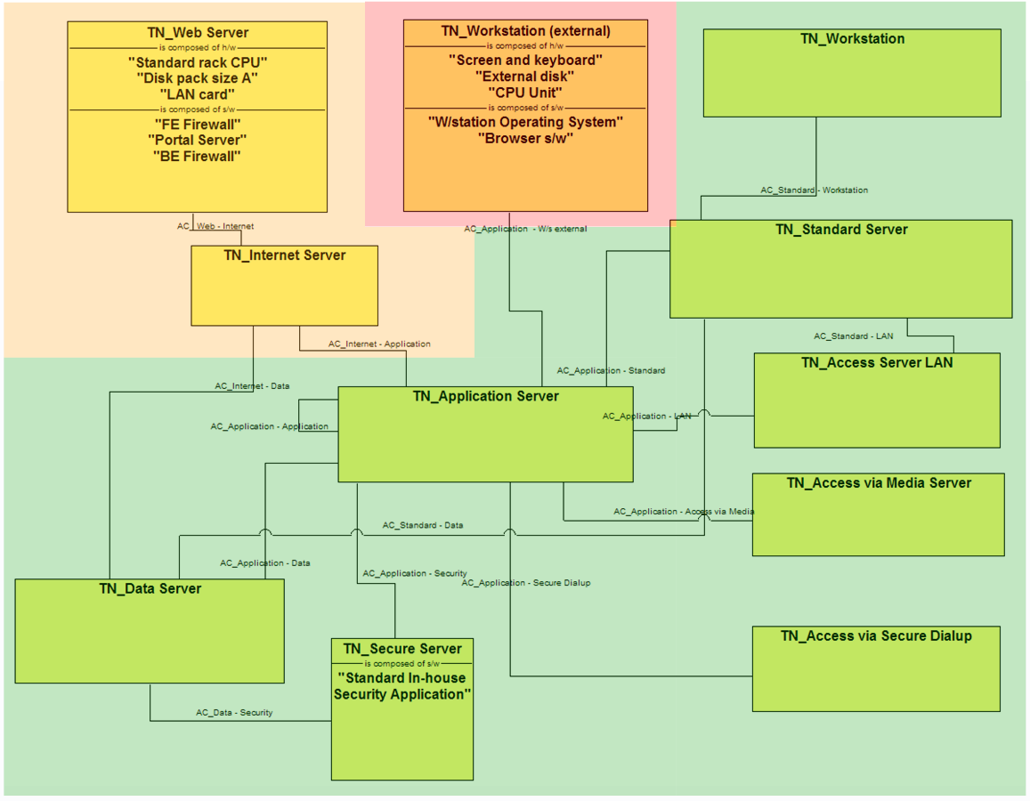
Figure 31: AmGro-from-Home’s Node Model’s logical structure view

Figure 31 shows the logical view of AmGro’s Node Model, documenting the technical logical nodes that can be used to provide the technical functionality needed to underpin the Operational Model’s application level logical located nodes. It also indicates

- The Zones in which these technical nodes may operate – colour coded as
  - Red: untrusted, external to AmGro
  - Orange: partially trusted (popularly referred to as the “DMZ”)
  - Green: trusted, inside AmGro
- For some Nodes, the hardware and software (systems software and middleware) from which they are constructed. According to convention (and as discussed in section “What can it run on? The Node Viewpoint (Node Model)”) for software, this represents the execution of the technical componentry.

Node Model’s Physical View
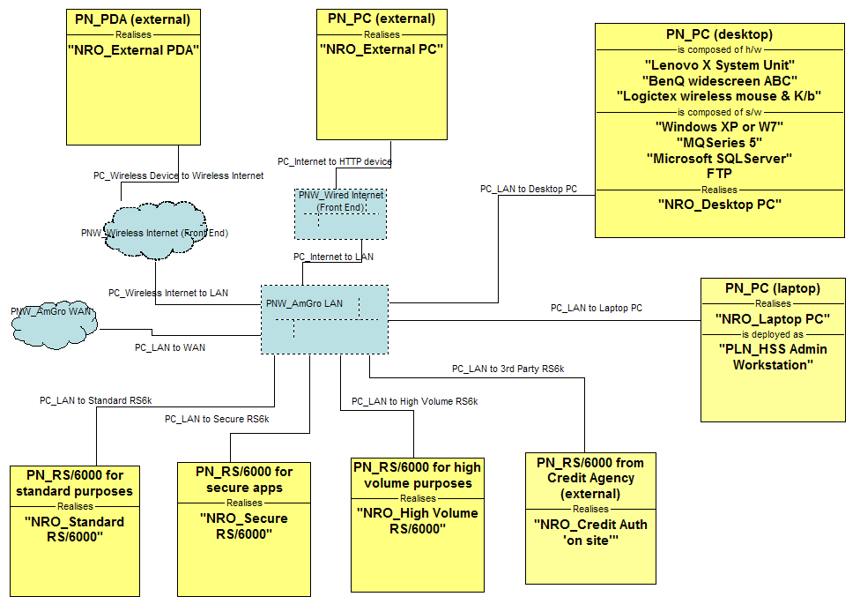
Figure 32: AmGro-from-Home’s Node Model’s physical structure view

Figure 32 shows the physical view of AmGro’s reference Node Model, documenting the “standard builds” of hardware and software technologies available to solution Architects designing systems for deployment into AmGro. It also references, in outline terms, the standard types of network deployed in AmGro and how they are used by these standard platforms. In addition, each physical node also refers the Node Realisation Options it belongs to:

Defining Node Realisation Options
For any complex target IT system, whether “green field” or deployed into an enterprise’s existing IT infrastructure, there is likely to be several, even many choices on how any one part of the logical design may be realised in technology. For example, an enterprise’s Enterprise Architecture may provide a number of permitted alternatives for each building block or there are several existing services all capable of realising the same logical functionality. In these cases it may be appropriate to formally describe each of these choices as a Realisation Option.

A realisation option declares:
- For any given purpose,
- There is a technology,
- Which is strategically, tactically or otherwise recommended,
- under certain circumstances (selection criteria)

“Purpose” may be more precisely defined to be any type of logical model element (component, node, DU, access mechanism, etc.) and “technology” as a physical model element of the same type. Equally, the meaning of “strategic”, “tactical”, “legacy” and so on would need to be understood – it may be that a strategic choice is one that is expected to remain in use over the long term and will be fully supported, whereas a tactical choice is likely to be deployed for a short while and will require non-standard support mechanisms.

The reverse of a realisation option is just as important, that technologies (implementations) can have different recommendations for any number of different purposes (specifications). For example:
- Lotus Notes
- is a “strategic” choice
- for e-mail
- when local systems management skills are strong
And
- Lotus Notes
- is a “tactical” choice
- for data management
- when good data distribution capabilities are available
Whereas
- Microsoft Exchange
- is a “tactical” choice
- for e-mail
- when local systems management skills are weak.

Bear in mind that choices may still need to be made even without such formality – Lotus Notes can be used for e-mail and data management, and email can be realised by Lotus Notes and Microsoft Exchange: there is an N:N relationship between logical and physical parts.

Thus, in this AmGro-fro-Home case study Figure 33, documents the realisation options available for each technical logical node, as defined in AmGro’s own EA. (As a cross reference, notice that Figure 32 documents the NROs in which each technical physical node appears.)
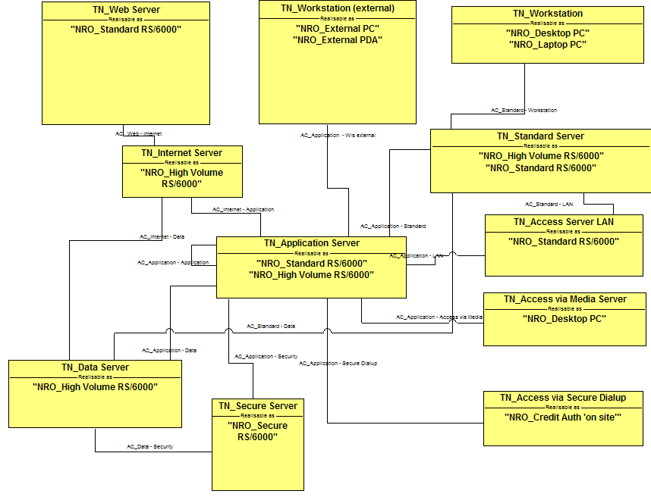
Figure 33: AmGro’s EA’s Node Realisation Options

Figure 32 and Figure 33 highlight how it is “permitted” for:
- A technical logical node to be implemented several ways, such as “TN_Workstation (external) can be a PC (“NRO_External PC”) or a PDA (“NRO_External PDA”).
- The same technical logical node to be implemented using the same physical node, such as technical nodes “TN_Internet Server” and “TN_Application Server” may be implemented as option “NRO_High Volume RS/6000”
These choices are circumstantial and contextual, as is documented in the NRO. For example:
- “NRO_External PC” states that
- Physical node “PN_W7 PC”
- is a strategic choice
- for logical node “TN_Workstation”
- when used by AmGro’s customers at home
- “NRO_External PDA” states that
- Physical node “PN_PDA”
- is a tactical choice
- for logical node “TN_Workstation”
- when used by AmGro’s customers needing mobile internet access

OMS’s Operational Model
There are two basic types of view from the operational deployment viewpoint – structural (static) views and behavioural (dynamic) views, generally referred to as walk-through views.

As is the case with component modelling (Ref [5]), it is perfectly possible to reason about the deployment of the target IT system by:

- First understanding the behaviour between the located parts (Nodes and DUs) needed to support “architecturally significant” use cases, using any number of walk through views.
- Then constructing the overall structural view by composing these walk-through views together, identifying the required connections between located nodes from the messages flowing between them in the various walkthrough views.

This may be a good approach to reverse engineering the operational model of an existing operational system since it invites exploration of “what do the physical bits do as they support an external agent’s use case?”

This paper, however, takes the alternative approach of using the underlying viewpoints (System Context’s operational views, plus the DU Model, Location Model and Node Model) to forward engineer the Operational Model’s logical structure views first, given that this ensures the Solution Architect maintains an overall perspective on the solution’s design, before testing that key parts will work via walk through views:

- First, work out how it will all logically work
- Developing the Outline view of the Logical Structure View
Identifying where everything can go, locating the system’s actors and deciding where located nodes will (or may) be needed.
- Populating the Logical Structure View with application-level located DUs
So that the application’s parts are deployed in such a way as to meet the solution’s non functional requirements
- Adding in the technical level of the Logical Structure View
By identifying the underlying technical componentry needed to support the inter-operation of the application’s DUs, such as database managers, transaction monitors, and security control services
- Testing the Operational Model via Logical Walkthrough Views
Ensuring the target IT System’s parts can work together to satisfy carefully selected use cases

- Then determining how the solution will be implemented physically:

- Developing the unsized physical operational Model
By identifying the technologies and products that will be used to implement the solution’s physical parts
- Developing the sized physical Operational Model
By deciding “how big” and “how many” of these physical parts will be needed

Note that it is equally valid to directly construct the Operational Deployment Viewpoint’s physical structure views in exactly the same “forward engineering” manner as described in steps 1, 2, 3 and 4 above. Therefore, throughout the next sections reference is made to “logical” and “physical” model elements only when a clear distinction is required.

Bear in mind, however, that while working on the physical level may appear more “natural”, it may quickly become a much more difficult task, since – in the real world – the simplifications afforded by thinking logically (and which are discussed in detail in section “Where is everything? The Operational Deployment Viewpoint (Operational Model)” cannot be exploited.

For example, reasoning on the physical level will require the modelling of a myriad of “many to many” relationships between inherently complex physical parts, rather than the simpler logical approach of modelling “1 to many” and “1 to 1” relationships between more, simpler logical parts.

Throughout this section and where possible, the notations used on the Operational Model’s views are based on the standard notations documented in Ref [1].

Step 1: Outlining the Logical Structural View
The logical structure view of an Operational Model may be built up using UMF’s Operational Modelling’s techniques. This step-by-step approach uses information gathered and modelled in the Operational viewpoint’s other views – beginning with the operational deployment view’s outline (i.e. without located DUs) and starting with the structure view’s “geographic backdrop”.

Step 1a: Lay Out Locations and Borders
An Operational Model documents the deployment of an IT system’s parts across a landscape. This landscape may be defined in more abstract “characteristic” terms (using Zones as discussed in section “Where is everything? The Operational Deployment Viewpoint (Operational Model)” or, much more commonly, in more concrete terms using locations and borders as he landscape.

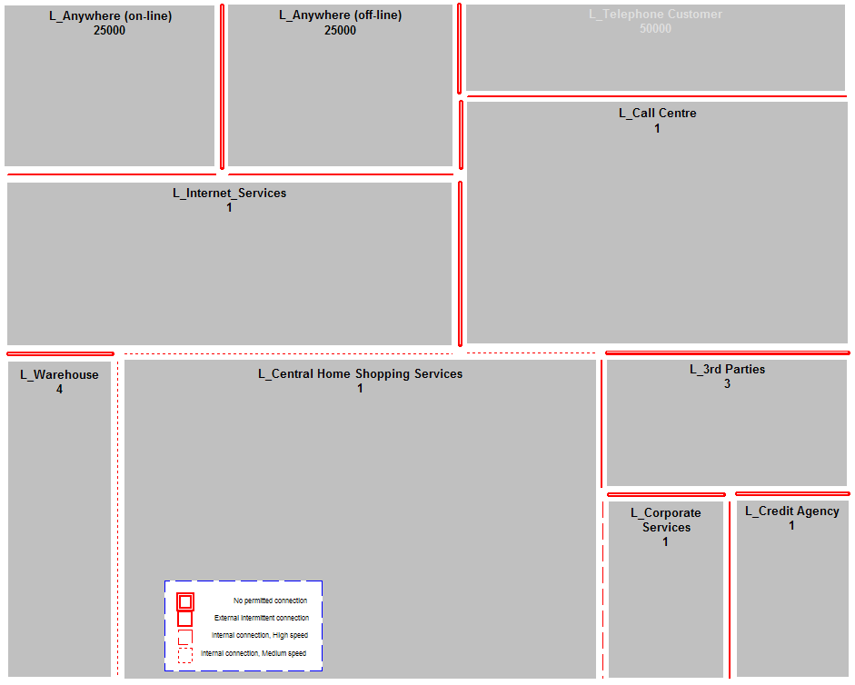
Figure 34: Step 1a -Laying out the locations and borders “backdrop”

Figure 34 shows the logical locations and borders over which AmGro-from-Home’s Order Management System may be deployed. These are exactly as modelled in the Location Model (see Figure 29), but are drawn according to a different notation: all locations are drawn alongside each other, with their borders drawn parallel.

- This has a significant advantage, in that it enables the modeller to immediately distinguish available (or “to be provided”) connectivity between locations from required connectivity between located nodes (as will be seen later)
- But there’s also a disadvantage, in that this form of layout prevents the easy drawing of some location models, which would be easier to see if borders were drawn as connective lines. It will be necessary in these cases to re-draw the structure view “from different angles”.

Note: OM and SA4TeamSD
This Operational Model’s view is “identically equal” to the Location View, except for the different notation. Therefore SA4TeamSD provides a utility to automatically draw all borders on an Operational Model’s Structure View, using information provided on the easier-to-draw Location Model’s view.

Step 1b: Place Located Actors
The target IT system’s located actors can be added to the Operational Model’s “locations and borders” view, based on knowledge gained from the operational views of the system’s System Context:

- Every (functional) actor’s Access Mechanisms identify all the places where that actor is when using each Access Mechanism. Therefore, for each actor, a located actor can be defined using one of the access mechanisms and located in the appropriate location.

Thus, Figure 35 shows where the three “home shopping” users’ five actors are located, as 11 separate located actors.

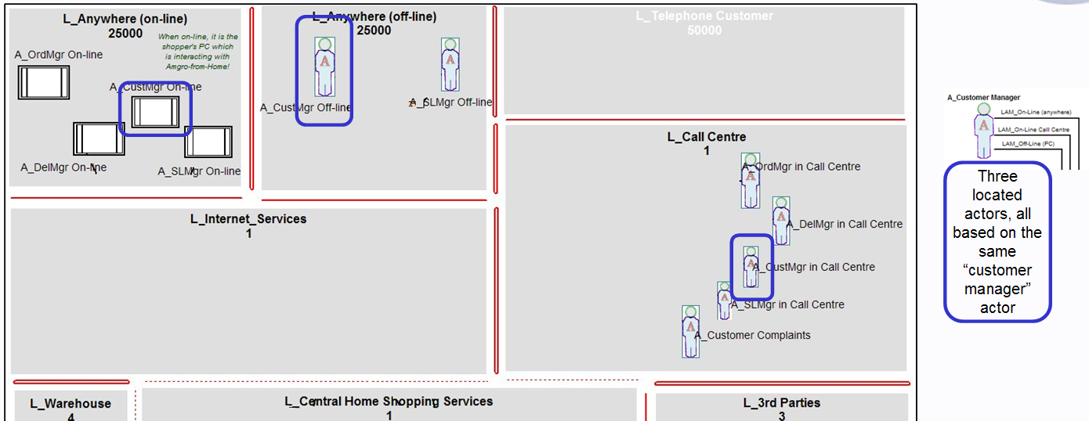
Figure 35: Step 1b - Locating located actors in logical locations

The figure highlights the three located actors all associated with the “A_Customer Manager” actor:
- Located Actor “A_Customer Manager On-line”
- Located Actor “A_Customer Manager Off-line”
- Located Actor “A_Customer Manager in Call Centre”

These located actors exemplify:
- How one of the “A_Customer Manager” actor’s located actors represents the role of an IT System, whereas the other two are human users’ roles
- That different actors’ located actors can be in the same location

Step 1c: Place Access Mechanisms and Edge Located Nodes
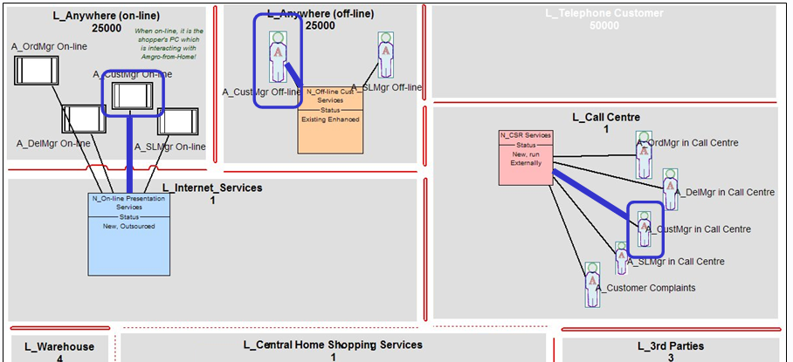
Figure 36: Step 1c - Placing access mechanisms & edge located nodes

Each located actors’ access mechanism has been added in Figure 36, together with the located edge nodes the Solution Architect has decided will support these access mechanisms.

The nature and location of each access mechanism’s outer end was identified as part of the System Context’s operational views (ie. co-incident with the associated located actor). But the location and nature of each access mechanisms’ inner end are “design decisions”, being taken by the Solution Architect as they constructed this view, such as is highlighted above:

- The located actor “A_Customer Manager On-line” will shop on-line from anywhere via the internet, connecting to the service via a front-end “N_On-line Presentation Services” located node, located in AmGro’s own “L_Internet Service” location.
- The located actor “A_Customer Manager Off-line” will shop on a device acting as located logical node “N_Off-line Cust Services”, in their location.
- Located Actor “A_Customer Manager in Call Centre” will also shop on a device local to them

The figure also shows all other located actors using the same access mechanism are being supported by the associated logical located nodes, clearly documenting the “permutations” of shopping roles that will be available from each location.

How did the Solution Architect decide on what edge nodes to locate where?

- It may have been that the Architect simply used their personal experience, knowing the challenges they may face later in the design (which may be why they decided the inner end of the “on-line” users’ access mechanism would not co-located with the users, but would be in the “L_Internet_Services” location).
- Or maybe they used a Reference Architecture.

It was the latter case.

Their Reference Architecture is documented in section “OMS’s Node Model”, specifically illustrated on Figure 31. This shows a “best practice” infrastructure design for systems such as this, from which the Solution Architect was able to determine the underlying technical nodes on which their solution’s located logical nodes will be based, such as:

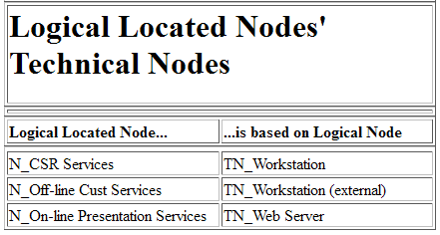
Table 6: OMS's Edge Logical Located Nodes based on Standard Technical Nodes

Note: Assumption becomes a Decision
Up until this point, it had been assumed the located actor “A_Customer Manager On-line” was to be the customer’s PC (i.e. it’s the PC that will interact with the OMS). Only now, by deciding the target IT system’s edge node is located in the “L_Internet_Services” logical location, has this decision been taken.

Note: OM and SA4TeamSD
Conforming to the best practice discussed in section “Where is everything? The Operational Deployment Viewpoint (Operational Model)”, SA4TeamSD ensures logical located nodes, such as “N_On-line Presentation Services”, are constrained to support only one access mechanism, thereby helping the Solution Architect focus the design of the node on the needs of its actors.

Note: OM and SA4TeamSD
SA4TeamSD has a number of sophisticated utilities designed to help ensure consistency between the “black-box” System Context’s operational views and the Operational model. For example:

- If an actor is “added” to a location, SA4TeamSD recognises that the modeller intends to represent that actor in that location and, if none exists in the model, automatically creates a located actor for the selected actor, adding its symbol to the view (i.e. the actor is not added to the view- that’s not allowed!).
- If the located actor exists in the model, then SA4TeamSD automatically adds their access mechanism and associated located node to the view (assuming these too exist).
- If the actor does not have an access mechanism associated with the target location (and therefore SA4TeamSD must have created a new located actor in step 1), SA4TeamSD invites the modeller to define one. This is also associated with the corresponding actor, and the next time a relevant system context view is opened (or saved) on which the actor appears, the newly created access mechanism is automatically added.
- If the supplied access mechanism already exists (e.g. it’s supporting other located actors) it is added to the diagram, together with the associated edge located node.
- If it’s a new access mechanism or an existing one without an edge node, SA4TeamSD asks where it’s inner end will be located, and for the located node in that location to which it is attached. These are then also automatically added to the view.

Step 1d: Identify Potential “Inner” Located Nodes
Using either their experience, or (as was the case here) basing their decisions on a Reference Architecture, the “inner application level nodes” can be added to the model, together with the inter-node connections, as shown on Figure 37 and Table 7 .

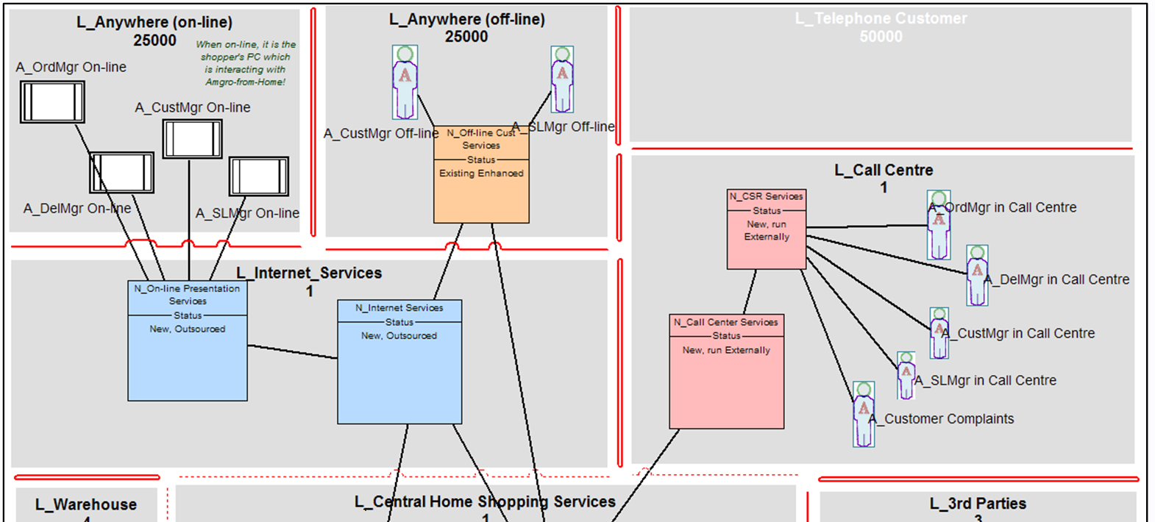
Figure 37: Step 1d - Identifying Inner Located Nodes

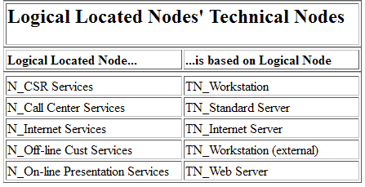
Table 7: OMS's Logical Located Nodes based on Standard Technical Nodes (detail)

For the moment, it is only possible to say that these located nodes and their connections might host some part of the OMS application – i.e. they might be needed to support located deployment units. As will be seen later, only when the solutions located DUs are added to the model will it be possible to say some are not needed (in which case they will be removed from the model), or some are found to be missing – for example it may transpire that:

- Some located DUs on a located node need a high level of security, while other DUs require significant storage space, but can be accessed by anybody: in which case, the node may be refactored into two logical located nodes, one providing high security and the other high capacity.
- Some traffic between two nodes is regular and transactional, whereas other traffic between the same two nodes is intermittent and file based: in which case, two logical located connections will be needed between the same two logical located nodes

But, at this point in the design process, Figure 37 does now present an outline version of the Operational Model’s Logical Structure View, as does Figure 38, portraying exactly the same model in its entirety, but drawn in a manner which may be more approachable to non-technical audiences (although with the potential confusion of showing a logical view using very physical symbols!):

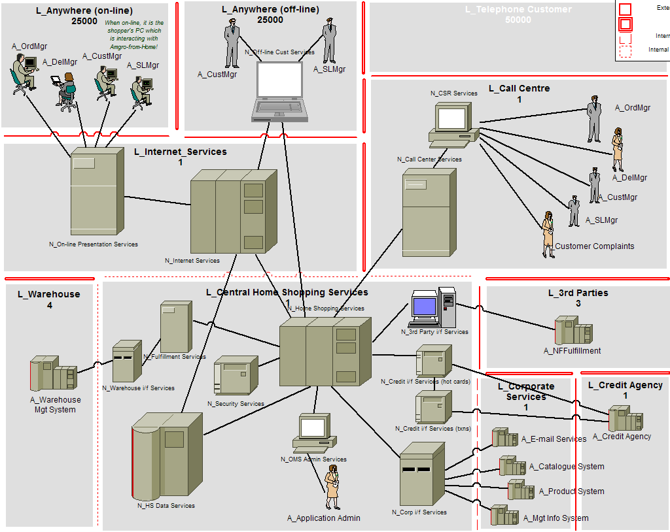
Figure 38: An alternative, “pictorial view” of the OM’s outline logical structure view

Note: OM and SA4TeamSD
SA4teamSD provides the facility for any view to “flip-flop” between Figure 37 and Figure 38.

Note: Why no numbers?
As a logical view of the Operational Model, these nodes and connections do not and will not specify how many there needs to be – rather, as the design develops, only the operational non-functional requirements will be recorded for each of them.
It only makes sense to judge “how many” when decisions are taken on the technologies used for these logical nodes’ implementation, as discussed in section “Step 6: Sizing the Physical Operational Model” – it may be, for example, that the operational characteristics of one technology may satisfy the solution’s needs with “one per location”, whereas another choice may require two devices to be used.

Note: Are these views Application Level, or Technical Level, or both?
It is the case that
- The Operational Model’s logical structure view’s located nodes may or may not be based on underlying (standard) technical nodes – in this case (as highlighted by Table 7) they are.
- These nodes are connected together with “point to point” located logical connections, since these logical views do not describe the underlying network structure needed to achieve these logical requirements.

But this does not mean that each and every located node must “host” some part of the application – there may turn out to be nodes without application level located DUs. For example, it may be necessary to introduce non-application hosting located nodes to support some function of systems management (data distribution, problem reporting, performance monitoring).

It has been shown to be helpful to distinguish between views that do, and do not include these “non-application” located nodes:

- “Application level” views of the OM
only include nodes and connections that are directly associated with the application – specifically, all the nodes shown on the view must host application level located DUs
- “Technical level” views of the OM
do include other located nodes and connections – specifically, some nodes on the view do not host application level located DUs

This case study does not present any “technical level” views of the OMS’s Operational Model, although – as will be seen later – such views will be required in order to describe how the solution will be managed and maintained

Note: How have these located nodes been named?
At first glance, these located nodes have been named in a way that implies their use by the OMS application – and yet the application (rather, its DUs) has not yet been deployed onto them. So where did the names come from?

- They can be based on putting the underlying technical nodes’ names into context
- They are “reverse engineered” from what the nodes are known to be doing
- They reflect the fact that, in reality, the design is iterative – and that the located DUs have been removed from the view before it was included here!

When genuinely “forward engineering” a new design, a powerful technique is to leave the nodes unnamed, or with very generic names, and only to select a name once they have been populated with located DUs: it’s the DUs that define what the node “does”, and should therefore suggest it’s logical name.

Step 2: Completing the Application Level Logical Structure View
The outline of the OM’s logical structure view may for many situations be a sufficient level of detail – it documents a target IT system’s located logical nodes, located actors and the communication mechanisms (access mechanisms and connections) between them – all of which may be based on fully defined standard technical platforms. This will be sufficient for, for example:

- An infrastructure proposal, explaining how a set of standard platforms may be deployed into an enterprise’s IT environment, for use by a variety of (undefined) applications
- An analysis of existing infrastructure endeavouring to establish “how it all works”, without focus on “what it’s being used for”.

This outline level is not, however, suitable for defining the deployment of a specific business solution such as AmGro’s OMS. For this, it is necessary to define how the application will be deployed over this “infrastructure” – specifically, where OMS’s DUs will be deployed, in order for the solution to achieve its operational non-functional requirements.

As with the Outline view, the complete, populated application level view can be built up using UMF’s Operational Modelling’s techniques, starting with the deployment of OMS’s presentation DUs onto the appropriate “edge” nodes.

Step 2a: Deploy Located Presentation DUs
The most straightforward (almost obvious) first step in populating the OM’s outline application level structure view is to decide where the presentation DUs must go – they have to go on edge nodes, and they have to represent the system’s interfaces with its located external actors. So, for example, consider the three Presentation DUs (PDUs) for component “C_Dialog Control” defined as part of the Deployment Unit model and documented in Table 1:
- P1_Order & Delivery
- P2_Customer & SL
- P3_Complaints

These three PDUs are variously represented by the six located PDUs deployed onto the target IT system’s edge nodes shown on Figure 39 (with detail on Figure 40: Step 2a - Deploying located presentation DUs (detail)Figure 40).

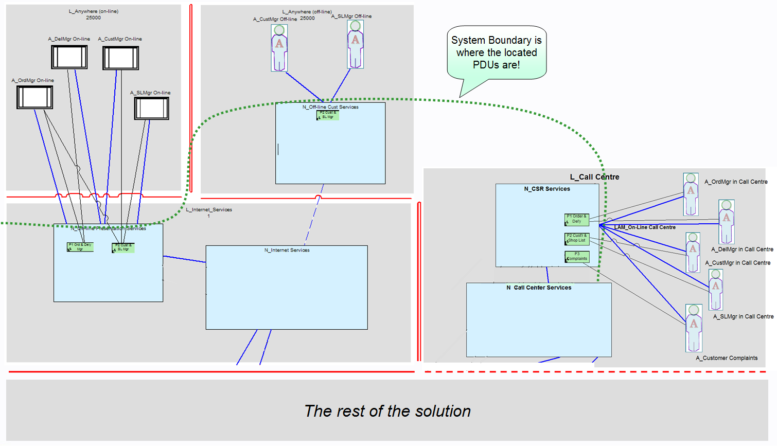
Figure 39: Step 2a - Deploying located presentation DUs

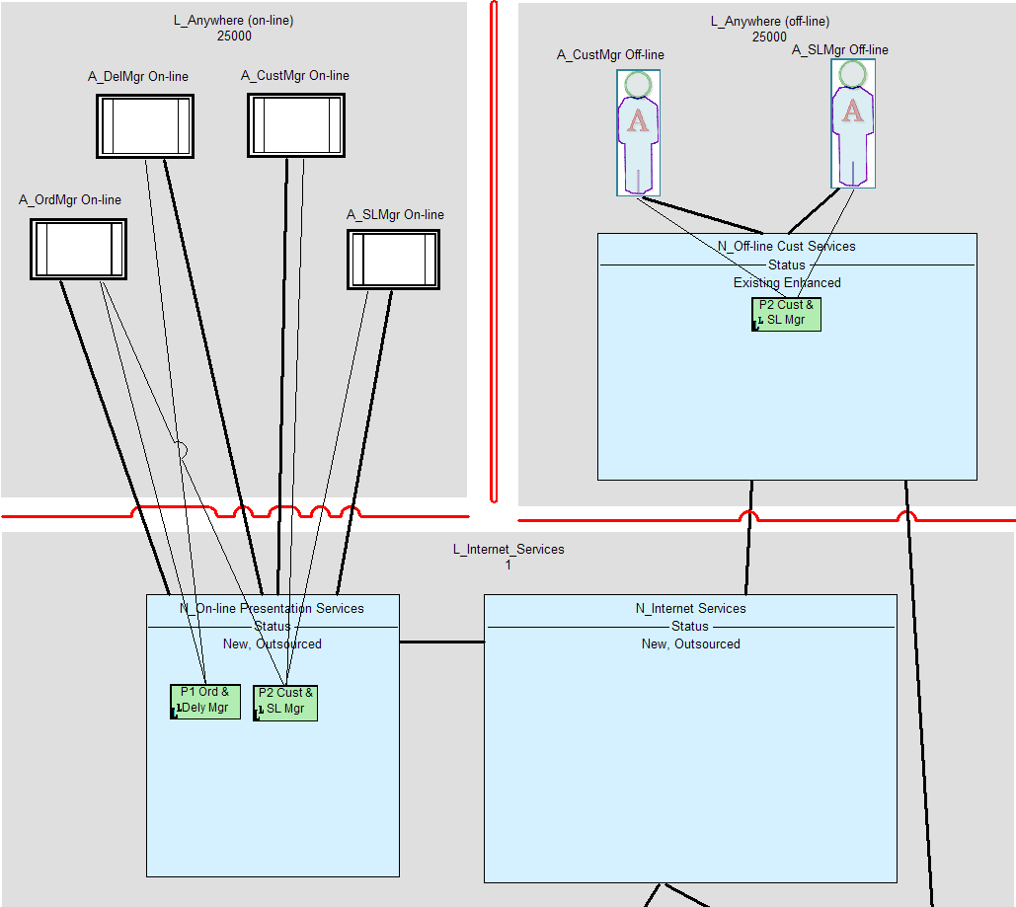
Figure 40: Step 2a - Deploying located presentation DUs (detail)

These located PDUs model the system’s application’s apparent interfaces to the various located actors. The figures also document the connectors required between the located PDUs and their associated located actors. Thus the figures show the OMS application’s edge component appears to present:
- All its functionality on workstations acting as the “N_CSR Services” logical located nodes
- Only Customer and Shopping List Management on devices that can act as “N_Off-line Cust Services” logical located nodes
- Everything except “Complaints” on devices that connect to the “N_On-line Presentation Services” logical located node

Figure 39 has also been annotated with a dotted line highlighting the target IT System’s boundary. As discussed in section “What needs deploying? The Component Deployment Viewpoint (Deployment Unit Model)”, located Presentation DUs document the target IT system’s boundary (or rather, they are just on the inside of that boundary).

But access mechanisms are also “at” the boundary – their outer end attaches to external agents “outside”, while their inner end attaches to edge nodes “inside”, where is the boundary?

Access mechanisms, PDUs, located actors, and edge nodes
Understanding the design complexities at the edge of a target IT system and its relationships with its actors is vital to the success of the business solution; which is why Operational Modelling places such a focus on modelling how things connect, what goes on between them, and the nature of the interface “through” which it all happens. For example, consider this part of AmGro’s OMS, the interface between the Call Centre’s actors and the solutions “workstation” edge node – there are six sorts of model element:

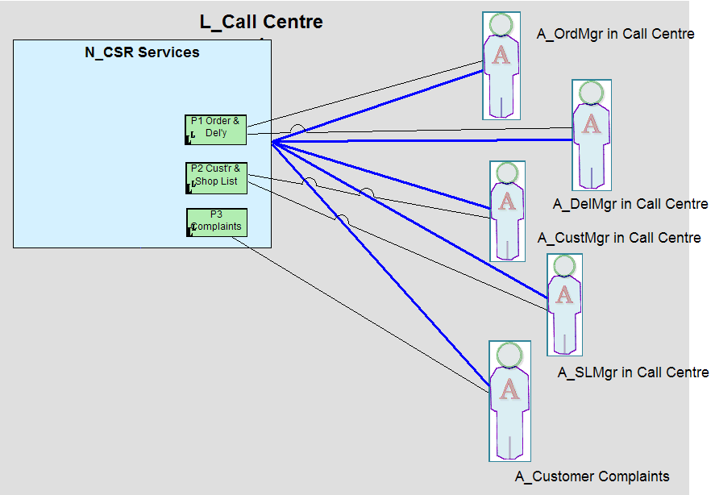
Figure 41: Access mechanisms, PDUs, located actors and edge nodes

Why do we need all these types of model element, and how do they relate to one another?

- For the underlying infrastructure (and therefore the Operational Model’s “outline” views, we need to model four things:
  - Where things can be, so we need logical locations (and borders) such as “L_Call Centre” to document the characteristics of and relationships between the solution’s geographic landscape
.
  - Where our actors are, wherever they are outside the target IT system, so we need located actors such as “A_CustMgr in Call Centre” to document how these actors can be in many places.
  - What are and where are the devices these located actors are using, wherever these devices are inside the target IT system, so we need located nodes such as “N_CSR Services” to document what these devices are used for, and how they will support these responsibilities
  - How actors connect (across the system’s boundary) to these devices, so we need access mechanisms such as “LAM_On-line Call Centre”, with their outer end in the actor’s location, and their inner end attached to the device.

- This “infrastructure” is then used by the solution’s application – it represents the structure over which the application is deployed, runs, and communicates, which at the edge means we need to understand:
  - Where the application appears to present itself to its users, and the nature of that presentation, so we need located Presentation DUs, deployed onto edge nodes, “through” which the application is “seen” by its actors.
  - Which located actors are using these “interfaces”, by modelling the transport mechanism between them as located DU connectors, carried over access mechanisms

Note: Where’s the edge?
In the System Context’s operational views, the boundary was simply modelled by the target IT system’s access mechanisms. But the System Context’s “black box” views only document the outer end of the access mechanism – there is no sense of it having “two ends”, just that it is “at the boundary”.

Thus, the System Context’s operational views do not (cannot) define where the target IT System’s boundary is. Whether it is co-incident with the actors (i.e. in the same location) or somewhere else is not modelled in this “black box” view – it only models where and what these actors “experience” of the target IT system, and only from their “requirements” point of view.

So where is the edge? It is somewhere along the access mechanism, but where? A simple example will highlight the less-than-obvious answer:

Imagine the external agent to be an IT system, connected via an access mechanism to an edge node.
- If they are connected via wired Ethernet
  - The internal edge node has an RJ45 socket
  - The external agent has an RJ45 socket
  - The access mechanism is an Ethernet cable/network

- If they are connected via wireless Ethernet
  - The internal edge node has a wireless transmitter
  - The external agent is a wireless enabled computer such as a laptop PC
  - The access mechanism is the wireless signal

In the first case, the access mechanism would be
- Wholly "inside" the target system if the cable is supplied by the system, in which case the boundary is between the access mechanism's outer end and the external agent's RJ45 port.
- Wholly “outside” the target system if the cable was supplied by the external agent, in which case the boundary is between its inner end and the internal node's RJ45 port.
- Partly “in” and “out”, if the access mechanism is actually two cables connected via some intermediary such as the internet, in which case the boundary is somewhere between its two ends

In the second case, the access mechanism is
- Wholly "inside" when traffic flows out (it's supplied by the router) – in which case the boundary is at the router.
- Wholly "outside" when traffic flows in (it's supplied by the PC), so the boundary is at the PC.

All of this makes the "boundary" a rather complex notion when we think deeply - so we tend to keep it simple by saying the access mechanism connects "something somewhere on the inside" to "something somewhere on the outside" and must therefore "cross" the boundary, even if the boundary is actually crossed at one end, at the other, somewhere in-between, or both!

Note: Nodes and DUs
Section “Where is everything? The Operational Deployment Viewpoint (Operational Model)” says
- a node is only a co-located collection of things that have a collective, connective relationship to other co-located collections of things.
In other words, nodes (and their connections) are aggregates of things all in the same place (or joining two places). For the moment, then, the edge node shown in Figure 41 “is only” three presentation DUs

Note: Actors and actor’s parts
Consider these two sentences:
- Located nodes connect to located actors via access mechanisms
- Located DUs interact with located actors via connectors
“Located actor” appears in both sentences, connecting to something different than it interacts with. This is because we choose not to model the things that make up the actor, and therefore choose not to consider the actor as an aggregate of things.

If we did, then we would need to model how:
- The outer end of a human access mechanism connects to a person’s fingertips and eyes, its inner end connects to the keyboard and screen and the link between is physical contact and light. Then, the application’s PDU interacts with a person’s fingertips and eyes via messages received by a person pressing keys with their fingertips and sent via the projection of a window on the screen for their eyes to read.
- The outer end of an IT access mechanism connects to an external IT system’s WiFi adaptor, its inner end connects to the WiFi hub, and the link is radio waves. Then, the application’s PDU interacts with the apparent interface of the program on the external IT system via a transport protocol such as TCP/IP.

Thus, if we were to go to this level of detail, then the target IT system’s PDUs would interact with an interface explicitly modelled “on” the external actor. But we don’t.

Note: connections and connectors (and messages)
Section “Step 4a: Walk Through Accurately – Located DU to Located DU” discusses this in detail, but for the moment think of:
- Connections between nodes (or access mechanisms between nodes and actors) as roads between cities.
- Connectors between DUs or PDUs and actors as cars, trucks and buses travelling between places in these cities by using these roads.
- Messages between DUs or between PDUs and actors as being the people and packages carried backwards and forwards by these cars, trucks and buses.

Note: Notation
The standard naming convention for DUs (fully documented in Ref [1]) signifies the DU type as a single letter uppercase prefix, which for presentation DUs is “P_”.

The standard notation for located DUs is the same, with additional variants - any primary located presentation DU also has an upper case “P_” prefix, whereas any backup located PDU is a prefixed by a lower case “p_”. The notation can then expanded to cater for a variety of deployment options, illustrated for a master presentation DU:

- A full located presentation DU
  - “P_Order Management”
  - “P1 Ordering”
  - “P1”
- A partial located presentation DU, where only some element of the presentation DU is available
  - “P_Order Management (Browsing)”
  - “P1.1 Browsing”
  - “P1.1 (s)”

Typically, the shorter names are used on views where space is often limited, while the longer more informative names are textual.

Step 2b: Deploy Located Data DUs
Experience suggests the second step in populating the OM’s outline application level structure view is to decide where the data DUs must go. It may be that they can only go where the enterprise’s Enterprise Architecture dictates (“all data is managed centrally”) or where a package can allow (“all data is held in a single database”). Even if this is the case, the Solution Architect may want to understand the implications of these constraints by asking

- “Where should the data be placed, in order to achieve the solution’s non-functional requirements?”

Will it be stored “conveniently close” to the external agents using it, maybe providing higher levels of performance and availability, or will it be stored centrally, where security and systems management may be easiest? Will it be appropriate to deploy it in a master database with copies distributed around the system, or maybe it might help to split it up in some fashion?

Notice how these options are neutral to the location of the application’s execution (i.e. they do not refer to the location of its EDUs): the key consideration is accessibility v manageability. Thus, the technique suggests:

- Identify how far away from the “centre” a single copy of a data DU can be so that it is “equally accessible” to all located actors who need to use it in some way (read, write etc.).
- Is this somewhere it can be “easily” managed? If not, move it closer to the centre until you are satisfied it can be.
- Can all located actors still get at it, and if they can, can they do so easily enough?
- If not, can copies of the data DU be placed closer to the located actors, taking account of their data access NFRs, while not compromising the solution or creating excessive systems management challenges?

The result of this technique for AmGro’s OMS is presented on Figure 42, for those located data DUs associated with AmGro’s customers shopping “on-line” (via their own devices) and “off-line” (using their own devices).
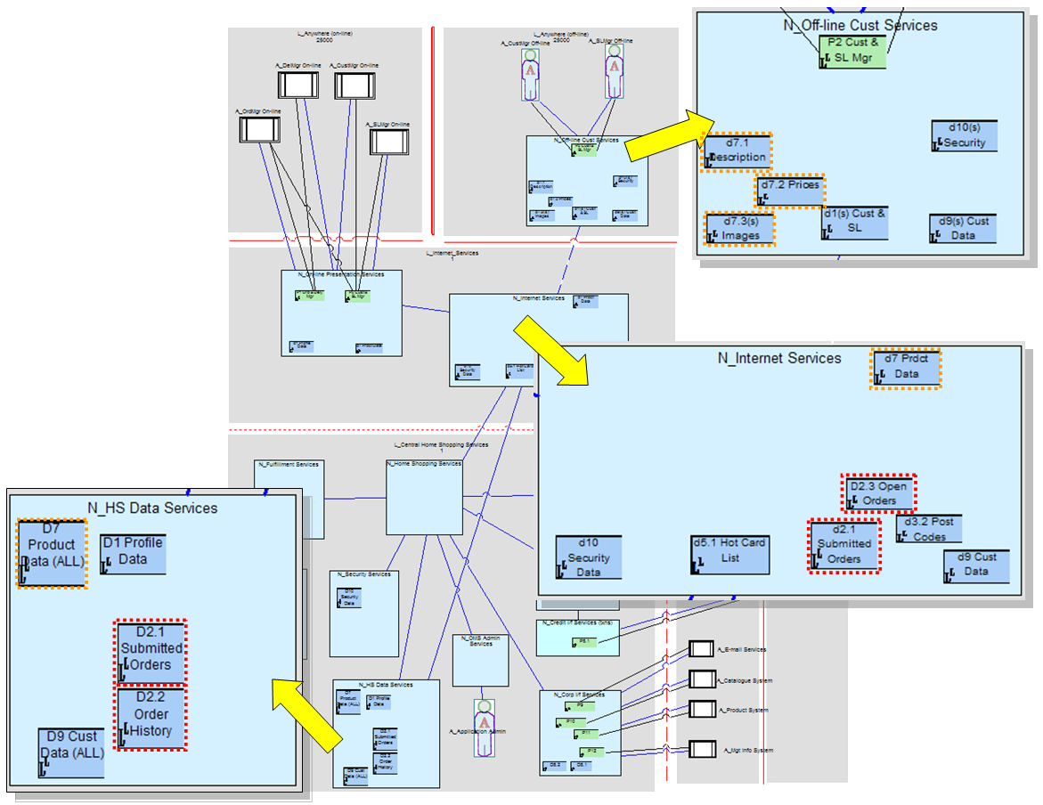
Figure 42: Step 2b - Deploying located data DUs

This example highlights:

- How three of the data DUs associated with component “C_Order Manager” identified in Figure 28) have been deployed in different ways (highlighted as  )
  - For data DU “D2.1 Order Manager (Submitted Orders)”:
    - A master is deployed as data DU “D2.1 Submitted Orders” on node “N_HS Data Services” in the “L_Central Home Shopping Services” location. This reflects the need for this data to be accessible to all “shopping” located actors.
    - If AmGro’s customers or their agents in the call centre need to modify a submitted order (before it is delivered), then, while access may be slow, this has to be to the central Master to help prevent duplicate updates from different sources.
    - However, rapid access to a “read only” copy of this data can be given to AmGro’s customers by deploying located data DU “d2.1 Submitted Orders” on the “N_Internet Services” located node in the “L_Internet Services” location.
  - For data DU “D2.2 Order Manager (Order History)”:
    - A master is deployed as data DU “D2.3 Order History” on node “N_HS Data Services” in the “L_Central Home Shopping Services” location. This reflects the need for this data to be accessible to all “shopping” located actors.
Since this access is infrequent, and users will tolerate relatively long response times, even though this is a read-only data DU a design decision was taken not to provide copies closer to each of the shopping channels.
  - For data DU “D2.3 Order Manager (Open Orders)”:
    - Node “N_HS Data Services” in the L_Central Home Shopping Services” location provides equal read/write access to all users.
However, performance will be compromised, and “read-write” copies placed closer to each located actor are considered unmanageable.
    - Therefore a master has been deployed as located data DU “D2.3 Open Orders” closer to the “on-line” and “off-line” located actors on the “N_Internet Services” located node in the L_Internet_Services” location. Thus a shopper can switch from one mode to the other as they wish and continue working with their order.
This design decision prevents customers from switching to a phone call with a CSR to continue building an open order.
- How component “C_Product Manager”’s data DUs (identified in Figure 28) have been deployed in different ways (highlighted as  )
  - For data DU “D7 Product Manager”:
    - A master is deployed as data DU “D7 Product Manager” on node “N_HS Data Services” in the “L_Central Home Shopping Services” location. This reflects the need for this data to be accessible to all “shopping” located actors.
    - Since this data DU is “read only”, it has been possible to place a copy “d7 Product Manager” on the “N_Internet Services” located node in the L_Internet_Services” location, for access by “on-line” and “off-line” users.
    - However this read-only copy is not accessible to the “off-line” located actor (they are disconnected from the central service!), so copies need to be downloaded onto their local device as it acts as located node “N_Off-line Cust Services”.
It is recognised that different parts of this data DU have very different non-functional characteristics, that will affect the frequency and size of downloads needed to ““N_Off-line Cust Services”. It has therefore been modelled as three distinct located data DUs:
      - “d7.1 Description”, moderate size and reasonably stable.
      - “d7.2 Prices”, very small, changes frequently, probably daily.
      - “d7.3(s) Images”, hardly ever changes, but because of its size only a sub-set of images are available.

Deploying data DUs as several located data DUs requires data distribution mechanisms and data management functionality – provided by underlying technical level components (“software” and “hardware”). In order to document these requirements, the model may include “data management” located DU connectors, as shown on Figure 43

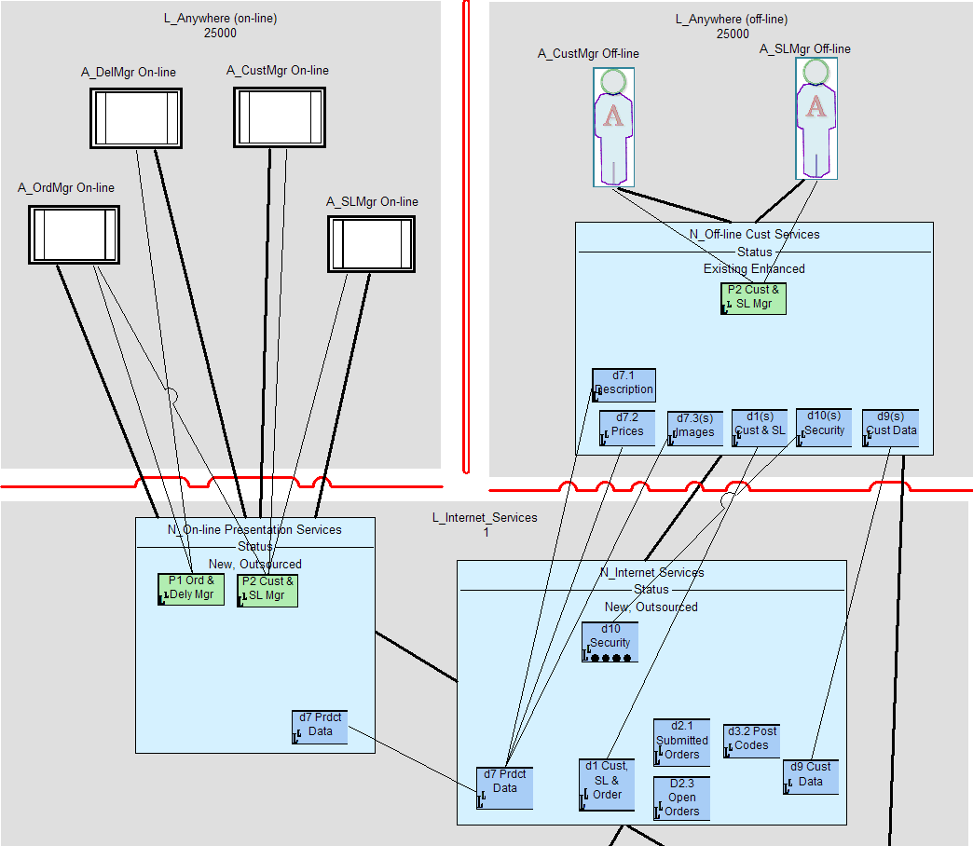
Figure 43: Data distribution located DU connectors
For example, an architectural decision may be that
- installing OMS on the “N_Off-line Cust Services” located node will include the installation of all product descriptions (d7.1) and prices (d7.2)
- Prices (d7.2) is checked and updated whenever the off-line user goes on-line
- Images (d7.3) are downloaded to the off-line application “on demand”

Note: Notation
The standard naming convention for DUs (fully documented in Ref [1]) signifies the DU type as a single letter uppercase prefix, which for data DUs is “D_”.

The standard notation for located DUs is the same, with additional variants - any master located data DU also has an upper case “D_” prefix, whereas any backup located DDU is prefixed by a lower case “d_”. The notation can then expanded to cater for a variety of deployment options, listed below for a master data DU:

- A full data DU
  - “D_Product Catalogue”
  - “D1 Product”
  - “D1”
- A partial data DU, split “by row”, all of some of the records/items in the data DU
  - “D_Product Catalogue (Europe)”
  - “D1(s) Product”
  - “D1(s)”
- A partial copy, split “by column”, some of all the records/items in the data DU
  - “D_Product Images”
  - “D1.1 Images”
  - “D1.1”

(In all cases, the notation does not distinguish “read only” or “read write”). Typically, the shorter names are used on views where space is often limited, while the longer more informative names are textual.

Step 2c: Deploy Located Execution DUs
As with deploying data DUs, where the application’s execution DUs will be deployed may be constrained by external forces such as architectural guidance (“we do not support workstation based clients”) and a package’s capabilities (“this only runs on mainframes”). Even if this is the case, the Solution Architect may want to understand the implications of these constraints by asking

- “Where should the application run, in order to achieve the solution’s non-functional requirements?”

There are four simple options:
- Close to the located presentation DUs
- Close to the located data DUs
- Somewhere in-between
- Close to both located PDUs and DDUs (i.e. “client/server”)

The technique suggests:

- If there is significant interaction between the located actor and the application, with only limited/intermittent data access, then run the application close to the located PDU (i.e. deploy the EDU’s located EDU close to the PDU).
- If there is significant interaction between the application and located DDUs, with only limited/intermittent communication with the located actor, then run the application close to the located DDU.
- If there is significant interaction with both, can the application be run in a client-server configuration?
- Modify decisions based on #1, #2 and #3 depending on systems management capabilities and constraints.
The result of this technique for AmGro’s OMS is presented on Figure 44, for those located execution DUs associated with AmGro’s customers shopping “on-line” (via their own devices) and “off-line” (using their own devices). In addition, the figure also documents the located DU connectors needed to allow these located EDUs to communicate, to access the DDUs they need, and the PDUs they apparently present at:

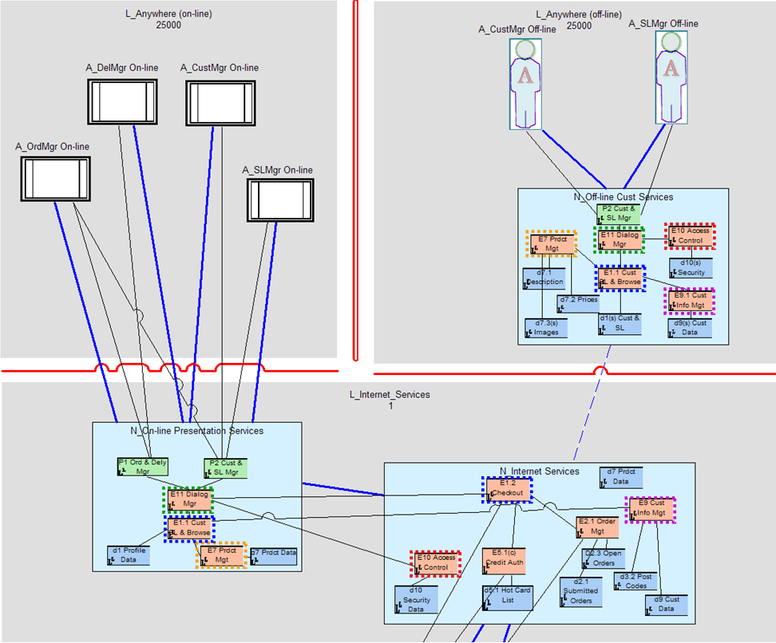
Figure 44: Step 2c – Deploying located execution DUs

This example highlights:

- How execution DU “E11_Dialogue Management (see Figure 28 and identified as  on the figure) has been deployed twice, separately for “off-line” and “on-line” located actors
- How execution DU “E1_Customer, Order and SL Processing” (the execution of three components (“C_Shopping List Processing”, “C_Customer Processing” and “C_Order Processing” as per Figure 28 and identified as  on the figure) has been deployed:
  - Twice, as located execution DUs “E1.1_Cust, SL & Browse” on nodes in locations “L_Anywhere (off-line)” for off-line shoppers and “L_Internet_Services” for on-line shoppers.
Located DU connectors indicate (suggest) that these located EDUs are used by the dialogue manager’s EDUs (), as well as using the Product Management component’s EDUs () to allow browsing and shopping (but not checkout!); the Customer Manager’s EDUs () to allow review and update of the customer’s personal data; and directly use the shopping profile’s located DDUs.
  - As located execution DU “E1.2 Checkout” on the “N_Internet Services” located node only for located actor “A_OrdMgr On-line”. This located EDU works with other components’ EDUs to verify and submit the customer’s shopping basket as an order.
- How, for the on-line located actors, located EDU “E7 Product Management” () and its associated DDU) is placed together with “E1.1_Cust, SL & Browse” on the “front end” located node in the L_Internet_Services” location, whereas “E10 Access Control” () and “E9 Cust Info Mgt” () are with “E1.2 Checkout” on the “backend” located node.
- How, for the “off-line” located actors, the complete “set” of located DUs are deployed onto “N_Off-line Cust Services”, although with reduced functionality, and a subset of the application’s data.

Note: OM and SA4TeamSD
It is perfectly possible for located DUs and their associated connectors to be added to a Operational Model’s structure view (i.e. placed on located Nodes) without corresponding inter-located node connections.

In these circumstances, <By the time this paper is published> an SA4TeamSD utility can be used to create those inter-located node connections needed (between located nodes) to support any connector identified by the modeller between located DUs on those nodes) for which no connection exists.

Note: Notation
The standard naming convention for DUs (fully documented in Ref [1]) signifies the DU type as a single letter uppercase prefix, which for execution DUs is “E_”.

The standard notation for located DUs is the same, with additional variants - any primary located execution DU also has an upper case “E_” prefix, whereas any fall-back (stand-in or stand-by) located EDU is a prefixed by a lower case “e_”. The notation can then expanded to cater for a variety of deployment options, listed below for a primary execution DU:

- A full located execution DU:
  - “E_Order Management”
  - “E2 Ordering”
  - “E1”
- A partial located execution DU, where only some element of the execution DU is available:
  - “E_Order Management (Browsing)”
  - “E2.2 Browsing”
  - “E2.2”
- A split located execution DU, where functionality is located two (or more) places, such as client (c) – server (s):
  - “E_Order Management (Shopping Basket)” and “E_Order Mgt (Checkout)”
  - “E2.1(c) Shopping” and “E2.1(s) Checkout”
  - “E2.1(c)” and “E2.1(s)”

Typically, the shorter names are used on views where space is often limited, while the longer more informative names are textual.

Step 3: Adding the Technical Level Logical Structure View
The model now describes the deployment of the application across the target IT system’s outline infrastructure, itself being placed across the target IT systems locations.

How will it all work? For example, as highlighted on Figure 45 how will:
- The located DDUs of “C_Product Manager” be managed – ensuring “D7 Product Manager (All)”’s located DDUs  will be available for off-line located actors “anywhere off-line”?
- It be possible to ensure located EDU “E10 Access Control”  and its associated data DU are in a secure environment?
- The “off-line” version of the OMS application be loaded and installed onto “N_Off-line Cust Services”  ?

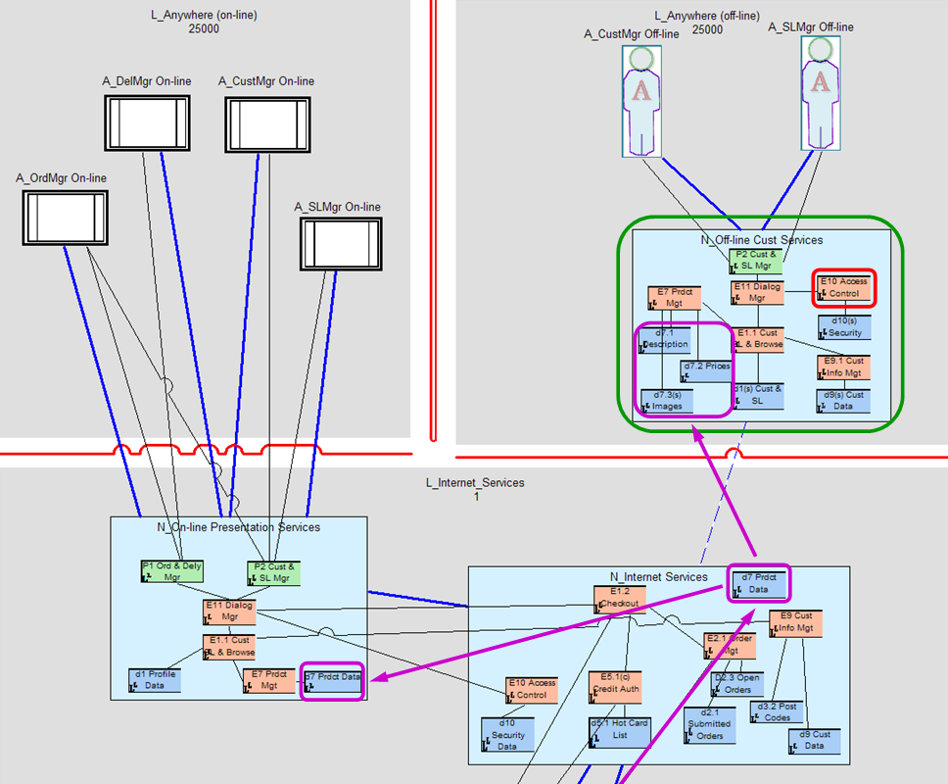
Figure 45: Application management requirements

These and many more application-level operational requirements (as distinct from business requirements) are solved at the technical level of the Operational Model by, for example, the deployment of “data distribution” technical components as illustrated on Figure 46:

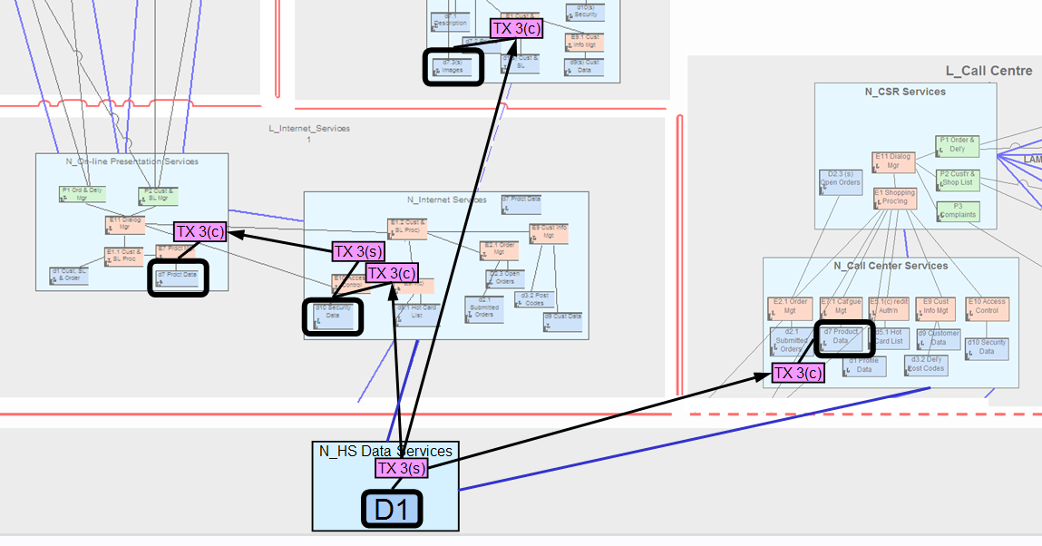
Figure 46: Deploying “data distribution” technical components

Critically, the figure documents the deployment of this technical component as a located execution DU - it is perfectly possible to construct an Operational Model that fully documents how (in this case) data distribution will be accomplished. But, as discussed in section “Any Level - Application, or Technical, or Both?”, this “elevates” data distribution to be the focus application, with the corresponding need to understand the data distribution management component model, as well as the operational model’s views of located data distribution management DUs.

In similar vein, technical, component based solutions to “problem management” or “security control” would probably also need to be modelled as separate application-level (Component Models and) Operational Models.

But, in all events, the manner in which the application-in-focus (AmGro-from-Home’s OMS in this case) is operationally supported would normally still require modelling – albeit in a far less precise and accurate way. This is accomplished by establishing the composition of the technical node underlying each located (application-level) node, in terms of the software and hardware parts from which it is made:

Step 3a: Identify Located Nodes’ Required Technical Software and Hardware
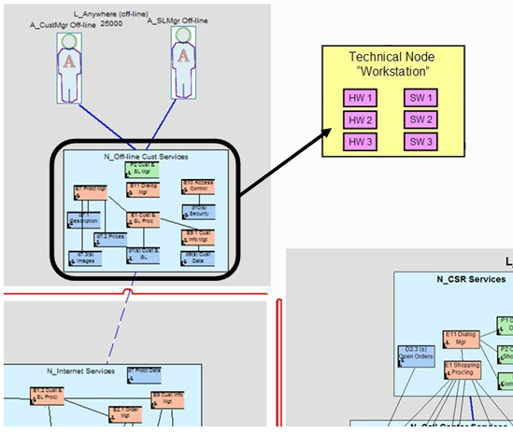
Figure 47: Step 3a - Identifying technical nodes

Figure 47 schematically identifies that (application-level) located node “N_Off-line Cust Services” to be based on a technical node “Workstation”, and that this technical node is composed of the necessary hardware (HW1 etc) and software (SW1 etc) needed to support the application-level located DUs placed onto “N_Off-line Cust Services”.

Be aware that “composed” is not formally defined. In this document it means the software “runs” here and the hardware is “used” here, although it is sometimes taken to mean the technical node is a collection of “installed” software that may run somewhere else.

Note: How detailed do we go?
Figure 47’s technical node is just a sketch, and does not indicate which software and hardware is supporting which application-level located DUs. When required, therefore, a notation similar to that of Figure 48 may provide a greater level of detail, enabling the architect to ensure the application’s technical requirements can be supported (and, correspondingly, ensuring the technical architecture can influence the application level choices):
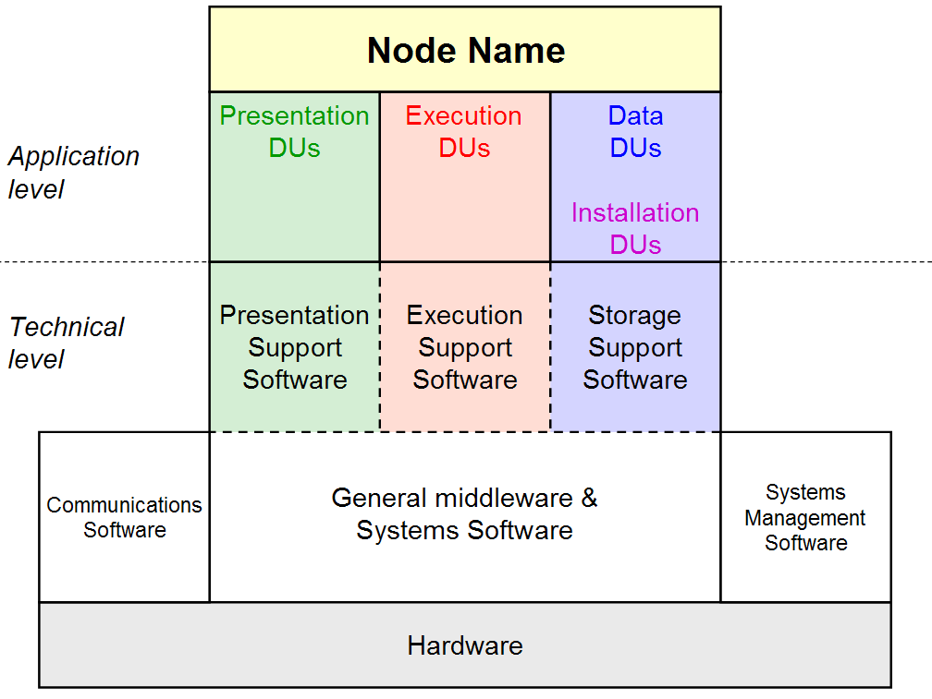
Figure 48: Node box diagram (notation)

Anything deeper than modelling the internals of a node as simple lists of application-level DUs and technical-level software and hardware, such modelling the interactions between application-level and technical-level things is part of infrastructure deployment modelling, where the focus is on designing individual (located) nodes.

Step 3b: Identify “Technical” Located Nodes and Routing Connections
It’s not only necessary to underpin a located node’s application-level DUs with technical software and hardware, it is also necessary to work out how the application-level DUs will communicate between these application-level located nodes.

For example, Figure 49 shows part of the case study, in which three application level nodes are connected via two “point-to-point” logical located connections; with one of them transporting three located DU connectors for the nodes’ located DUs (the other’s DU connectors are not shown):

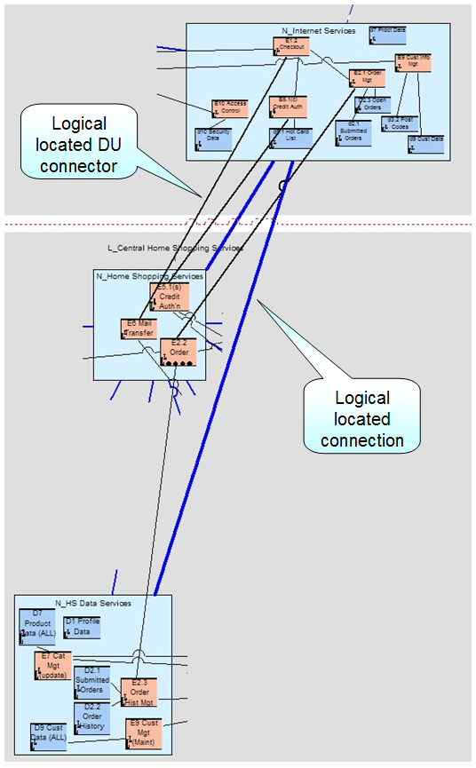
Figure 49: Step 3b – Application-level nodes and “point to point” logical connections…

How is this “application level connectivity” to be achieved? In this case study, by the technical level design shown in Figure 50, in which additional technical-level located nodes have been added as a means of inter-connecting “routing” located connections:

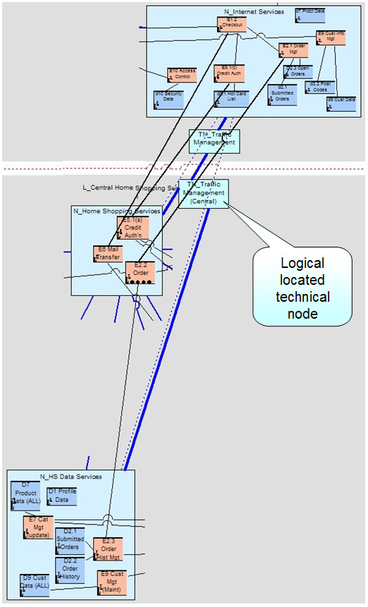
Figure 50: Step 3b – …achieved by technical-level nodes and routed logical connections

Thus:
- Application-level located nodes host some aspect of the target IT system’s application, usually modelled via located DUs
- Technical-level located nodes are located nodes needed to support the operation of the target IT system, but which themselves do not host (application-level) located DUs. They may be needed for any number of systems management purposes, such as network management, security control, or data distribution
And:
- “Point to Point” located connections model the connectivity required between application level nodes to support DU to DU connectors
- “Routing” located connections are “connection segments”, between technical-level nodes (or technical-level nodes and application-level nodes) needed to model the route taken by DU to DU connectors.

Thus, technical level located nodes and routing located connections only appear on technical-level operational model structure views. Or, put otherwise:

- The aspirational point-to-point connections and application level located nodes define the operational requirements to be satisfied by the logical Operational Model’s technical located nodes and routing connections.

Step 3c: Use the (Technical) Node Model
In many cases, the Solution Architect must use their own experience and knowledge to directly determine the suite of software and hardware needed by each located node’s located DUs, together with the identification of the need for data distribution software, and to determine how this technical software will work across the solution’s network, as was begun on Figure 46 and discussed in the two sections above.

However, it is often the case that the infrastructure used by applications such as AmGro’s OMS is (or can be) based on Reference Architectures, or may already be deployed and available as an infrastructure model. In these and other cases, the Solution Architect is therefore able to work with a (reference) Node Model, such as that documented in the earlier section “OMS’s Node Model”, which they can use, to identify the standard logical platforms on which each of their located nodes will be based:

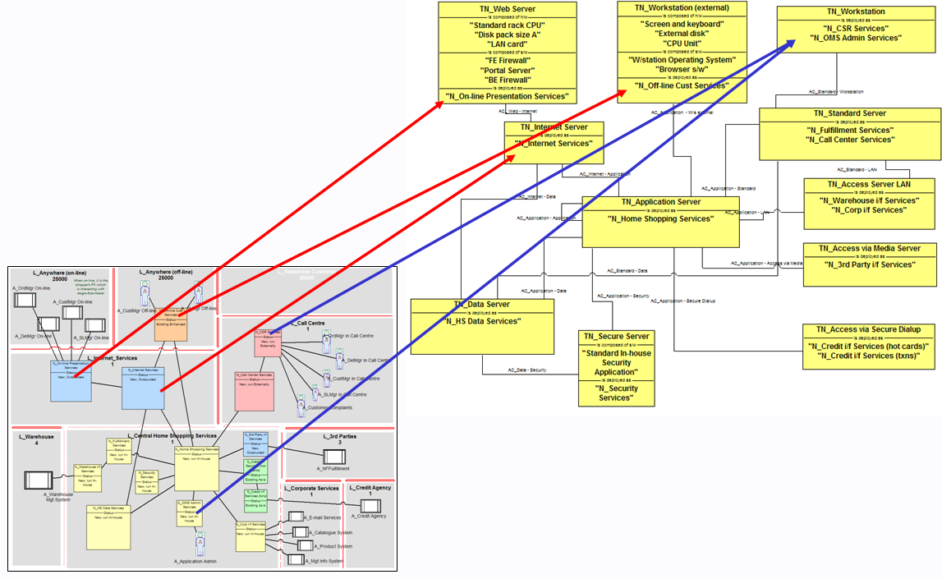
Figure 51: Step 3c - Using the Node Model

So, for example, Figure 51 highlights the technical nodes on which five of the OMS’s located nodes are based. Three of them are “unique” choices from the reference model (red arrows), but two located nodes are based on the same underlying technical node (blue arrows). In every case, the suite of software and hardware from which each technical node is built is documented in the node model.

This use of a (technical) Node Model to underpin a solution’s Operational Model exemplifies how IT departments can guide those creating IT based business solutions for the enterprise into using the same (common) underlying platforms, confident in the compatibility of software and hardware from which their located nodes are made and yet still enabling the projects to define their own specific (application centric) use of these platforms.

Note: Technical-level Technical Node Models
The Node Model example shown in Figure 51 presents a set of technical nodes that can be used to support the DUs placed on application-level located nodes.

Node models also include technical nodes that underpin technical-level located nodes. For example, the two technical located nodes added to the case study in Figure 50 would, in all probability, be based on the same “TN_Network Gateway” technical node (and which should therefore appear in Figure 31, but doesn’t ☹ ).

Note: Process Considerations
The last two sections remain faithful to the forward engineering approach chosen for the case study, in which the OMS’ target IT system’s technical nodes (and their software/hardware parts) are “discovered” based on the located nodes’ operational requirements. This pure approach is, however, unlikely ever to be the case in real life.

It is far more likely that way back in “Step 1c: Place Access Mechanisms and Edge Located Nodes” and “Step 1d: Identify Potential “Inner” Located Nodes” the Solution Architect will immediately base their located nodes either on reference technical nodes, or technical nodes with which the Solution Architect is familiar and comfortable (- this explains why it’s possible to “guess” what nodes might be needed in the first place!). Under these circumstances, what DUs can be deployed where is then constrained by these choices, rather than based purely on first principles.

Reality will, of course, ☺ generally be a mix of the two!

Step 4: Verifying the architecture via Logical Walkthrough Views
(The word “verifying” implies the forward engineering nature of the Case Study. They have other uses, as discussed later!)

The previous steps developed the OMS’s Operational Model through its structure views, determining where everything is to be (or has been) deployed as located model elements working together over node-to-node connections using DU-to-DU connectors.

This is the most reliable approach for the Solution Architect to balance all the forces acting on the operational viewpoint of their solution, achieving its non-functional requirements within the constraints of the real world’s (actual or desired) capabilities.

It can, however, be important to “test” the solution, to see how it behaves when supporting its users; whether it can do what is asked of it and – most critically – how it behaves when something goes wrong such as a network failure or hardware outage or when some part of it is unavailable due to scheduled maintenance.

These tests are performed as “walkthroughs”, in which the Solution Architect models what happens to the various parts of the target IT system as it reacts to an event such as a use case. There are two types of walkthrough – an accurate one, and an approximate one:

- When it is necessary to be absolutely sure of the systems behaviour, then the Solution Architect is likely to accurately walk through the system’s behaviour by modelling at the “located component” (i.e. located DU) level - as discussed in the next section.
- But, as will be seen, this can involve a large amount of effort for each and every use case. It is, therefore, sometimes appropriate to perform a walkthrough in a less formal fashion, approximating the system’s behaviour “node to node” as discussed in section “Step 4b: Walk Through Approximately – Located Node to Located Node”.

Step 4a: Walk Through Accurately – Located DU to Located DU
Operational modelling’s walkthrough views adopt a similar notation to that used for component modelling’s sequence views, in which the located DUs involved in the walkthrough are strung out across the view, and the interactions between them modelled as located DU to DU messages flowing back and forth.

Unlike component modelling, and as shown in Figure 52, it is normal to explicitly portray the “backdrop” of locations and located nodes together with their borders and connections behind the located DUs. This helps the Solution Architect understand the viability of the design: if two interacting located DUs are in locations with no border, then it is probable the design will not work!

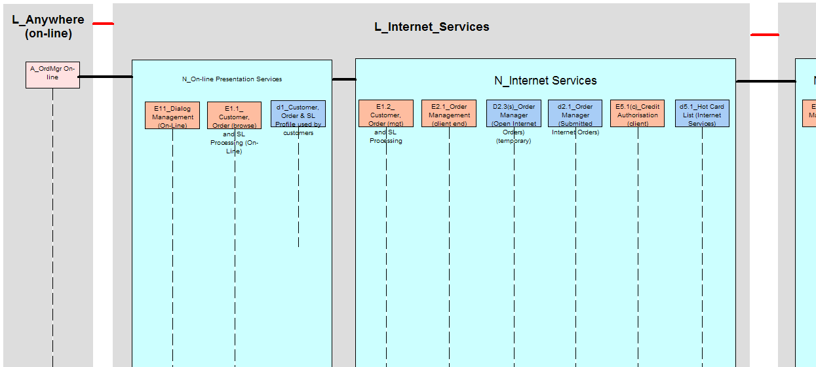
Figure 52: Step 4a - Logical walkthrough view (accurate), backdrop

Messages are then drawn back and forth between the components’ located DUs, as illustrated on Figure 53.

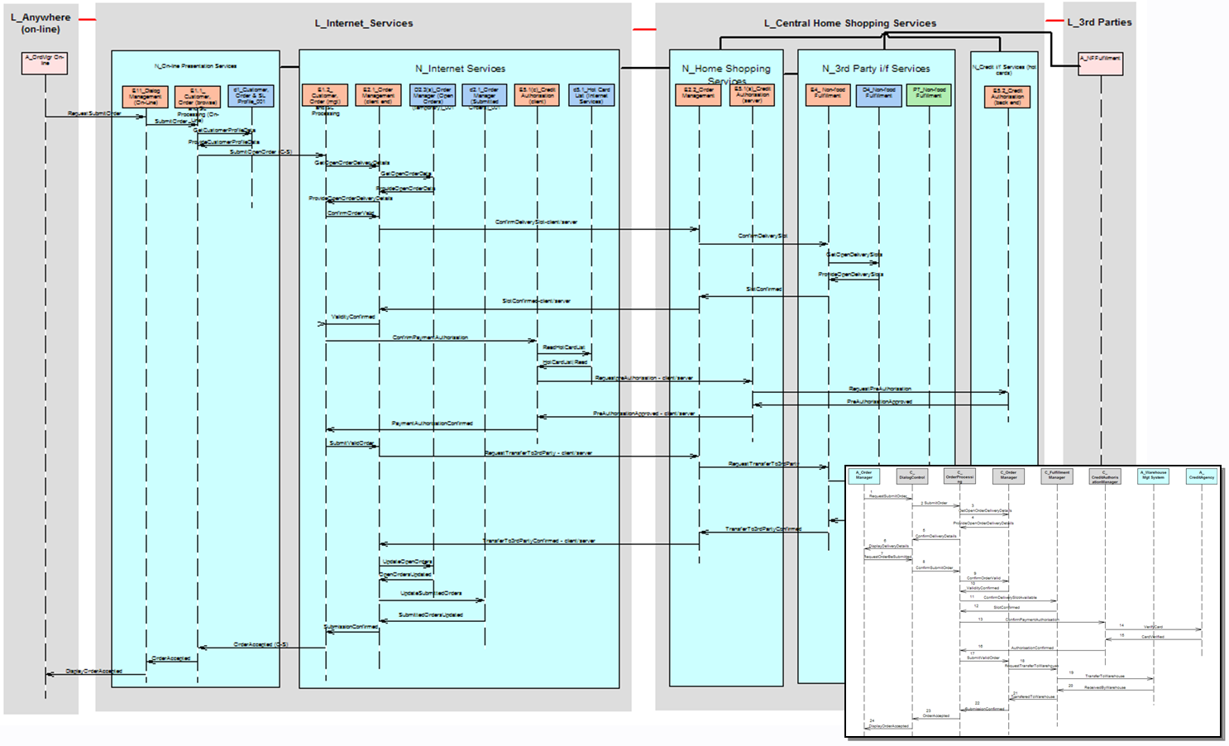
Figure 53: Step 4a - Logical walkthrough view (accurate), interactions

The figure shows (and as highlighted on Figure 54) that these DU to DU messages are directly related to the messages modelled on an equivalent component sequence view:

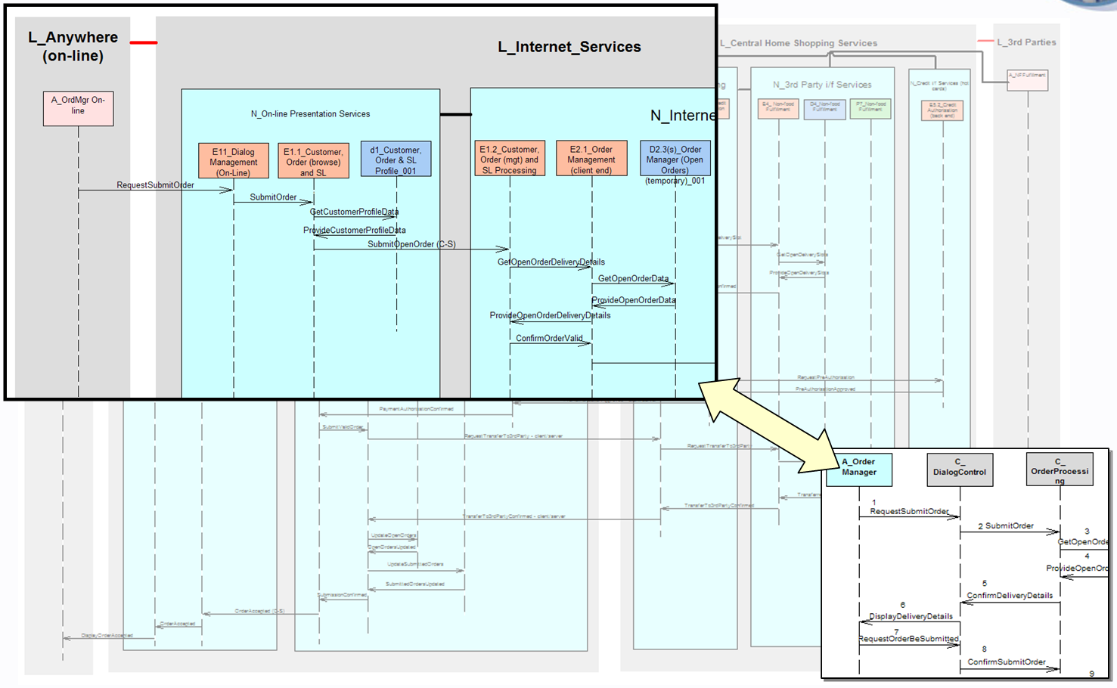
Figure 54: Step 4a – Logical walkthrough view (accurate), comparison with component sequence views

Note: Are walkthroughs logical and physical? Just logical – but…
Throughout this part of the paper, care has been taken to ensure discussion about the various steps and views has avoided direct reference to “logical” and “physical” – although the views have been logical, much of the discussion has been restricted to “located node” and not “logical located node”. This is because it is perfectly reasonable to construct the physical views of the Operational Model in much the same way as the logical views.

This is not the case with accurate walkthrough modelling, which is a purely logical perspective of the target it System.

As with functional messages between components in component modelling, and use cases between (logical) actors and the target IT system, operational messages between located DUs in operational modelling are logical - they describe the payload carried between logical located DUs (or between a located actor and DU) and are directly related to the payloads carried by functional logical messages between logical components (or logical components and actors).

If it were ever thought necessary to model accurate walkthrough views from the physical perspective, it would not only be necessary to model physical messages between physical components, and use cases between physical users and the target system, but it would also be necessary to understand what is meant by “logical message(s) implemented by physical messages”.

This constraint does not apply for walkthrough freeform diagrams, whose approximate nature allows the Solution Architect to model “freeform messages” between either logical or physical located nodes.

Note: Are walkthroughs modelled at the technical or application-level? Both!
The example portrayed in this section (e.g. Figure 53) only shows application-level located nodes (and therefore all hosting located DUs) – it’s taken from the application-level structure view (such as Figure 44). It is equally valid – and often more insightful – for these accurate, DU centred walkthrough views to convey the system’s behaviour at the technical level, and therefore to include (DU-less) technical nodes and routing connections like those shown in Figure 50.

This technical level walkthrough view will still show messages between located DUs, but they will now be seen to be routed over a number of “routing” located connections and technical nodes, giving a more complete view on the requirements being placed on the underlying technical infrastructure. Such precision is usually not required, however, until detailed Deployment Modelling, using information provided from the solution’s Operational Model.

Note: OM and SA4TeamSD
<By the time this paper is published>, an SA4TeamSD utility is available to automatically sequentially number each messages between located DUs, against a time line flowing down the view.

Note: Process
In keeping with the case study’s forward engineering approach, the located DU messages on OM’s walk through views can be directly related to the corresponding components’ messages on equivalent component sequence views. However, it need not be the case that equivalent sequence views exist – indeed, it may be that there is no component model (as may be the case when reverse engineering); in which case it would be possible to deduce much of the component model’s behaviour from this accurate, located DU based operational walkthrough view.

Note: OM and SA4TeamSD
In a similar vein, it is perfectly possible for such accurate walkthrough views to be made when the model does not contain any (or may be missing some) of the corresponding located DU connectors. In these circumstances, <by the time this paper is published> an SA4TeamSD utility is available to create all missing inter-located DU connectors needed to carry any message on a walkthrough diagram for which no connector has been identified.

Step 4b: Walk Through Approximately – Located Node to Located Node
Figure 53 and Figure 54 highlight how accurate walkthrough modelling can involve a significant amount of work, requiring information that is simply not available to the modeller.

It may also be the case, during Step 1: Outlining the Logical Structural View, the modeller wishes to check the overall validity of their located node structure, but does not yet wish to introduce the complexities of located DUs.

In these and other circumstances, the modeller may choose to reason about the Operational Model’s located nodes as active model elements, and to construct walkthrough views as if they described the nodes interacting.

So, although section “Where is everything? The Operational Deployment Viewpoint (Operational Model)” says:
- “a node is only a co-located collection of things that have a collective, connective relationship to other co-located collections of things.”
It also says:
- “But it is of course perfectly reasonable to think of this “co-located collection of things” as a tangible and complete object in it’s own right… in exactly the same way as a bridge or a car are things,”

And therefore in these circumstances node based walk through freeform diagrams can legitimately be thought of as a powerful way of “testing” an outline operational model, abstracting the underlying located components’ DUs out and presuming messages to flow between nodes.

As with the accurate located DU based walkthrough views of section “Step 4a: Walk Through Accurately – Located DU to Located DU”, it is conventional to portray the located nodes taking part in this approximate walkthrough against a “backdrop” of the locations and borders over which they have been deployed, as can be seen in Figure 55. This helps the Solution Architect establish the viability of the design – is the border between two locations capable of supporting the communication requirements between two located nodes?

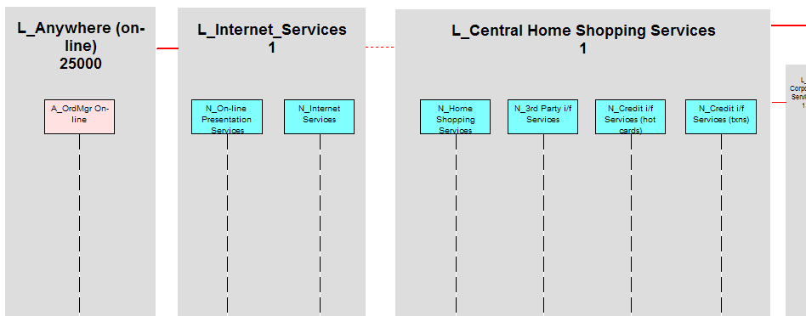
Figure 55: Step 4b - Logical walkthrough freeform diagram (approximate), backdrop

Freeform messages between located nodes are then drawn back and forth between the nodes, as illustrated on Figure 56:

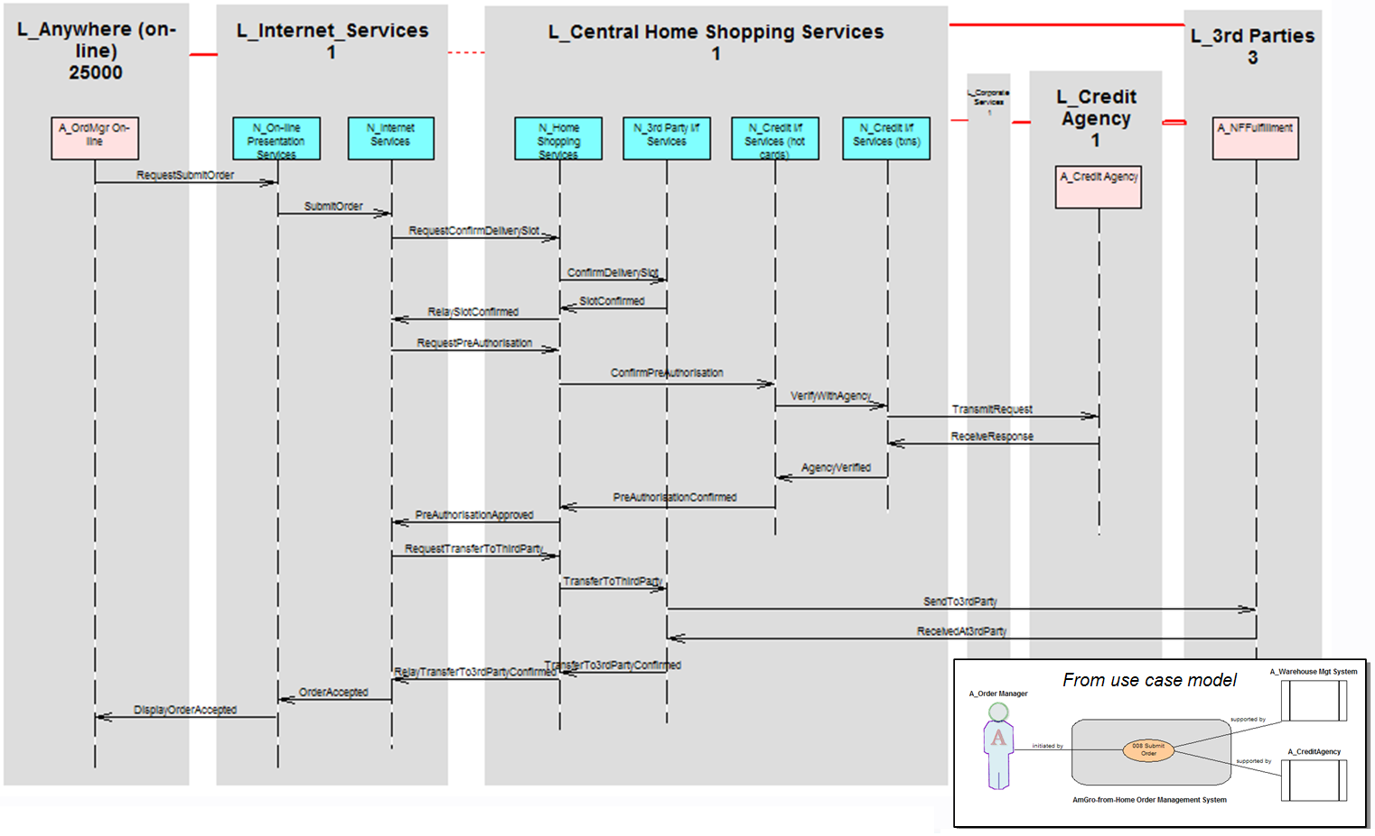
Figure 56: Step 4b - Logical walkthrough freeform diagram (approximate)

These freeform messages have a very indirect relationship to the actual messages flowing across the infrastructure, and therefore the approximate nature of these operational node-to-node walkthrough freeform diagrams makes it very difficult to relate them to any equivalent component sequence view – unless the modeller has contrived to equate the functionality of (the DUs on) a located node directly to that of a component - something argued strongly against in section ““Where is everything? The Operational Deployment Viewpoint (Operational Model)” which argues:

- “[working with] nodes as if they were components (e.g. “database server”) can lead to operational issues such as data distribution or client-server arrangements being overlooked, and subsequently leading to a target IT system which fails to deliver its operational requirements”

None-the less, these approximate walkthrough views, showing how nodes (appear) to co-operate in responding to critical use cases are a powerful means of explaining, in outline terms, how a target IT system will (does) work and can still, very specifically and as shown on Figure 56, be linked to the systems “black box” behaviour described in the Use Case Model.

(Directly Determining the Physical Structure Views)
As discussed earlier, it is “equally valid to directly construct the Operational Deployment Viewpoint’s physical structure views in exactly the same “forward engineering” manner [as its logical structure views]” and therefore the “parallel” series of steps needed to create the physical level of the operational model are not discussed in this paper:

- Outlining the Physical Structural View
- Lay Out Locations and Borders
- Locate Located Users
- Place Access Mechanisms and Edge Located Nodes
- Identify Potential “Inner” Located Nodes
- Completing the Application Level Physical Structure View
- Deploy Located Presentation DUs
- Deploy Located Data DUs
- Deploy Located Execution DUs
- Deploy Located Installation DUs
- Adding the Technical Level Physical Structure View
- Identify Required Technical Software and Hardware
- Use the (Technical) Node Model
- Developing Logical Walkthrough Views
- Walk Through Approximately – Located Node to Located Node

There are, however, some important distinctions and different conventions when modelling logical and physical views of the operational model, the understanding and adoption of which may greatly ease the understanding of how a system looks (physical views) and what it’s intended to do (logical views):

- Physical things tend to do more than logical
The nodes, connections, locations and borders that appear in a logical view are generally best defined as “doing” one thing, whereas in physical views it is almost inevitable that they “do” many things.
While it is generally hard to determine exactly what physical model elements are doing by pure observation of the model’s views (they’re doing lots of things!), it may generally be expected that
  - There are fewer “physical things” than there would be “logical”
  - There are more “inter-relationships” between physical things than logical

- Physical located nodes can “span” locations”
While it is generally unhelpful to model logical located nodes across logical locations, the fact that physical located nodes do span physical locations must be modelled. For example, a device linking a hazardous environment with an office, or a physical access security node’s keypad being in an “unsecure” location.
- “Physical networks”, not “logical connections”
Maybe the most striking difference between an Operational Model’s logical and physical structure view is the manner in which networking is modelled:
  - All the logical sections’ structure and walkthrough views show logical connectivity modelled
    - either via “point to point” logical connections documenting the operational requirements of logical located DUs’ connectors as they transport the solution’s messages from DU to DU.
    - or via “routing” logical connections and (network centric) technical located nodes that define the actual routes taken by these connectors.
  - Physical views model physical connectivity via “any–to-any” physical networks, documenting the “backbone” over which the physical located DUs’ connectors flow.
Note that a “hub-and-spoke” notation is used for “any-to-any” physical networks, making it important to distinguish the “hub” of an “any-to-any” network from an active network hub node. This is explored later.

Step 5: Outlining the Physical Structure View
The differences between the real world’s inherent complexity and our desire to avoid induced complexity has over the years given rise to conventions that prove helpful when mapping (or modelling) between the logical and physical views of a target IT system. None of these are “fundamental truths”; rather they represent what has come to be seen as good practice, when creating new designs, or modifying/enhancing existing designs.
- Logical nodes do not span physical nodes
While it is often vital to recognise a physical node may do more than one thing (i.e. it may be composed of more than one logical node), excessive complexity is introduced if logical nodes are realised across multiple physical nodes – if necessary, re-factor a logical node so that it does not span physical nodes.
- Physical nodes can “span” logical locations, Logical nodes do not
While it may be unusual, it is possible for a physical node to span physical locations, although it is much more common for it to span logical locations (such as an Internet Server being both in a DMZ and an application services location). It is generally unhelpful to model a logical node doing likewise – if necessary, re-factor a logical node so that it does not span logical locations.
- Many physical access mechanisms per physical node
A physical edge node may support multiple access mechanisms, each being used by multiple (physical) users for various reasons and in different ways – a very complex reality as will be seen later for AmGro-from-Home’s OMS. This is why sections “Where is everything? The Operational Deployment Viewpoint (Operational Model)” and “Step 1c: Place Access Mechanisms and Edge Located Nodes” highlight how the behaviour of this inherently complex part of the system is most easily understood if it is described logically by maintaining “one-to-one” relationships between each logical edge node and logical access mechanism, while modelling the users’ different actors as being able to use the same logical access mechanism.
All this dictates that a physical node is modelled as multiple logical nodes, each one supporting one of the logical access mechanisms needed to describe all the ways in which the physical node’s physical access mechanisms are being used:
  - If, for example, a user’s workstation (that’s “in” the system) is being used differently when accessed via voice recognition from the conventional screen/keyboard, then two edge logical nodes, each with one access mechanism would be needed.
  - On the other hand, if a workstation (that’s “outside” the system!) accesses the target IT system in the same way, but using two physical access mechanisms (wired and wireless), then it would be modelled as one edge logical node, with one logical access mechanism, that is being realised by two different physical access mechanisms.
- Logical “point to point” connections may cross many physical “any-to-any” networks (as “routed connections”)
“Point-to-point” connections on an application level logical structure view represent the end-to-end connectivity needed between two located nodes, so that logical located DUs’ connectors can get from DU to DU. This aspirational connectivity is then accomplished by the design’s actual logical connectivity, modelled as routing connections and technical located nodes.
The physical structure view’s “any-to-any” networks therefore realise these routing connections and (network centric) technical located nodes, thereby defining the physical routes taken by physical DU’s connectors across the target IT system.

All of these conventions are exemplified in AmGro-from-Home’s OMS case study

Step 5a: Transform Located Actors to Located Users
The complexities of the real world emerge as the logical structure view’s description of what the target IT system’s users are doing (and how they are doing it) is transformed into the physical view:

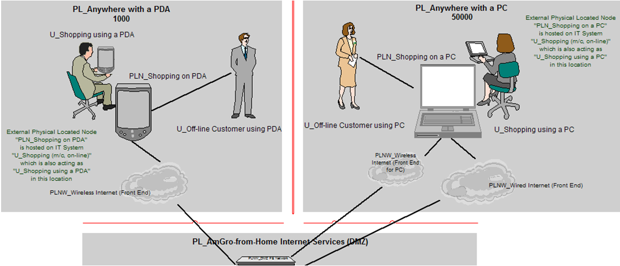
Figure 57: Step 5a - Locating located users in physical locations

Figure 57 documents where the OMS’s “shopping” users will be, and how they will connect to the target IT system from there – compare it with the logical view of Figure 35. It shows how AmGro’s customers can be anywhere with their PDA or PC, in either case “on-line” or “off-line” via an application on the PDA/PC, with Figure 58 emphasising some of the inherent complexity in the target IT system:

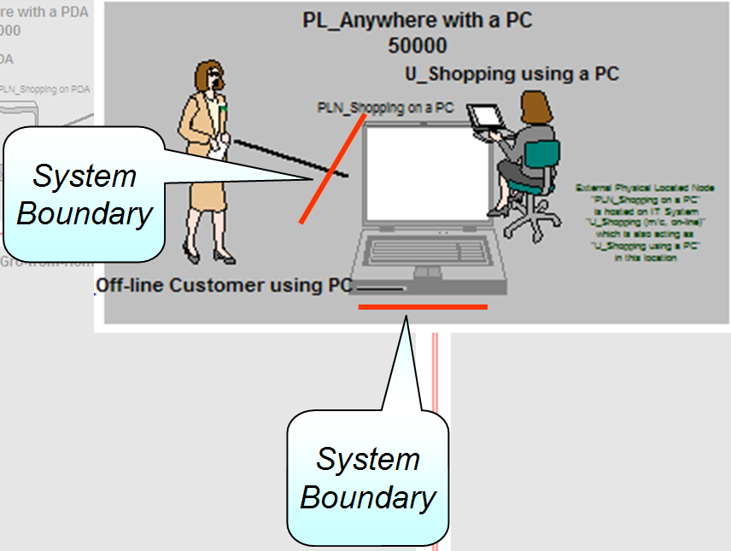
Figure 58: Step 5a - Locating located users in physical locations (detail)

If an AmGro customer chooses to shop:
- “Off-line” using their PC, then the PC is part of the target IT system (modelled as physical located node“PLN_Shopping PC”) and the system’s boundary is between the customer and their PC.
- “On-line” using their PC, then the PC is actually the located user (“U_Shopping Using a PC”) and the system boundary is somewhere beyond the PC

Thus, the shopper’s PC must be modelled as located things twice in the physical model: once as a located user, and once as an “external located node”.

“Duplicate deployment” and the use of external devices for hosting part of the target IT system are common aspects of the real world, hence the distinction between “users” and “located users” – and a particular formal notation for external nodes as shown on Figure 59:

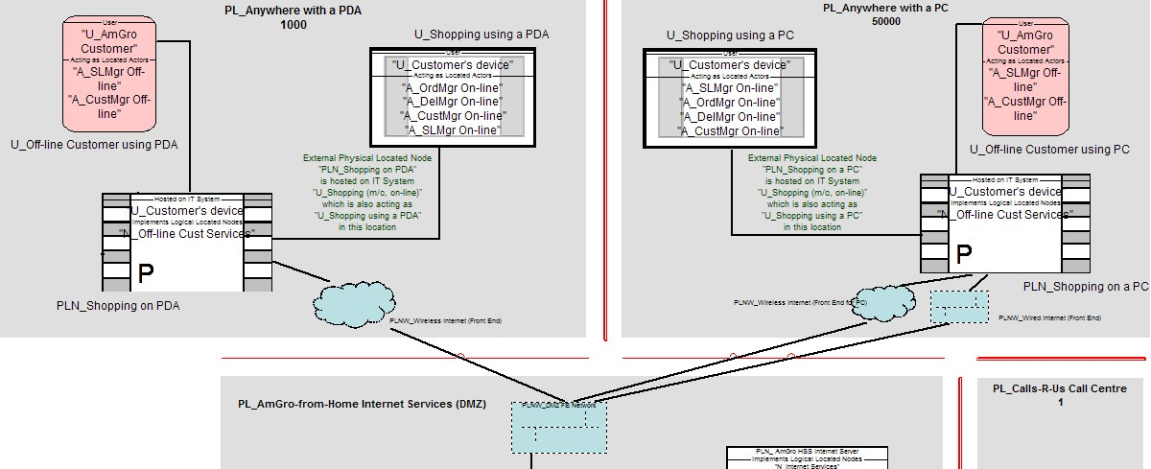
Figure 59: Step 5a - Locating located users in physical locations (formal notation)

This figure documents helps explain a number of things about the physical OMS:

- “U_Shopping using a PDA” and “U_Shopping using a PC” are located users,
  - Of the same (IT system) user – “U_Customer’s device”
  - able to act as four of the five OMS actors
- “PLN_Shopping on PDA” and “PLN_shopping on a PC” are external physical located nodes
  - implementing the same logical located node “N_Off-line Cust Services”
  - running on the same (IT system) user “U_Customer’s device”
- “U_Off-line Customer using PDA” and “U_off-line Customer using PC” are located users,
  - Of the same (Human) user, “U_AmGro Customer”
  - Able to act as two of the five OMS actors

The OMS case study has another “classic” example of an external physical node hosting part of the solution (as may be seen in Ref [9]) - the use of “PLN_Credit Agency Gateway RS/6000”, provided by the credit reference agency (PDQ Services), located in AmGro’s data centre as a secure gateway to credit reference services, and running two logical located nodes - one for real-time credit reference transactions, and one for the nightly download of the hot-card list.

These figures also include partial views of the solution’s physical networks (as far as Operational Modelling addresses network design, which is addressed in section “Step 5d: Realise and Rationalise Physical Networks”.

Step 5b: Identify Technologies (Realisation Options)
The technologies of the external physical located nodes discussed above are “given” – mandated either by a service supplier (such as PDQ services) or automatically defined “just because” they are the target IT system’s external users (as are AmGro’s customers’ own devices).

In the same manner, the technologies used for each of the system’s internal logical located nodes, DUs and connections may also be “given”, maybe because the infrastructure on which the solution is to be deployed is already in place, or because the suite of technologies are IBM’s products. Otherwise, simple techniques such as that described in “Appendix A: Techniques of Product Selection” (and in much greater detail in Ref [11]) can be used to determine the “catalogue of physical parts” from which the solution will be built, which the Solution Architect will then use to transform the system’s logical specification into an outline physical design, as exemplified for AmGro in “Step 5c: Realise and Rationalise Physical Located Nodes”.

However, and as is the case for AmGro-from-Home’s OMS, the underlying technical physical nodes are to be based on standard platforms defined in AmGro’s Enterprise Architecture as Node Realisation Options. NROs are discussed in section “OMS’s Node Model”, as part of the node model, and their use in the Operational Model exemplified in Figure 60:
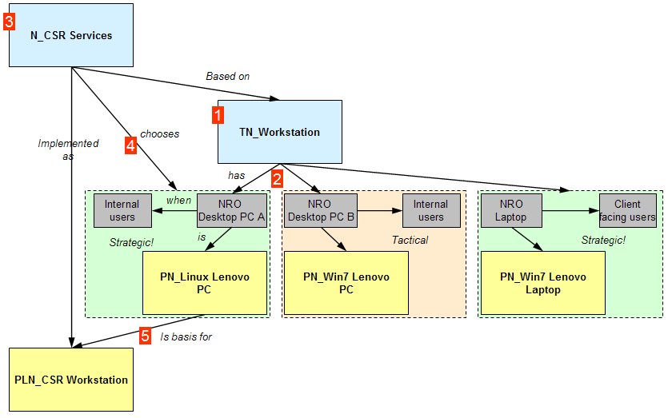
Figure 60: Step 5b - Using Node Realisation Options

- One of technical logical nodes in the Node Model of AmGro-from-Home’s OMS is “TN_Workstation”.
- This logical node is part of AmGro’s EA, and has therefore been pre-defined by an Enterprise Architect to have a number of Node Realisation Options:
- “NRO_Desktop PC A”, referencing physical node “PN_Linux Lenovo PC” as being a strategic choice for internal users
- “NRO_Desktop PC B”, referencing physical node “PN_Win7 Lenovo PC” as a tactical choice for internal users
- “NRO_Laptop”, referencing physical node “PN_Win7 Lenovo Laptop” as a strategic choice for any AmGro user who works directly with AmGro’s suppliers and other external agencies
- One of the logical located nodes in the OMS Operational Model is “N_CSR Services”. This hosts a range of logical located DUs associated with the work of CSRs and is built on technical node “TN_Workstation”.
- Because the OMS solution is strategic to AmGro, and the physical located node’s users are purely internal to AmGro, “NRO_Desktop A” is indicated
- Therefore the Solution Architect selects “PN_Linux_Lenovo PC” to be the basis of the physical located node “PLN_CSR Workstation”

(Alternatively, the Solution Architect may have decided that the circumstances dictated an alternative NRO (maybe driven by application package constraints), or even selected a technology directly, not based on any EA provided option.)

Note: OM and SA4TeamSD
For Operational Modelling, SA4TeamSD offers the control afforded by Realisation Options for Logical/Physical Nodes, DUs, and Actors/Users (human and IT). In each case, the Realisation Option offers a range of qualified choices for a “functional” (ie non-located) logical model element, from which the Solution Architect can select an implementation for each of the target IT System’s logical located model elements based on it.

Step 5c: Realise and Rationalise Physical Located Nodes
In the case of AmGro-from-Home, the Solution Architect was offered, and chose to use, Node Realisation Options for all of the solution’s logical located nodes, as shown in Table 8:
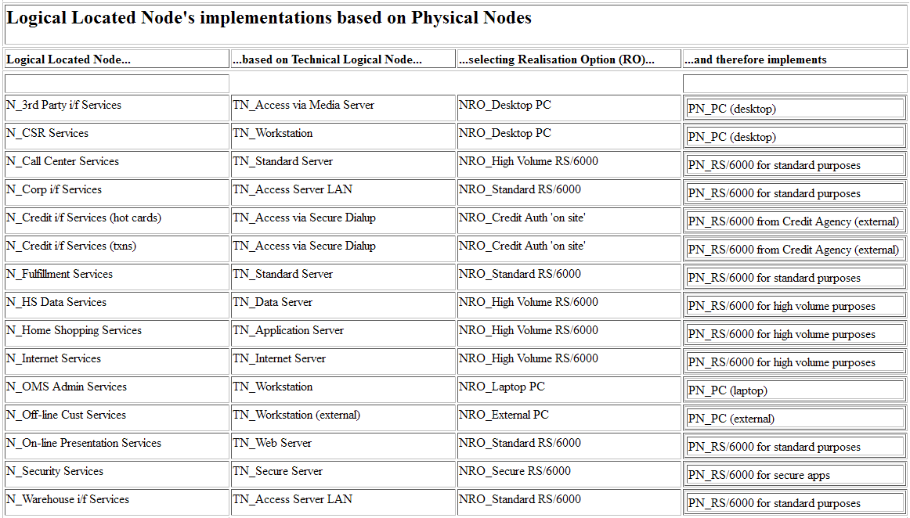
Table 8: Step 5b: Identifying Physical Node for each Logical Located Node

The table highlights how, by managing the range of NROs available for different (technical) logical nodes and the permitted implementations for these NROs, an organisation can effectively manage (i.e. minimise) the range of different “standard IBM platforms” used in its solutions – different logical located nodes, even those based on different technical logical nodes, being implemented by the same standard physical node, such as:

- Although logical located nodes “N_Call Center Services” and “N_Corp i/f Services” need different underlying technical logical nodes, they will be implemented on physical located nodes based on “PN_RS/6000 for standard purposes”.
- Similarly, logical located nodes “N_Warehouse i/f Services” and “N_Fulfillment Services” need different underlying technical logical nodes, but will also be implemented on physical located nodes based on “PN_RS/6000 for standard purposes”.
However, there still needs to be flexibility, such as:
- While logical located nodes “N_Call Center Services” and “N_Fulfillment Services” are using the same underlying technical node, the selection of different realisation options mean they will be implemented on physical located nodes based on different technical physical nodes.
These selections then underpin the flexibility and economy afforded to the Solution Architect as they determine the target IT system’s physical structure view by, for example, being able to implement two or more logical located nodes on one physical located node because they’re based on the same underling technical physical node.

For example, and using the choices listed in Table 8, the Solution Architect developed the outline physical structure view for AmGro-from-Home’s OMS shown on Figure 61:

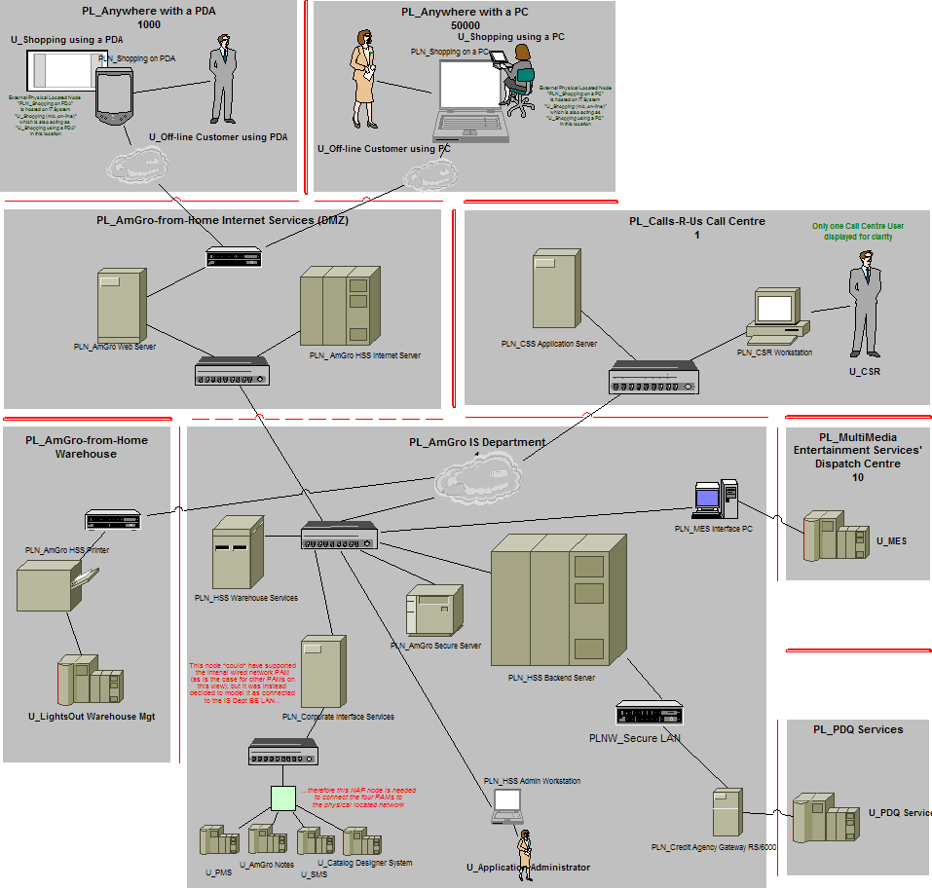
Figure 61: Step 5c - “pictorial view” of the OM’s outline physical structure view

Comparing this with the outline logical structure view (Figure 38) shows how the Solution Architect decided to merge three pairs of logical located nodes:
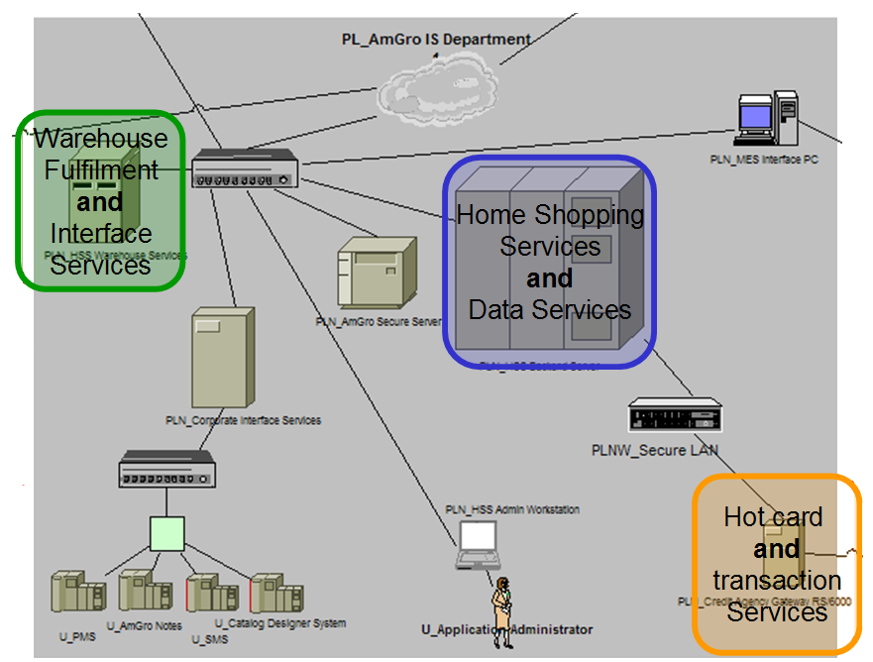
Figure 62: Step 5c – merging logical located nodes onto physical located nodes

- Logical located nodes “N_Home Shopping Services” and “N_HS Data Services” will be implemented together (on “PLN_HSS Backend Server”)
- Logical located nodes “N_Fulfillment Services” and “N_Warehouse i/f Services” will be implemented together (on “PLN_HSS Warehouse Services”)
- Logical located nodes “N_Credit i/f Services (hot cards)” and “N_Credit i/f Services (txns)” will be implemented together (on “PLN_Credit Agency Gateway”)

Note: Wasn’t this all completely obvious?
It may be said that these three decisions “were obvious” from the start and why was it, therefore, necessary to model separate logical located nodes in the first place? Because the non-functional characteristics of a data centric logical located node will be very different from those of an application centric one – it’s easier, even knowing that the data and application will end up on the same physical node, to size the physical located node based on two sets of NFCs.

Step 5d: Realise and Rationalise Physical Networks
Figure 63 highlights some of the “any-to-any” physical located networks needed to implement the logical Operational Model’s “routing” logical located connections like those shown on Figure 50:

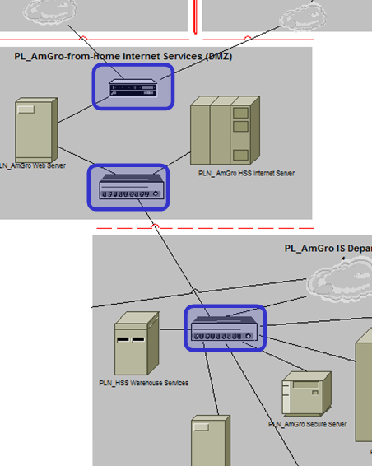
Figure 63: Step 5d – identifying physical located networks

As is the case with the internal design of nodes, Operational Modelling does not address detailed network design – it only provides a high level statement of connectivity requirements (maybe as little as indicative suggestions) on how the target IT system’s physical located nodes will be connect together.

Additionally, if the Operational model is sized (section “Step 6: Sizing the Physical Operational Model”), then it will be able to provide a specification of the networks’ required transmission times and bandwidth, availability and security characteristics, and so on.

Note: are these “any-to-any” networks, or active “hubs”?
The Operational Model’s “any-to-any” physical located networks are drawn with the network connected directly to each and every device on the network, whether the network is wired, wireless, local or wide area network etc. There is, therefore, inevitably the danger that the notation suggests the network has a “hub-and-spoke” topology, when no such implication is intended – it must be remembered that “any to any” connectivity is accomplished however the network technology decrees, such as “peer to peer”, “store and forward” or “hub and spoke”. In OM, all are drawn the same way.

Note: OM and SA4TeamSD
In order to minimise any confusion caused by the necessarily “hub-and-spoke” notation, physical networks (located or not) are modelled via individual “point-to-point” physical connections linking a “network” model element to all physical nodes in that network. Specifically, a network model element is not a physical node: it is purely a means of identifying and describing the network to which each physical node is connected. “Active hubs” or other network types for which the modeller needs to document network functionality is modelled as networking-centric technical physical nodes.

Step 6: Sizing the Physical Operational Model
It is only possible to “size” a physical view of a target IT system when the technologies from which it will be built have been selected – quoting from section “Step 1d: Identify Potential “Inner” Located Nodes”:

- “It only makes sense to judge ‘how many’ when decisions are taken on the technologies used for these logical nodes’ implementation – it may be, for example, that the operational characteristics of one technology may satisfy the solution’s needs with ‘one per location’, whereas another choice may require two devices to be used.”

Bear in mind that, in this context, “size” should not be limited to “how big” or “performance”. Designing mechanisms to achieve required levels of availability and security are also dependant on technology choice, and can therefore only be established at this point.

In the case of AmGro-from-Home’s OMS and as summarised on Figure 64, each and every one of the target IT- system’s physical located nodes are based on standard (technical) physical nodes, made up of standard hardware, systems software and middleware technologies. Similarly, it is anticipated that the subsequent detailed network design will capitalise on standard network devices.

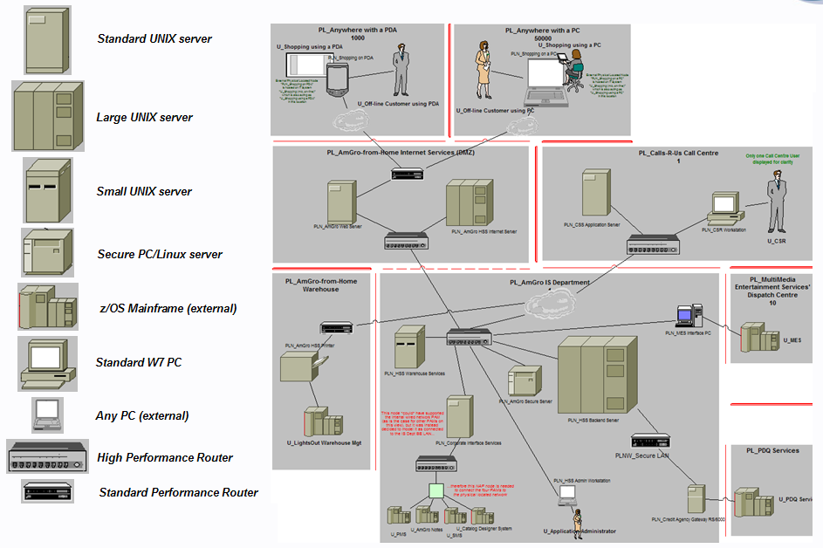
Figure 64: (Summarising technical physical nodes underpinning physical located nodes)

It will eventually be necessary to fully configure each of these physical located nodes - for example determining the required CPU, how much memory and storage is required, and how many i/o ports are needed. Then, if the chosen technology is still not able to achieve the required non functional characteristics, it will be necessary to decide how many physical located nodes may be required in order to achieve the required throughput; or how to arrange several in order to ensure the right levels of availability, and so on.

Much of this detailed design work requires specialised skills, relying on techniques such as those available in UMF for Deployment Modelling, Performance Engineering, Designing for Availability, and Data Distribution & Management. In all cases, this specialised technology centric work is facilitated by operational information available from the Operational Model as will be discussed in section “Step 6b: Size Physical Located Nodes & Networks” – in general it is outside the scope of Operational Modelling.

But such detailed work is often not possible or the necessary information is not available, yet it is necessary to establish some level of confidence that “it will work” or “it will cost this much”. In these, cases it is necessary for the Solution Architect to estimate the configuration needed to support the application, and to determine where the target IT system’s design will need careful consideration – its “Hot Spots”.

Step 6a: Identify Sizing “Hot Spots”
How does the Solution Architect know what their solution needs to do at these hot spots are? Because the development of the solution’s Operational Model has required them to:

- Understand the operational implications of the solution’s non functional requirements
- Map these requirements into the operational non functional characteristics of the application’s DUs
- Track and refine these non functional characteristics as the DUs are deployed (as located DUs) onto located nodes
- Determine how these non functional characteristics “roll up” into the non functional characteristics of the located nodes,
- Decide how these operational requirements drive the identification of the underlying technical components (technical nodes, hardware software etc.)

Then, and assuming the Solution Architect has got to #5 in this structured way, they should have a pretty good idea of where their challenges will lie!

It is usually helpful to approach this step from each specific type of non-functional requirement (characteristic) in turn: such as, for AmGro-from-Home’s OMS, Performance (Figure 65), Availability (Figure 66), and Security (Figure 67):
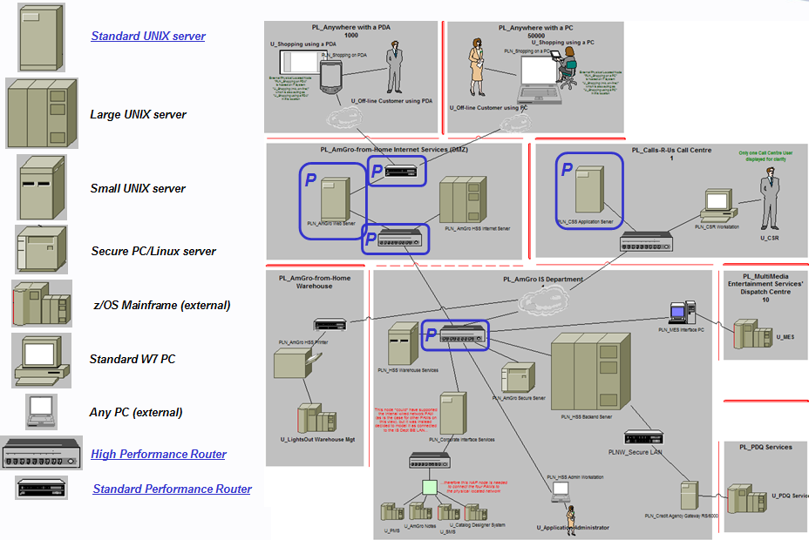
Figure 65: Step 6a – identifying Performance Hot-spots
Overall, the solution’s choice of technologies appears to be capable of supporting the application’s performance requirements, except maybe for the loading on the “PLN_AmGro Web Server” (supporting on-line shopping as well as the downloading of the off-line application) and its associated networks, and the Call Centre’s “PLN_CSS Application Server”. In both cases, it may be necessary to deploy multiple servers.

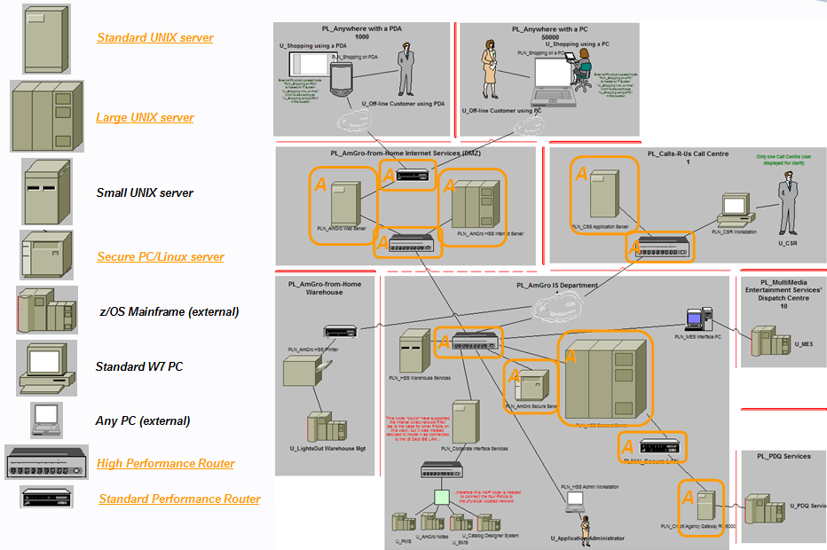
Figure 66: Step 6a – identifying Availability hot-spots

Figure 66 shows the solution’s greatest focus will probably be on availability: as it stands, in order for shoppers to shop it will be necessary to have “end-to-end” availability of all the critical physical located nodes and their associated networks. Detailed Deployment Modelling and availability engineering will indicate whether “stand by” or “stand in” mechanisms will achieve the required levels of availability.

The solution appears to be able to meet the application’s security requirements, except for a few concerns shown on Figure 67 - in “PL_AmGro-from-Home Internet Services (DMZ”), where there is a need for the Operational Model to incorporate firewalls and intrusion detection technical nodes; and the interfaces to AmGro’s partners “U_PDQ Services” and “U_MES”.
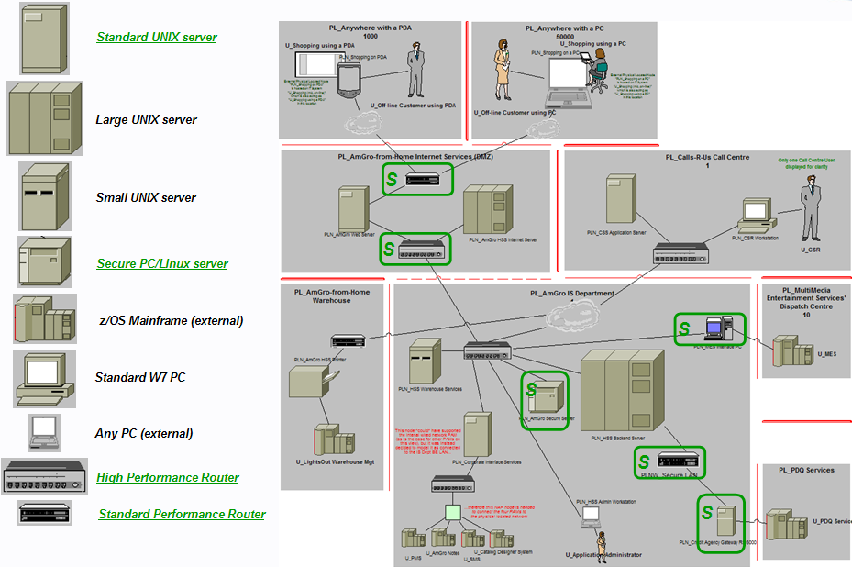
Figure 67: Step 6a – identifying Security hot-spots

These three examples show how “hot spots” in the chosen technology’s capabilities can lead to further operational modelling being required, in which the challenges faced at the infrastructure technology level may result in feedback “up” to the “earlier” levels, such as design changes being needed at the:

- Physical application level
Whether it be a re-factoring of the application’s parts across the system’s nodes, or maybe even requiring a different choice of package or development environment
- Logical application design level
Such as alternative decisions on data placement or adjustments to the target IT system’s boundary
- Logical technical level
Such as changes in the way data is distributed, or approaches to security authentication/authorisation.

They also highlight where detailed and specialised deployment modelling will be required, such as:
- Performance engineering and tuning generally requires specialised detailed deployment modelling skills, since it is predominantly tackled at the physical level.
- Designing for availability generally requires a blend of further Operational Modelling and specialist availability engineering, since it is tackled at both the logical level (using “stand in” techniques) and physical level (“stand by” techniques).
- Security concerns are usually tackled via further Operational Modelling, since it is tackled largely at the logical level, with the identification and inclusion of technical nodes intended to provide firewall, intrusion detection and logging services.

Step 6b: Size Physical Located Nodes & Networks
An Operational Model provides the data necessary to sizing and configure the solution’s physical located nodes through an understanding of how

- The logical workload applied to the system is seen in:
- The logical located DU’s operational characteristics, as they are “rolled up” into performance loadings and other operational requirements on each logical located node
- The accurate logical walk through views, as they define the messages and other payloads carried by the located DU connectors across the located node connections.
- This “logical loading” is mapped to the solution’s physical loadings by understanding the mapping between logical and physical located nodes including, as necessary mappings between logical and physical located DUs and logical connections to physical networks.
- Calculating the size and configuration of the technologies selected for the technical nodes that underlie each physical located node.

Appendices

Appendix A: Techniques of Product Selection
Ref [10] provides extensive guidance on determining the technologies needed to realise a logical operational model, including a technique that may facilitate product selection in complex systems, put simply:

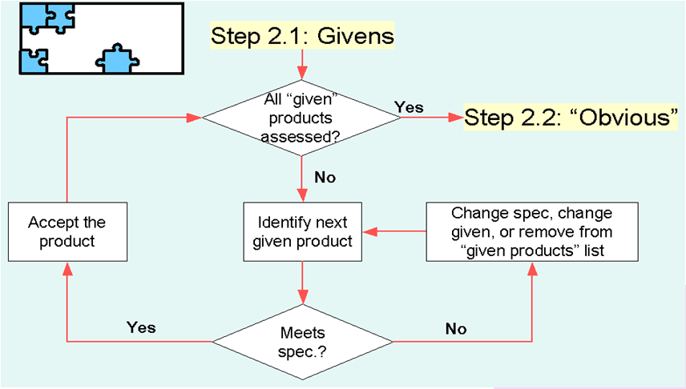

- Identify the “Givens”
  - In a client engagement
    - Usually defined in the client’s IT standards, existing Technical
Architectures or current IT environment. In all cases, from
the beginning you will have ensured the logical view of the
operational model are capable of being implemented in these
technologies
  - In an IBM proposal
    - IBM product, if they meet the requirements!
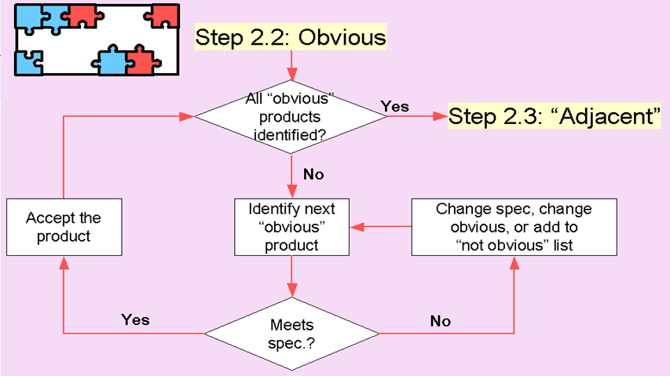

- Spot the “Obvious” products
  - “Easy to choose”, such as:
    - “Only one product/vendor meets the specs."
    - “We all know this will be product/vendor ABC"
    - “We could do a full vendor evaluation study, but it is more efficient
to choose this product/vendor now"
  - Reference Architectures, in which there is an operational model defined
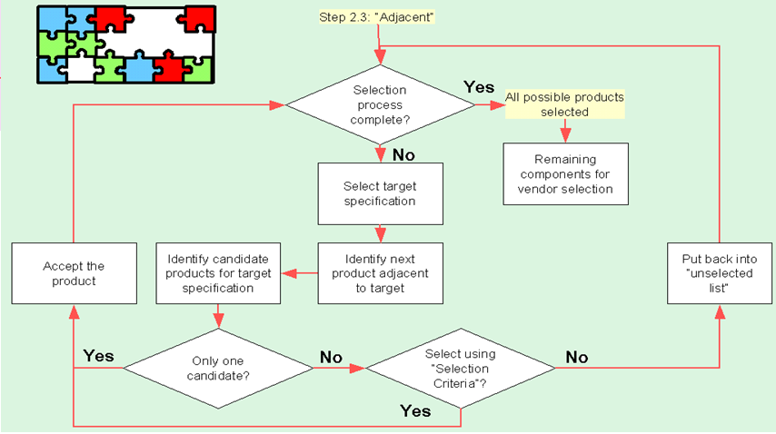

- Look at the “Adjacent” components
  - The ones that are the most difficult to choose

And finally:

- What is a product, anyway?
  - Is it a defined, “off the shelf” product that you can buy? YES!
  - Is it a “family” of products, for which a vendor is still to be selected? YES!
  - It is to be more deeply specified for development in the next stage of the project? YES!

Appendix B: Views and Viewpoints
Much of this paper relies on the underlying principles of models, viewpoints and views. Put simply this can be summarised as:

- "a representation (view) of something (model) looked at for a reason (viewpoint)".

Or, more completely:

- The model
Everything that describes the system at any stage in its development
- A viewpoint onto the model
Description of a way of looking at the underlying model, including standard formats for presenting the model from the viewpoint
- A view of the model
What is seen from a viewpoint, whether diagrammatic, textual or tabular

Originally the basis of an IEEE standard (1471), this is now addressed by the ISO/IEC/IEEE standard 42010 (Ref [4]), and is the foundation of UMF’s approach to modelling as discussed in Ref [3]. This paper uses these notions extensively, endeavouring to be consistent in using the words:

- Model whenever referring to a collection of descriptions and relationships that are a proxy for the real world thing's structure of parts and their behaviours. IEEE1471 calls this the “Architecture Description”
- Viewpoint whenever referring to a point-of-view from which the model is being looked at – in other words, what a observer is interested in when they look at the model
- View for anything such as a "diagram", "view”, "sketch", "table", "matrix", "list", and even "picture" and "narrative" whenever referring to what an observer draws/writes/reads as a representation of some part of the model from a viewpoint.

Basic and Cross-cutting Viewpoints
Ref [3] enhances these ideas by identifying two underlying types of viewpoint:

- A viewpoint that’s interested in looking at a particular (sub)set of model element types, such as actors, components, connectors, interactions, messages and so on - a basic viewpoint
- A viewpoint that’s interested in considering some theme across all of the model’s elements, such as all those parts associated with the application, or security, or systems management - a cross-cutting viewpoint

Ref [3] goes on to define a standard set of basic viewpoints, intended to address the four board areas of concern an IT Architect has when designing a target IT system:

- Requirements viewpoint: what the target IT system is required to do, together with all constraints under which it must be built and operate.
- Functional viewpoint: all concerns associated with the functional structure and behaviour of the target IT system.
- Operational Viewpoint: everything related to the deployment and operation of the target IT system.
- Validation Viewpoint: everything relating to the validation (does it do what it is required to do?) and viability (will it work?) of the target IT system’s design.

The relationship between these four standard basic viewpoints and a representative number of cross-cutting viewpoints is illustrated in Figure 68

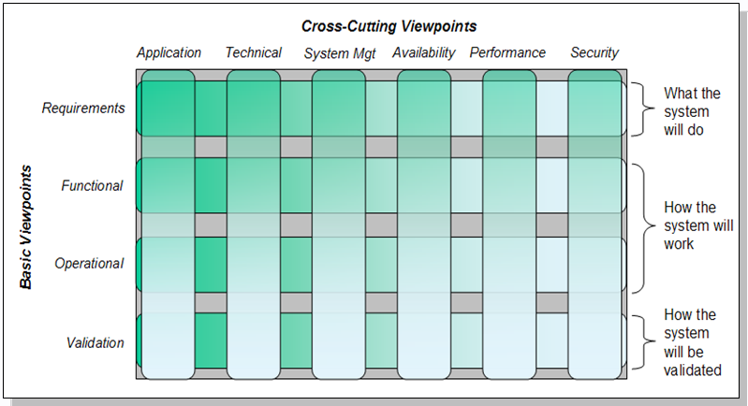
Figure 68: Standard basic and representative cross-cutting viewpoints

Each of these viewpoints can then be used as a means of “defining” various sets of views, which, in the case of basic viewpoints, are defined to be UMF’s artifacts as shown in Figure 69:

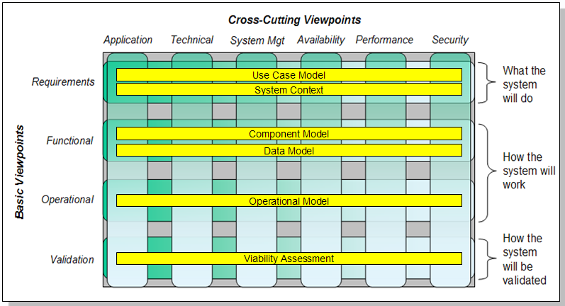
Figure 69: Basic viewpoints represented in UMF's artifacts

These “basic” artifacts can then be filtered according to a stakeholder’s cross cutting viewpoint, such as that for a performance engineer:

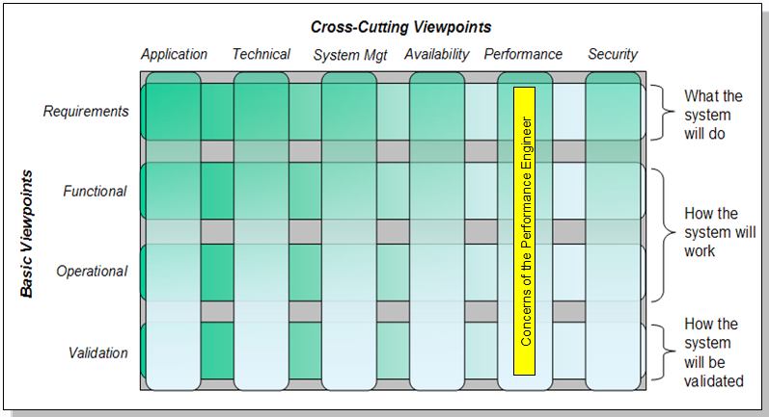
Figure 70: Example cross cutting viewpoint

In some cases, these cross-cutting viewpoints will include specific artifacts, supplementing the (filtered) artefacts from the basic viewpoints – for example, a performance engineer will be interested in a Technical Transaction Map and Performance Model to complement the performance aspects of their Component Model and Operational Model.

Thus, this distinction between basic and cross-cutting viewpoints gives the modeller a powerful means of focusing on specific concerns within the very broad spectrum of the target IT system’s design, addressing questions such as those on Figure 71 :

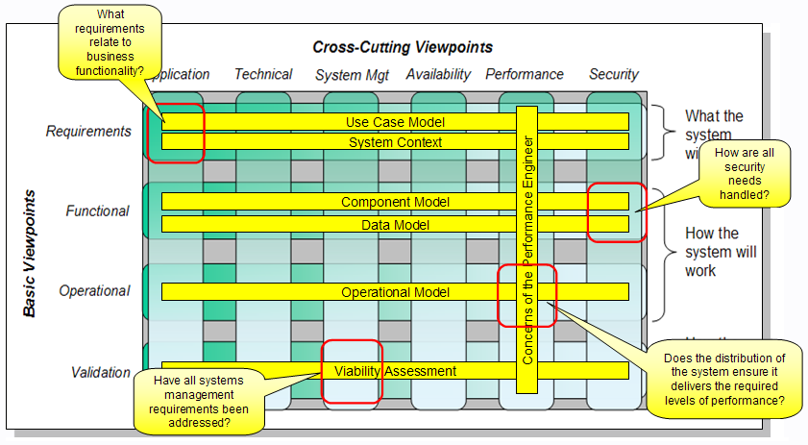
Figure 71: Using Viewpoints to “frame” specific solution architecture concerns

Viewpoints and Operational Modelling
This paper relates to the needs of a stakeholder reasoning about the target IT system from the operational viewpoint, with whatever cross-cutting viewpoint(s) they choose – the paper’s content is therefore limited to those parts of the target IT system’s model that are associated with the operational viewpoint.

This “operationally filtered” model is substantial, addressing a very wide range of topics and including a huge range of model element types and views. In order, therefore, to make it approachable, advantage is taken of a variety of (secondary) viewpoints onto this “operational model”. In other words, exploiting:

- A viewpoint onto a model can be satisfied by a smaller model, exactly big enough to support the needs of the viewpoint. This smaller model can then be observed from other (secondary) viewpoints.

This viewpoint/model content relationship is recursive – the model associated with the secondary viewpoint can then be looked at from (tertiary) viewpoints and so on. Thus, in the case of operational modelling:

- The Operational Model contains just enough of the target IT system’s model to satisfy the basic Operational Viewpoint.
- The Location Model contains just enough of the Operational Model to satisfy the Location Viewpoint.

Hence, in section “Formal OM – Operational Modeling’s Viewpoints & Views” the complexity of operational modelling is broken down into five manageable “chunks” or secondary viewpoints:

- Operational System Context Viewpoint, concerning the external agents that need to use the target IT system
- Component Deployment Viewpoint, concerning the things that need to be deployed
- Geographic Viewpoint, concerning the locations where things can be deployed
- Node Viewpoint, concerning the platforms and connections onto and across which things can be deployed
- Operational Deployment Viewpoint, concerning where all the target IT system’s parts will (or have been) deployed, together with the location of and access mechanisms used by the IT system’s external agents

The views from each of these secondary viewpoints are recorded in specific UMF artifacts:

Viewpoint | Artifact of views
Operational System Context | System Context (operational views)
Component Deployment | Deployment Unit Model
Geographic | Location Model
Node | Node Model
Operational Deployment | Operational Model
Table 9: Artifacts documenting views from viewpoints

Stakeholders can work with each of these basic viewpoints from a variety of cross-cutting viewpoints, such as those exemplified on Figure 68. Several particular cross-cutting viewpoints are discussed in detail throughout in this paper:

- Application and Technical level viewpoints, such as in sections “Any Level - Application, or Technical, or Both?” and “The Dimensions of Architecture Thinking”
- Logical and Physical viewpoints, such as those of the Operational Deployment Viewpoint in sections “Step 1: Outlining the Logical Structural View” and “Step 5: Outlining the Physical Structure View” and more generally in section “The Dimensions of Architecture Thinking”
- Located and non-located viewpoints of the Operational Viewpoint, generally throughout the paper, but specifically in section “Anywhere - Located, or Not?”

Many other topics are cross-cutting, such as the discussion on modelling a system in its current and future states in section “Any Time - “As Is” or “To Be”?”

References

- “SDS Operational Viewpoint Symbol Notation Guidance Paper V3” and
“SDS Operational Viewpoint Views Notation Guidance Paper V3”;
Ian Charters (2012)
Reference to be added by Tom Seevers
- “System Description Standard R3: Semantic Specification”; Philippe Spaas (2008)
https://w3.tap.ibm.com/w3ki/display/SDSR3/SDS+R3+Semantic+Specification
- “An Introduction to the IBM Views and Viewpoints Framework for IT Systems”; Denise Cook, Peter Cripps, Philippe Spaas (2008)
http://www.ibm.com/developerworks/rational/library/08/0108_cooks-cripps-spaas/
- “Systems and software engineering — Architecture description ISO/IEC/IEEE 42010”
http://www.iso-architecture.org/ieee-1471/index.html
- “Team Solution Design White Paper: ‘Component Modelling’” To be written
- “Team Solution Design White Paper: ‘System Context Modelling”; Ian Charters (2009)
http://gcd.ibm.com/RMCPlugins/TeamSolutionDesign/index.htm#core.tech.common.extend-ibm_int/guidances/whitepapers/system_context_modeling_8F09CE95.html
- “Architectural Thinking Class, AmGro-from-Home Case Study”; Ian Charters (2012)
- This is available to alumni of the class. An awareness level case-study, much of the material is presented by AT2 instructors.
- “TLU College 2, AmGro-from-Home Case Study”; Ian Charters (2011)
- This is available to alumni of the class. A technique level case study, much of the work is done by students.
- “AmGro-from-Home OMS sample encyclopaedia for SA4TeamSD”; Ian Charters (2012)
- Available to users of the SA4TeamSD configuration of Rational System Architect. For access, contact your Business Unit’s Deployment Contact, via
http://w3-03.ibm.com/support/tsdesign/tooling.html
- “Developing the Logical Operational Model (UMF Guideline)”; Ian Charters (2007)
http://b01aciwas31c.pok.ibm.com/rmchtml_ad_20/index.htm#core.tech.common.extend_supp-ibm/guidances/guidelines/dev_logical_operational_model_8F861D3.html
- “Developing the Physical Operational Model (UMF Guideline)”; Ian Charters (2007)
http://b01aciwas31c.pok.ibm.com/rmchtml_ad_20/index.htm#core.tech.common.extend_supp-ibm/guidances/guidelines/dev_physical_operational_model_B736E60.html
- Contains some “old” language, but is basically sound, particularly its discussion on product selection, and merging/splitting nodes (which it should call located nodes).

See “Appendix B: Views and Viewpoints”, as well as References [3] and [4] for a discussion on models, viewpoints and views
Elsewhere referred to as the Solution Architect or maybe Programme Architect, and may be an individual or a team.
Throughout this paper, a “diagram” means a free format sketch with no explicit notation – diagrams may have “custom and practice” notations (such as the symbol for a disk), but generally require extensive textual or verbal support to avoid ambiguity and confusion.
UMF does not distinguish the description of an artifact (the viewpoint) from the artifact on a project (the view). In this paper, any artifact name that includes its UMF reference is the artifact description.
“External agent” is an informal term, embracing both logical “actors” and physical “users”, either of which can be human or an IT system.
Formally called borders, as discussed later
Formally called nodes, as is discussed later
Cross-cutting and basic viewpoints are discussed in “Appendix B: Views and Viewpoints” and [Ref 3]
This is why most of this paper makes no reference to operational model being “as is” or “to be”, nor to scope or completeness; although you will find comments and considerations about using “application v technical” views and whether “location” is important, or not.
“Some” should really be “few”! Please do contact the author if you have other well established situations highlighting how these dimensions inter-relate!
Not the name of a UMF work product!
This is an excellent example of how some UMF artefacts do not distinguish the description of an artefact’s content (what it “models”) and how it is presented with the (possibly many) purposes to which the artifact can be put.
For example TEs do not portray the nature of the connections between physical node and physical network, or between logical node and logical node. these form part of the formal operational modelling views discussed in the next section. However, the freeform connector’s symbol’s “graphic comment” field allows the diagram to suggest the nature of these relationships.
Fortunately, System Architect allows the modeller to switch between pictorial and formal symbols (ie between Figure 5 and Figure 6) as the press of a button!
This linkage between the white-box operational model and the black-box system context model is also discussed in the system context modelling white paper [Ref 6].
It is unfortunate that this “subset” of the target IT system’s model may be confused with a specific set of views collected together in an artefact of the same name, even though the artefact’s views do not present all of the parts of this “subset”.
XXXXX Also see footnote Error: Reference source not found
See footnote Error: Reference source not found.
In which case the access mechanism can be called a Human-Machine interface, HMI.
Ref [6], section “Access Mechanisms and the “AmGro-from-Home” order management system”
Why “located”? See Observation #4
Edge nodes are discussed in “Access mechanisms, PDUs, located actors, and edge nodes”.
The target IT system’s access characteristics are modelled by presentation DUs – also discussed in “Access mechanisms, PDUs, located actors, and edge nodes”
If the access mechanism’s actors and edge node are in the same location the access mechanism’s ends are also in the same location.
There is, therefore, only “access mechanism” – there is no requirement for “access mechanism” and “located access mechanism”.
Discussed in Ref [5]
The difference being due to transmission delays across the internet.
While not all components have PDUs (or DDUs), it is assumed that all components must “execute” somewhere, and therefore every component must have an EDU!
This phrasing is critical, since the system is being reasoned about at the application level. Once the technical level is considered, the application’s interface is clearly co-incident with its execution; technical component’s “transporting” its interface to its apparent location at the edge of the target IT system. Look at example 4 in Figure 11: the word processor’s interface is really on the server, but appears to be on the PC.
As such, they have a strong relationship to access mechanisms – see section “Step 2a: Deploy Located Presentation DUs”.
The use of “D_”, “E_” and so on is part of the formal notation for deployment units, See notes on notation in section “Step 2a: Deploy Located Presentation DUs” and those following.
If necessary, deploying them in some form of “client-server” configuration whenever there is a need to model distribution of execution and presentation. See section “Step 2c: Deploy Located Execution DUs”
The author has no evidence of designers “placing components” to represent where they present. “Placing data” implies the modeller is using a classical function/data decomposition paradigm.
The same concern applies to nodes, although it is common practice to model logical to physical components N:N.
It is also perfectly valid to describe locations and borders as being in a zone, depending on their NFCs.
“Connection” and “communication” are very different ideas: connectivity is all about the thing that joins two parts; communication is what takes place between those parts.
“Technical” and “Technological” are very different ideas: technical refers to the underlying structure and shape of an actual thing (compared, for example, a “commercial” description); technological is a reference to the use of technology: “it was a commercial decision to automate the process through the use of technology, although technically a manual solution would have been less expensive”.
Section “What needs deploying? The Component Deployment Viewpoint (Deployment Unit Model)” provides an example of a component’s presentation appearing to be somewhere other than where it executes.
These are therefore standard parts, maybe managed as a catalogue of “types”. Compare this to the Operational Model’s located nodes and connections, which are “representative instances” in specific sorts of location.
The conditions in an office environment are very different from an engineering workshop or factory floor!
Therefore, in functional views, actors can be seen to be using multiple access mechanisms
This is a critical, formal distinction between a sub-system of components and a composite component.
Historically, Method Adoption Workshops (MAWs) have decided to include or exclude the Operational Model en masse, rather than picking and choosing specific views of the operational viewpoint.
It is the author’s experience that these circumstances are rare, yet models without walkthrough views are common.
Packages are increasingly described in an SOA fashion. In these cases it will be necessary to establish how the package’s services are offered and consumed (ie the package’s components), and how the packages components access the packages data in order to satisfy service requests from components that do not have direct access to the required data.
As they are on the “Architectural Thinking” course!
At this time, there are no notational means of distinguishing application and technical level content in system context modelling.
OMS: Order Management System
“Upstream” and “Downstream” are here related to a forward engineering process.
In Component modelling, it’s the component, in Process Modelling it’s the task, in Use Case Modelling it’s the step.
This is generally assumed to imply placement of the component’s execution, although co-location of their installation may also be intended.
Probably implying the location of execution for these components
Ref [6] provides a detailed discussion on physical users, and the roles they play as logical actors
While they are “further outside” the target IT system, the business system’s boundary remains between them and their PC – for example, training and support systems put the boundary “at the glass”.
Assuming a requirements specification has been provided! It’s often the case that “discovered” is a more appropriate word!
This is fully described in Ref [5]
For example, if a component is not responsible for any application level data, then it will not have a data DU. It is also possible (albeit very unusual) for a component not to require an installation DU. All components must, however, run (and therefore have an EDU)!
See Ref [5]. The same convention applies to nodes – see section “Step 5: Outlining the Physical Structure View”
As noted elsewhere, this reflects an artificial waterfall-like “forward engineering” approach – in fact, this model evolved in parallel with the solution’s Operational Model, and therefore the diagram shows the locations over which the solution is deployed, hence one of them being “greyed out”.
This is not part of a location model’s view’s standard notation! As will be seen later, each “person” symbol represents one located actor.
The appendix explains why the OMS’s users are modelled as “customers” and “CSRs”, not “members of the public”, “employees” or even “people”: for example, an employee could be users “Customer” and “CSR”.
If it has been the case that the OMS application was to run on existing infrastructure, and AmGro had been exploiting this EA for some time, then this Node Model would define the existing platforms onto which the Solution Architect was expected to deploy their application.
This would be true in a strictly forward engineering example. In this case, the location model exactly matches the needs of the target IT system ☺.
In which case the borders’ line symbols would cross. Imagine drawing a border between “L_Call Centre” and “L_Warehouse” on Figure 29.
The icon represents an IT system located actor, as per Ref [1]
Remember that the users in the Call Centre (such as the customer service representatives) can act in this role as well as AmGro’s customers (who are acting “off-line” and “on-line”).
As would be the case if the solution used local applets, for example.
Where is L_Internet_Services”? The Location Model (Table 5) tells us it’s in the DMZ in AmGro House – i.e. it is not in the customer’s home or anywhere else from where they can access the OMS!
Caution! If this is an error, then the newly created located actor must be manually deleted from the model!
At the time of writing, it is not possible to select from access mechanisms available in that location, although of course the (exact) name of an existing one can be given.
See the discussion on where the application appears to present its interfaces in section “What needs deploying? The Component Deployment Viewpoint (Deployment Unit Model)”
and used to transport messages back and forth between a located actor and the application’s EDU (via the PDU) – see section “Step 4a: Walk Through Accurately – Located DU to Located DU”
Ref [1] declares it to be “U_”, historically this DU was related to User access, rather than the more accurate target IT system’s Presentation to the user. This may also still be found in older UMF guidance material as well as old artefacts.
“Centre” and “equally accessible” are not defined! Neither is “easily” or “excessive”!☺
“Significant” and “limited/intermittent ” are not defined! ☺
Technically, these are distinct elements in the model although they are being displayed with the same name.
We need to look at the walkthrough views to be sure – see section “Step 4a: Walk Through Accurately – Located DU to Located DU”.
Subsequently, <by the time this paper is published> these will be automatically added to any operational model views on which they may be expected to appear, and then hidden from view as and when required
It was once “P_”. This may still be found in older UMF guidance material as well as old artefacts.
Source: E2E Infrastructure Design Method V3, 1995
They are sometimes referred to as “Systems Management” located nodes, although this may become confusing when systems management is the application!
And therefore (logical) use case
Subsequently, <by the time this paper is published> these will be automatically added to any operational model views on which they may be expected to appear, and then hidden from view as and when required
But all the while remembering nodes are not components, they are collections of components’ aspects!
See section “OMS’s Operational Model”
Not, as will be seen, physical walkthrough freeform diagrams!
When modelling an “as is” target IT system , you may discover any of these rules have been broken! Inherent complexity cannot be ignored, it has to be described, communicated and explained.
The figure also uses formal notation for human and IT system external users – note that the notation for human users 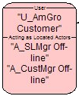 is an alternative to the human icon on previous figures, and allows information about the model element to be displayed more easily
Just as detailed design of nodes is part of Deployment Modelling, so network design is part of Network Modelling. Both are “downstream” of Operational Modelling
At the time of writing, nodes and DUs in 1.15.1.12, Actors/Users in the next release.
The same mechanism enables an enterprise to use their Enterprise Architecture to manage (minimise) the range of different “standard platforms” chosen by a Solution Architect.
So long as the two logical located nodes are also in the same location!
This physical solution is based on the application level outline logical structure view. It should be based on the full logical structure view, including all required technical logical located nodes, such as those shown in Figure 50.
Part of the solution most likely to need design focus to ensure the system’s operational requirements are met.
Alternatively, this would be achieved via a detailed review of the design (#5), comparing it directly to the non functional characteristics it’s intended to support (#1)!
Quoted from the “Architectural Thinking” Course’s module on Views and Viewpoints. Not that, as well as documenting the viewpoint’s presentation, UMF’s artefacts also include guidance on how to develop those parts of the model that can be seen from the viewpoint, as well as other information such as reasons the viewpoint will be useful, often with a particular type of observer (i.e. stakeholder) in mind.
In this context, one type of view is called a “view” – a faithful diagrammatic rendering of the model.
As well as their relationships and behaviours
From Ref [3]
This and subsequent figures are from “Architectural Thinking” course’s module on Views and Viewpoints
It is unfortunate that the term Operational Model also refers to a UMF artifact containing some of the views of the target IT system’s model that can be seen from the Operational Viewpoint. Here, the term is being used accurately to refer to the model, not a (sub)set of views of the model. The same is true for “Location Model”.

